**Session 10**

**Assignment 1**

Write a program to implement WordCount using Pig.

The command lines used to implement the WordCount program using Pig.

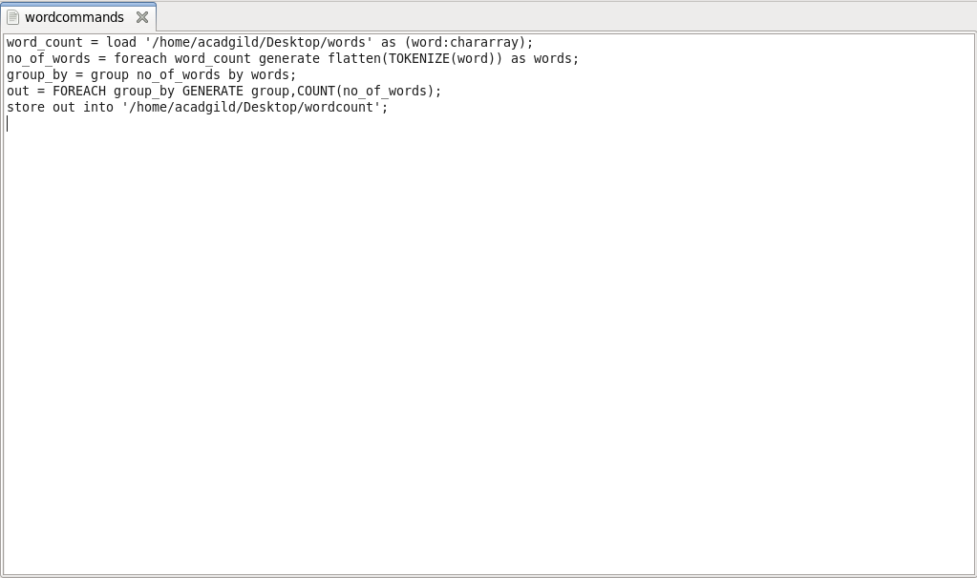

* The File for which the word count has to be performed is fed into the pig shell with the help of LOAD COMMAND.
* Flatten command is used to convert bag in to tuples.
* Group by command groups similar words.
* Count command counts the grouped words.
* Store command stores the processed output as a text file.

The text file used to implement the WordCount program by Pig.

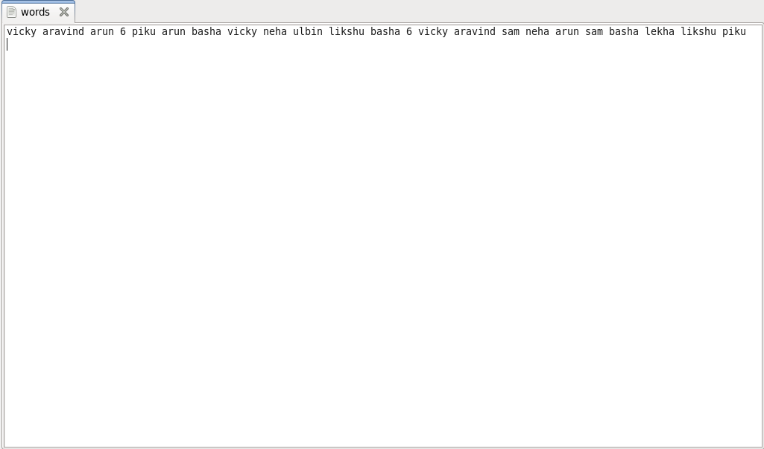

Command line to run the WordCount program by using Pig

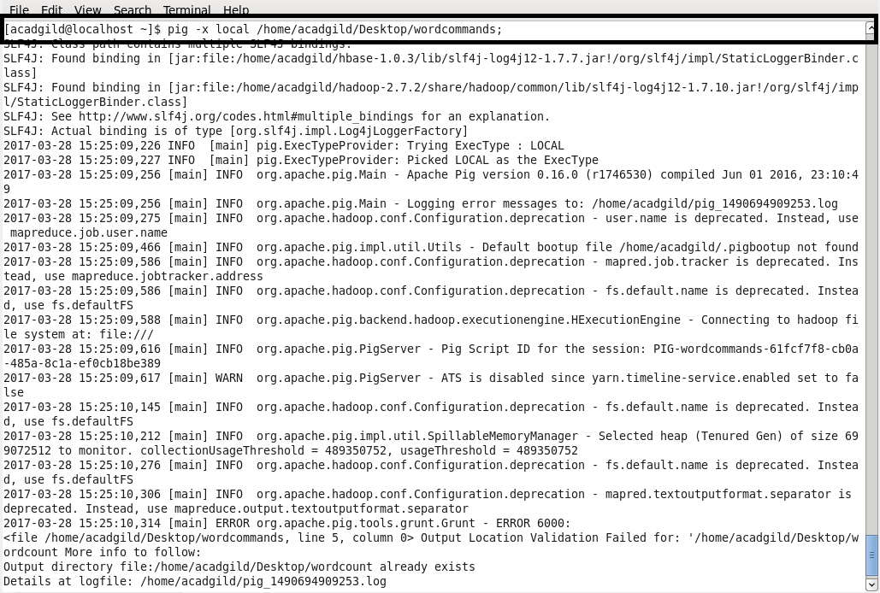

Output:

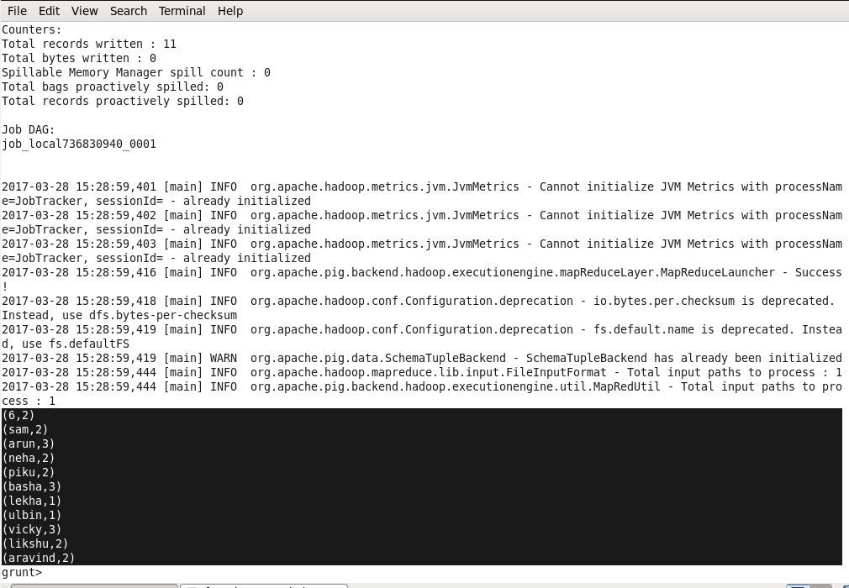

Output File:

