**Session 10**

**Assignment 4**

**Part 1:**

Write a pig script find the average age of male and female persons died in the titanic tragedy.

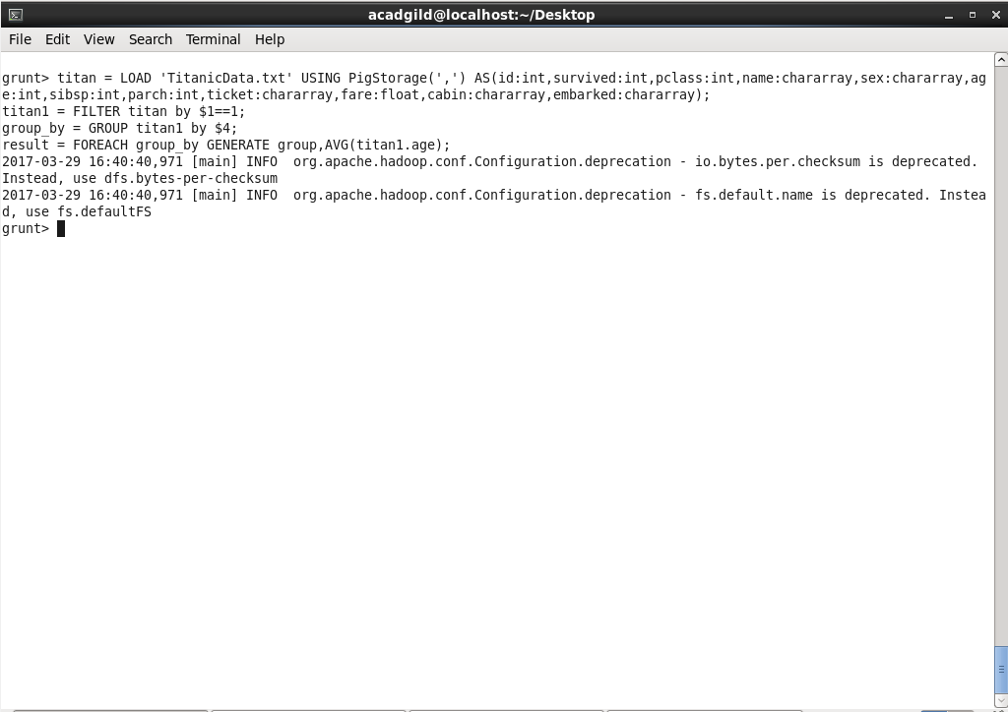

**Output:**

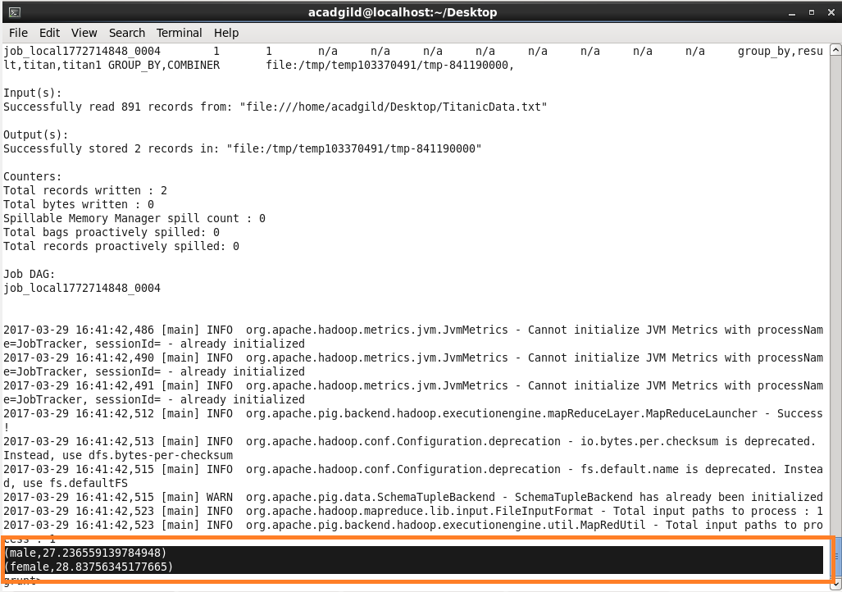

**Part 2:**

Write a pig script to find the number of people died and survived in each class.

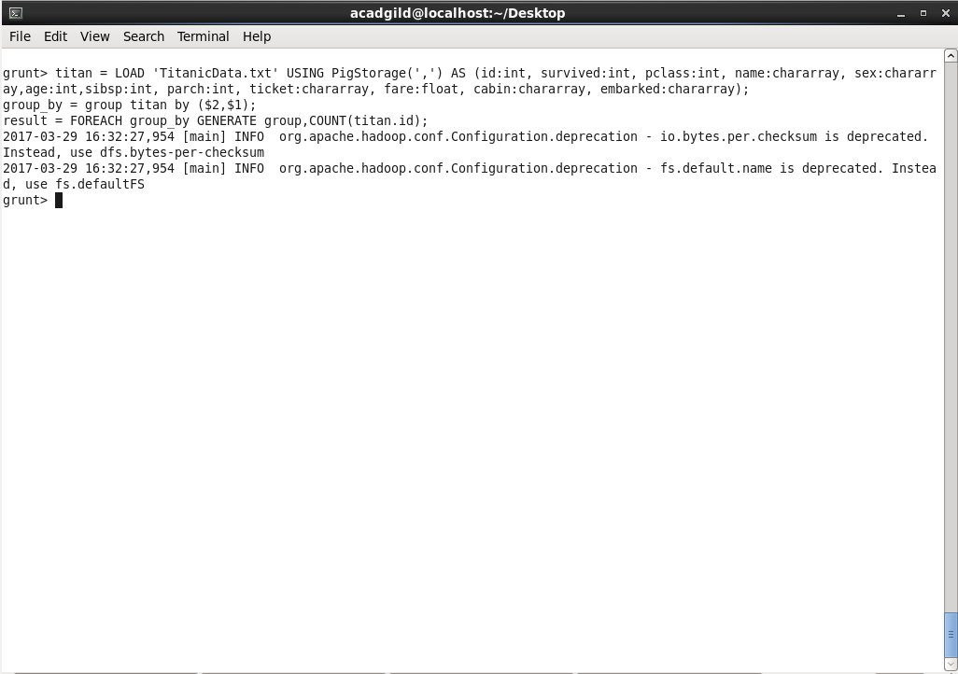

**Output:**

