**Session 10**

**Assignment 5**

**Part 1:**

Write a pig script to find the top 20 destination people travel the most based on the given dataset.

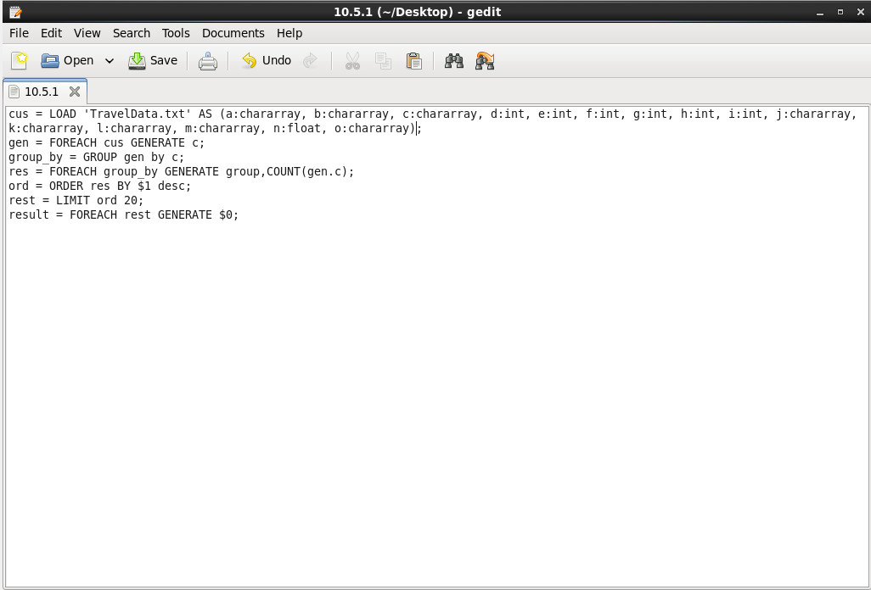

**Output:**

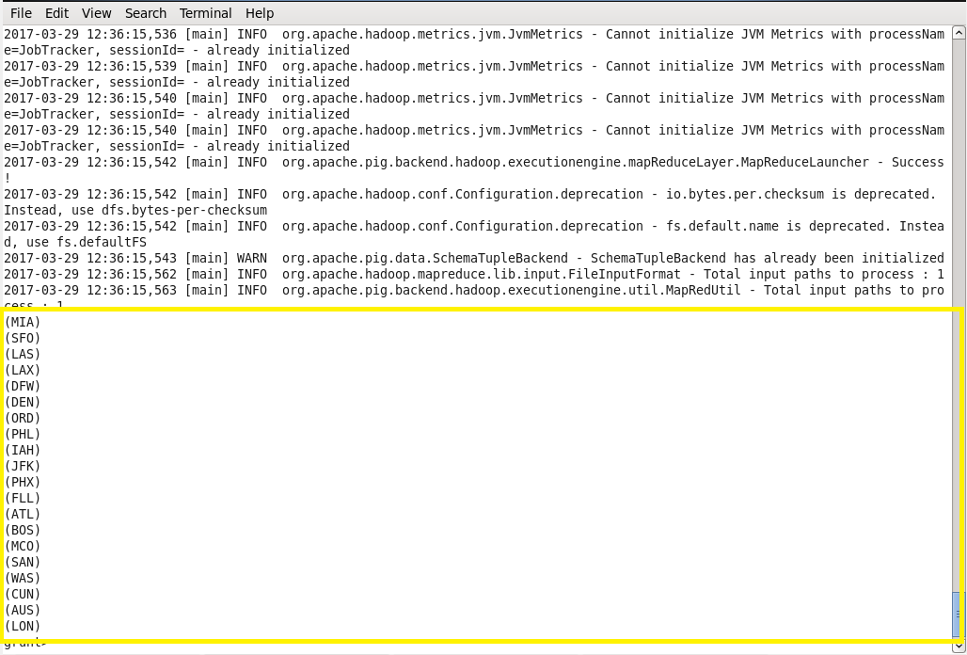

**Part 2:**

Write a pig script to find the top 20 locations from where people travel the most based on the given dataset.

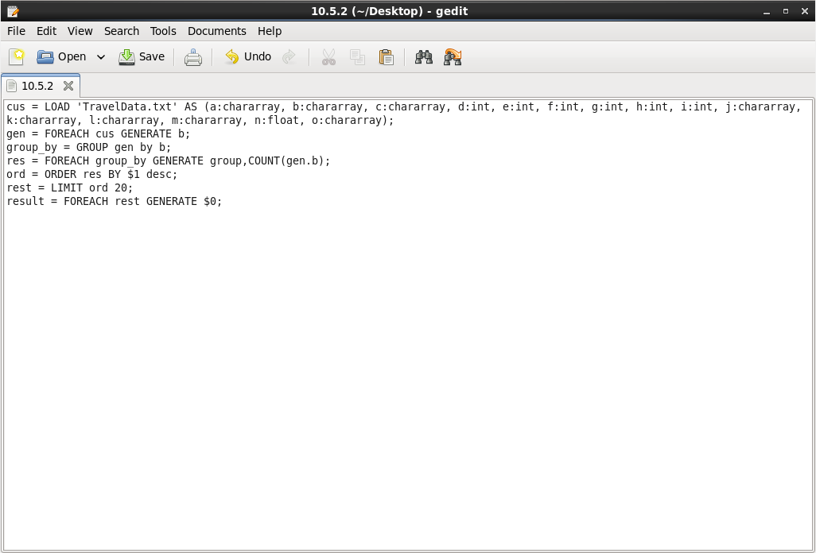

**Output:**

