**Session 10**

**Assignment 6**

**Part 1:**

Write a pig script to find the minimum temperature observed in a given weather station in a particular year.

This can be achieved by grouping the dataset based on stations and finding the minimum by using group by and count commands as shown in the picture.

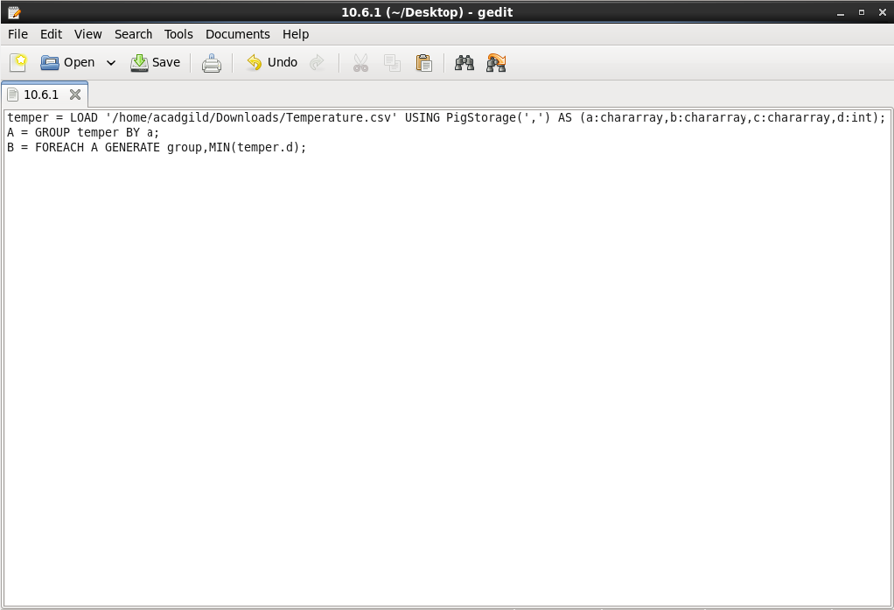

**Output:**

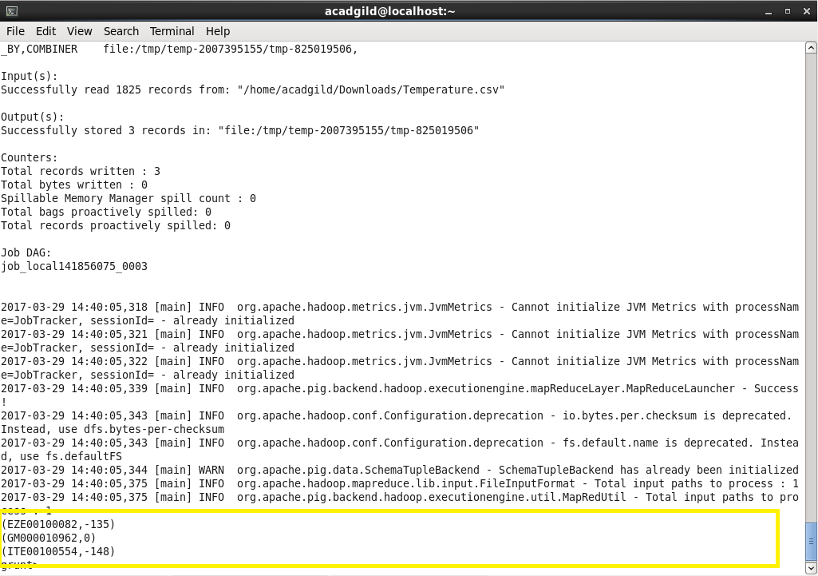

**Part 2:**

Write a pig script to find the maximum temperature observed in a given weather station in a particular year.

This can be achieved by grouping the dataset based on stations and finding the minimum by using group by and count commands as shown in the picture.

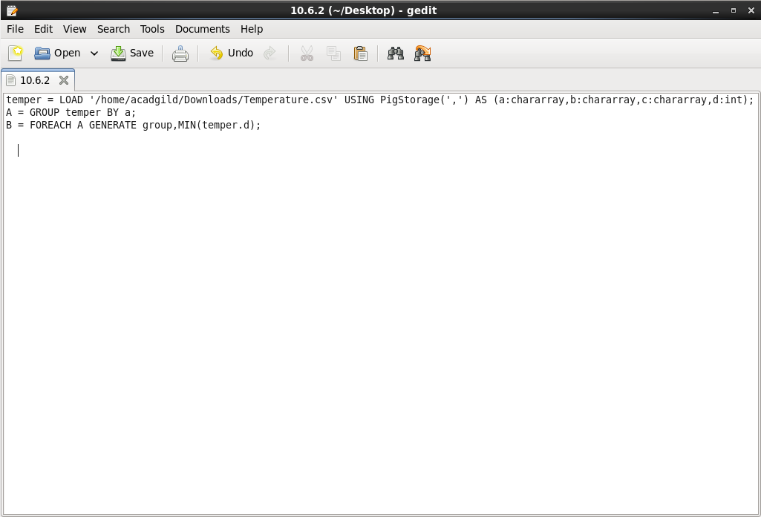

**Output:**

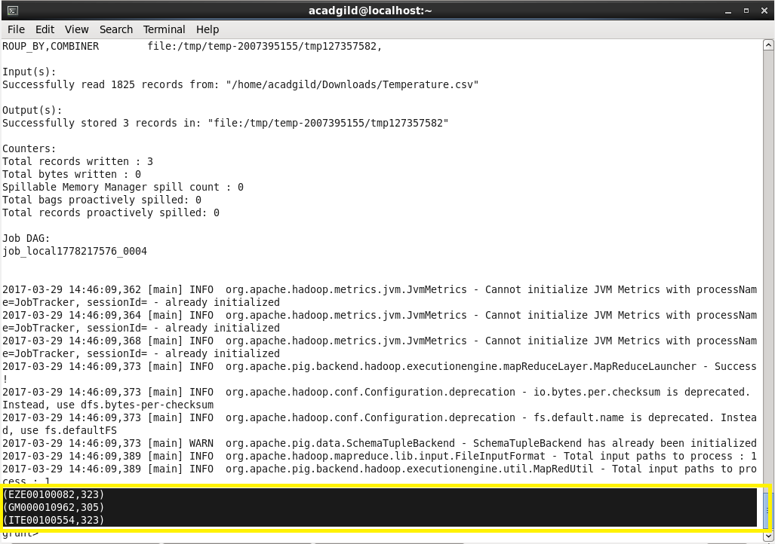

**Part 3:**

Write a pig script to find the number of readings given by each weather station according to the dataset.

This can be achieved by grouping the dataset based on stations and finding the total number of readings by using group by and count commands as shown in the picture.

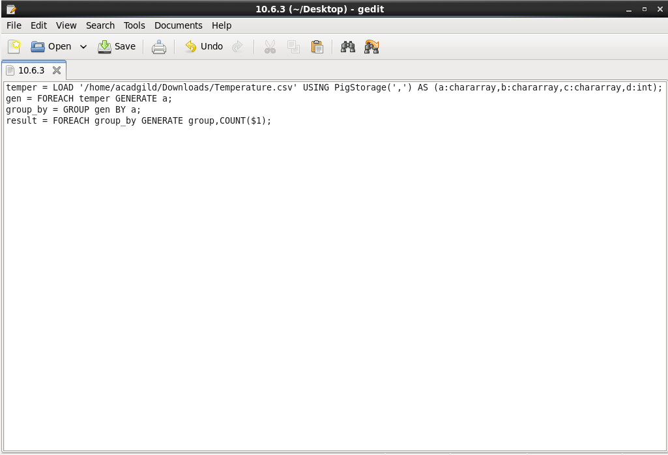

**Output:**

