**Session 11**

**Assignment 1**

**Part 1:** What is the total amount of petrol in volume sold by every distributor?

**Grouping by Distributor name using GROUP by command.**

**Summing the output volume using SUM () command.**

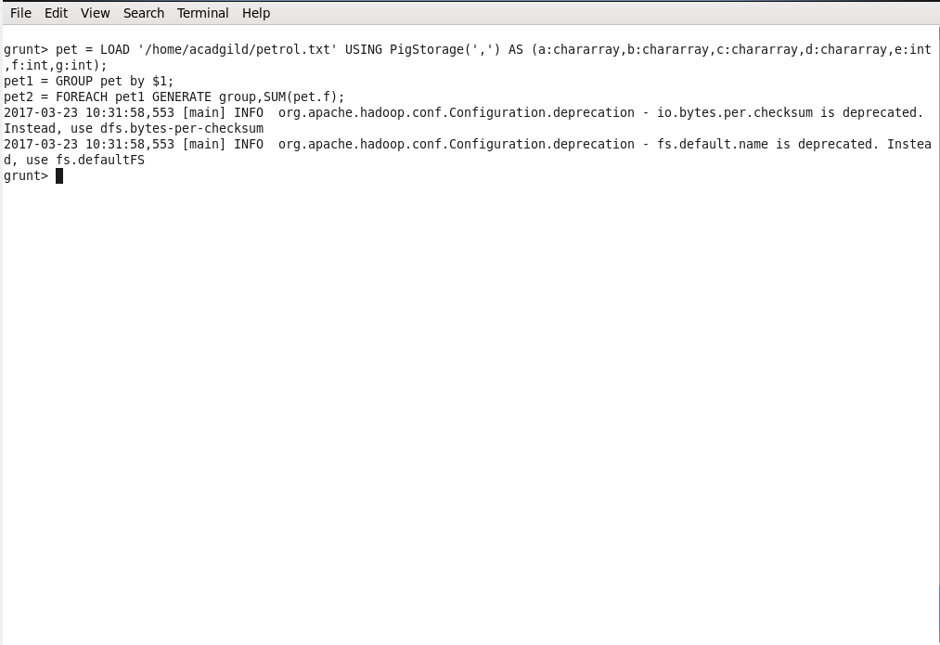

**Output:**

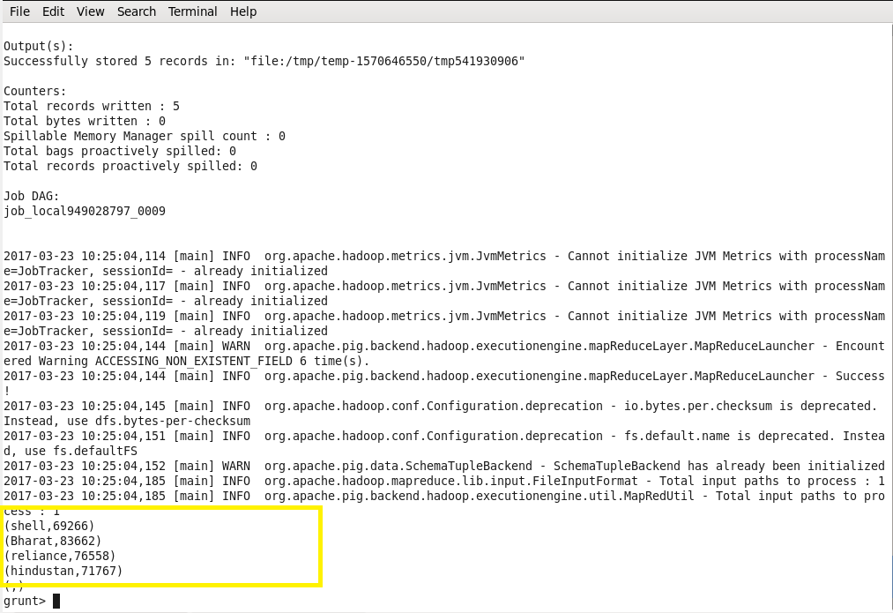

**Part 2:** Which are the top 10 distributors ID's for selling petrol? Also display the amount of petrol sold in volume?

**Grouping by Distributor ID using GROUP by command.**

**Summing the output volume using SUM () command.**

**Limiting the data after making the data into descending order by using ORDER and LIMIT commands.**

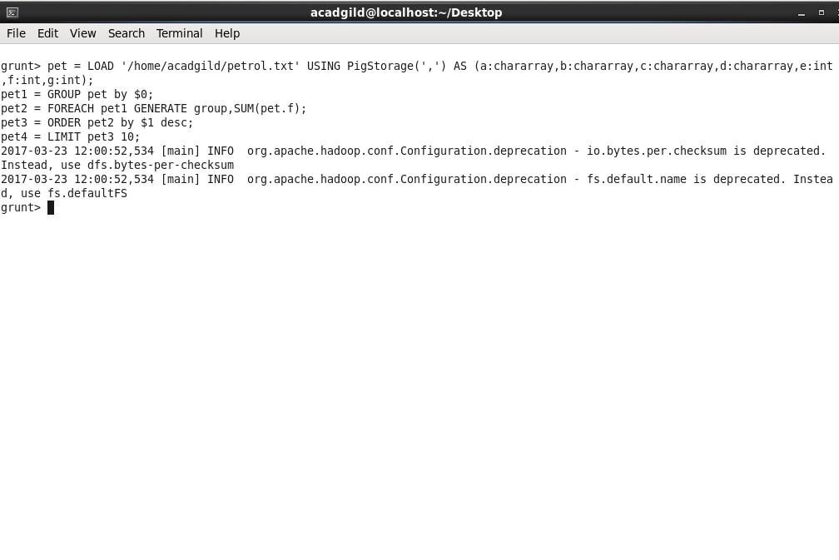

**Output:**

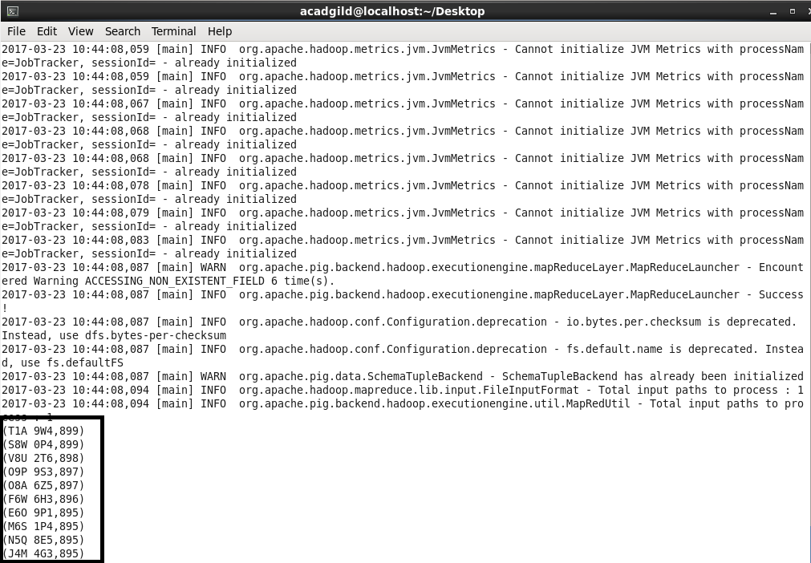

**Part 3:** List 10 years where consumption of petrol is more with the distributer id who sold it.

**Grouping by Distributor ID and Year using GROUP by command.**

**Summing the Volume in using SUM () command.**

**Limiting the data after ordering and flattening the data using LIMIT, ORDER and flatten commands.**

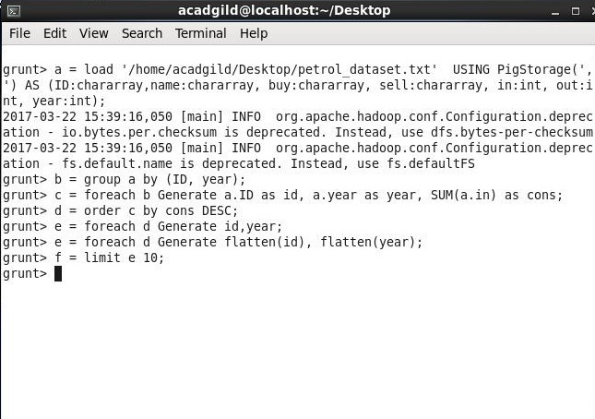

**Output:**

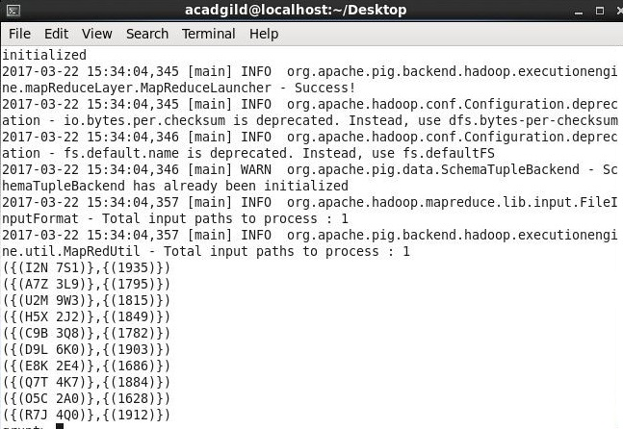

**Part 4:** Find the distributer name who sold petrol in least amount.

**Grouping by Distributor name and Year using GROUP by command.**

**Summing the Volume out using SUM () command.**

**Displaying the Name of the distributer by ordering and limiting the data using ORDER and LIMIT commands.**

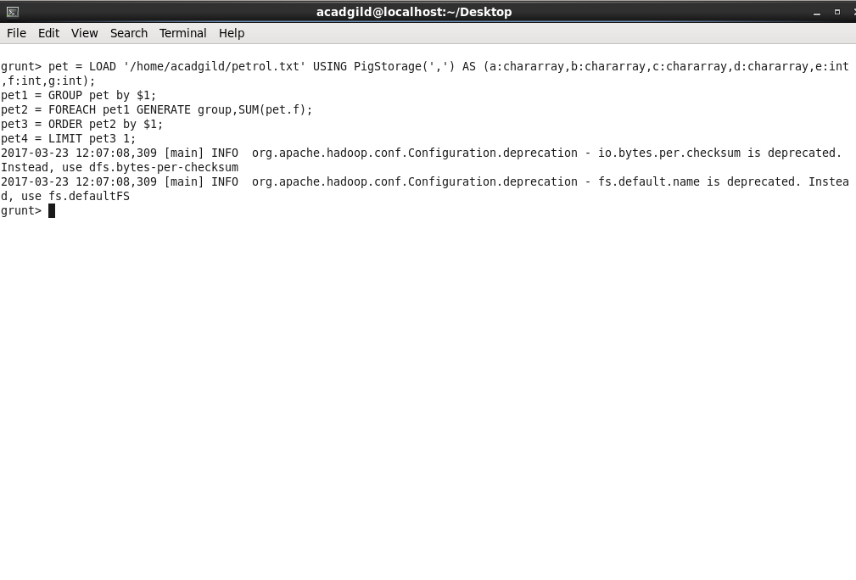

**Output:**

