**Session 11**

**Assignment 2**

**Part 1:** Find the number of students who scored less than 5 (50%).

**Filtering the students list of students scored less than 5(50%) using FILTER command.**

**Grouping the data by all the records using GROUP by command.**

**Counting number of those students using COUNT command.**

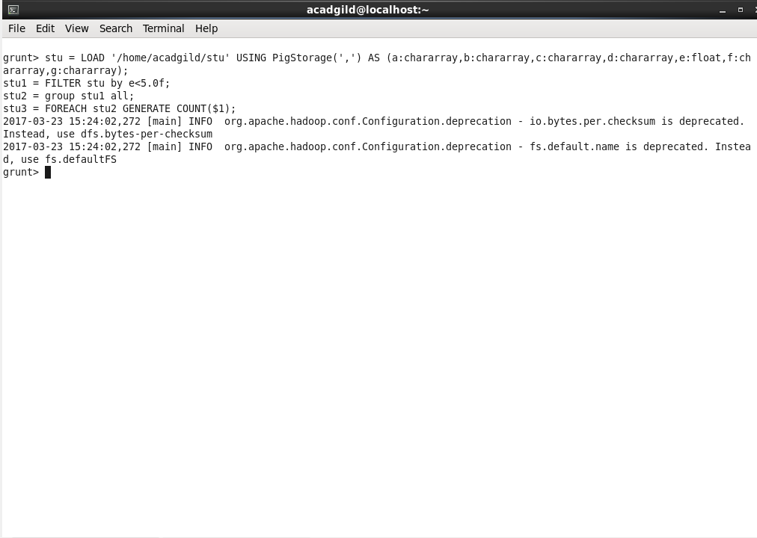

**Output:**

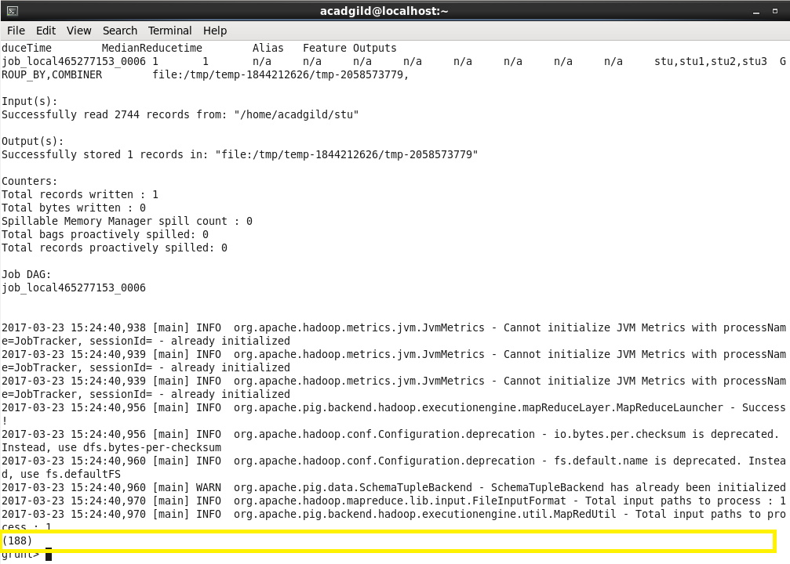

**Part 2:** List the name of students who are from Alaska.

**Filtering the students list for students from ‘alaska’ using FILTER command.**

**Getting output by using GENERATE command.**

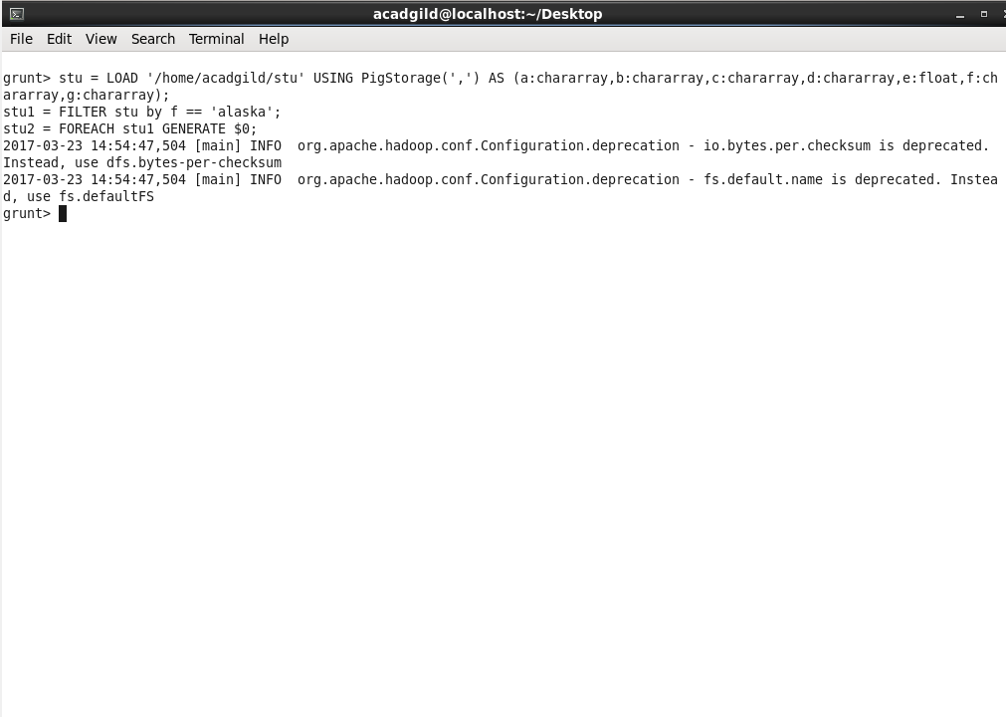

**Outputs:**

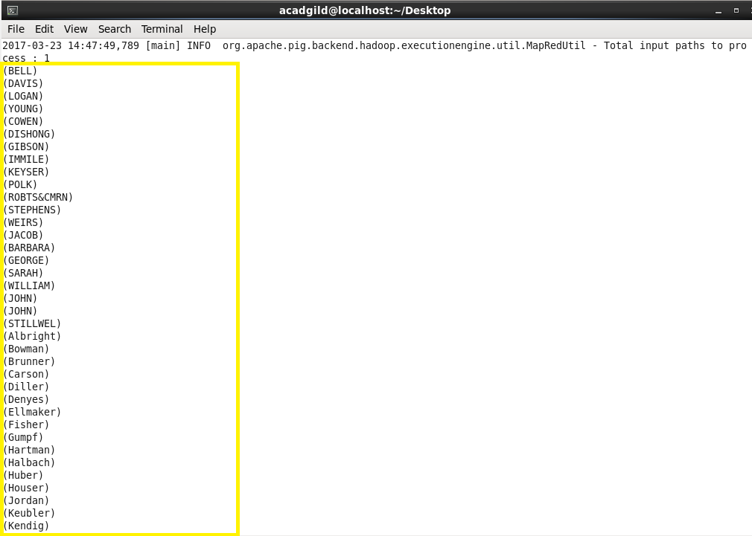

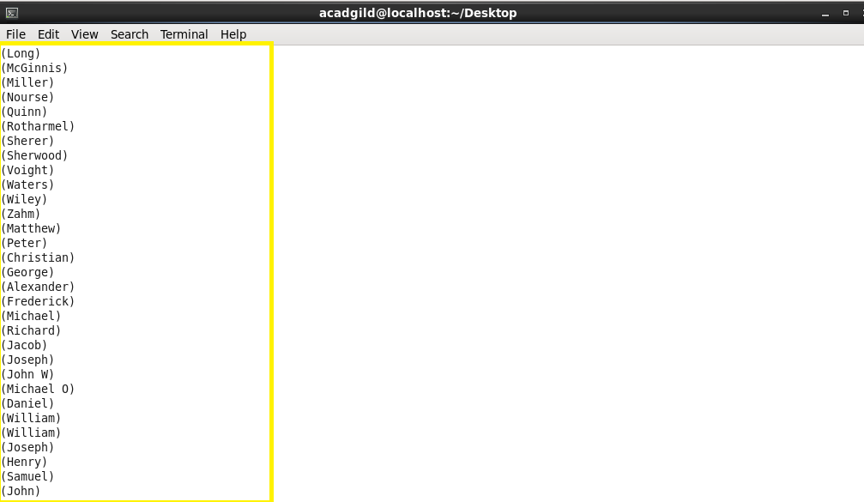

**Part 3:** How many government colleges are there in Alabama?

**Filtering the students data for colleges of category ‘government’ from ‘alabama’ using FILTER command.**

**Grouping the data by filtered categories using GROUP command.**

**Calculating the number of ‘government’ colleges using COUNT command.**

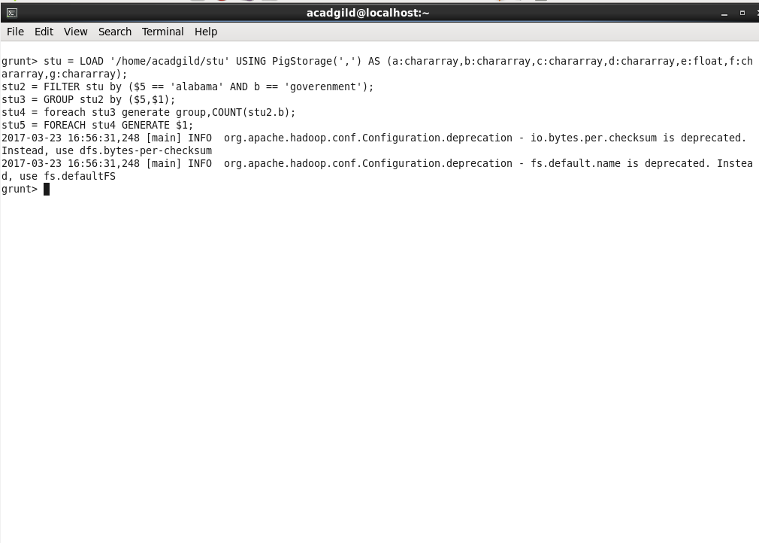

**Output:**

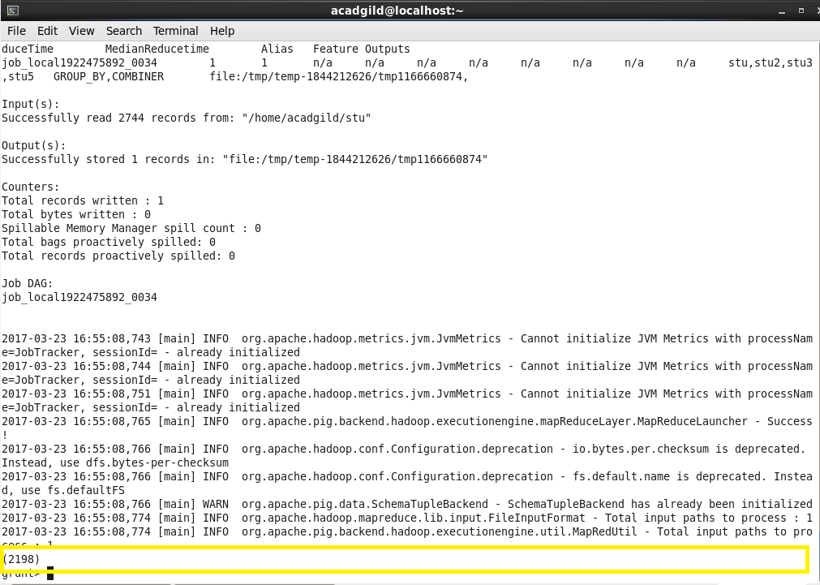

**Part 4:** List the name of students who are from Oregon and pursuing BE.

**Filtering the students list for students from ‘Oregon’ pursuing ‘BE’ using FILTER command.**

**Displaying only the list of students name using GENERATE command.**

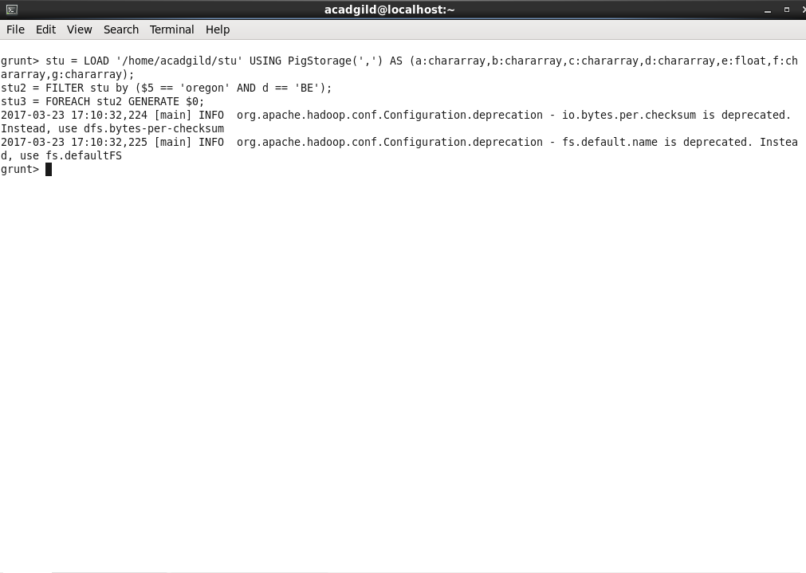

**Outputs:**

