**Session 11**

**Assignment 3**

Write a Pig UDF to find the tweets posted by @realDonaldTrump from the given dataset.

**UDF Class:**

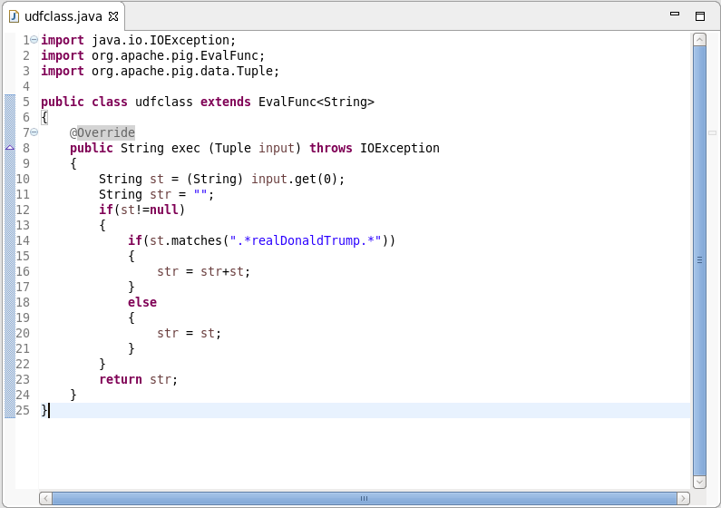

**Pig Command lines:**

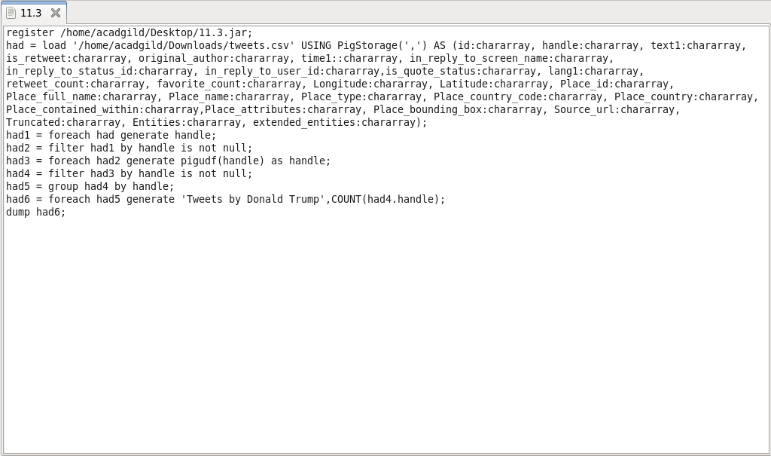

**Output:**

