**Session 11**

**Assessment 4**

**Twitter data analysis**

Write a pig script to find the count of each Hashtag in the dataset. You can download the twitter data from the given dataset

**Data 1: Flume Data - 1453125784129**

**Pig Command lines:**

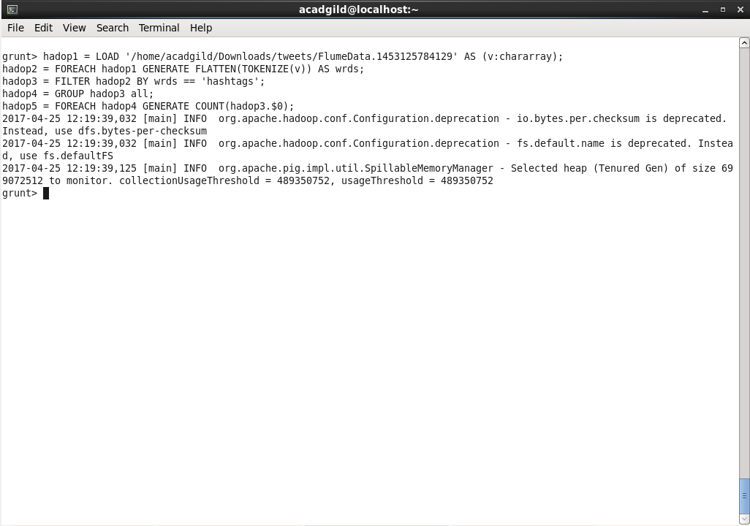

**Output:**

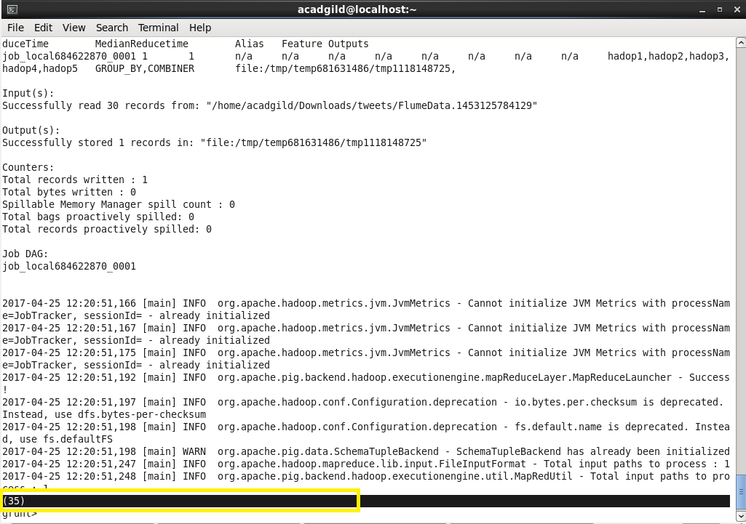

**Data 2: Flume Data - 1453126406734**

**Pig Command lines:**

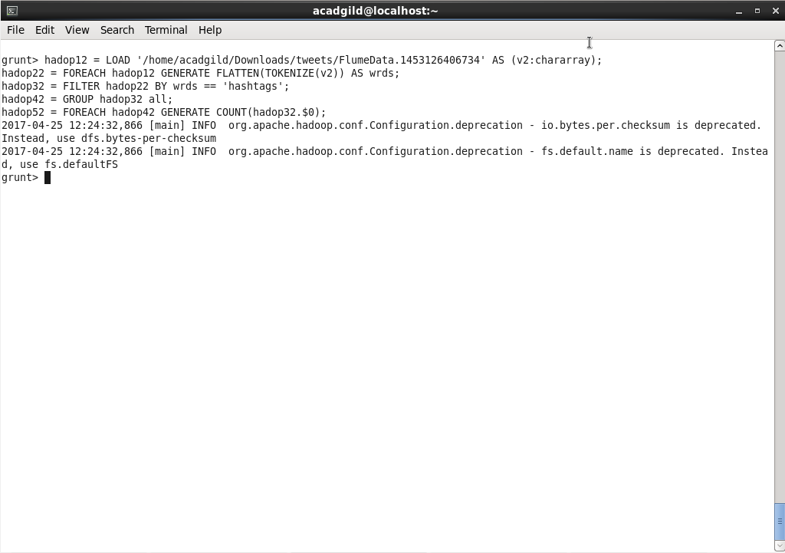

**Output:**

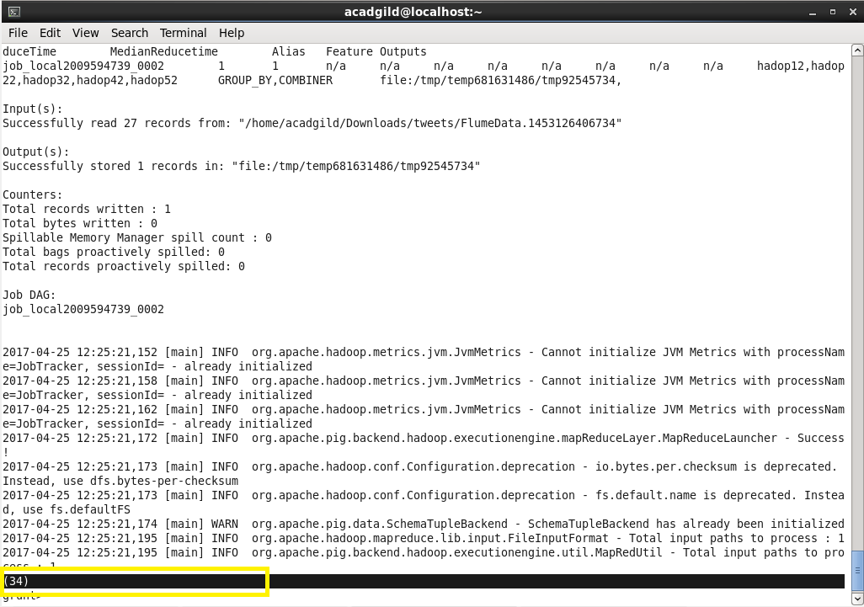

**Data 3: Flume Data – 1453127030506**

**Pig Command lines:**

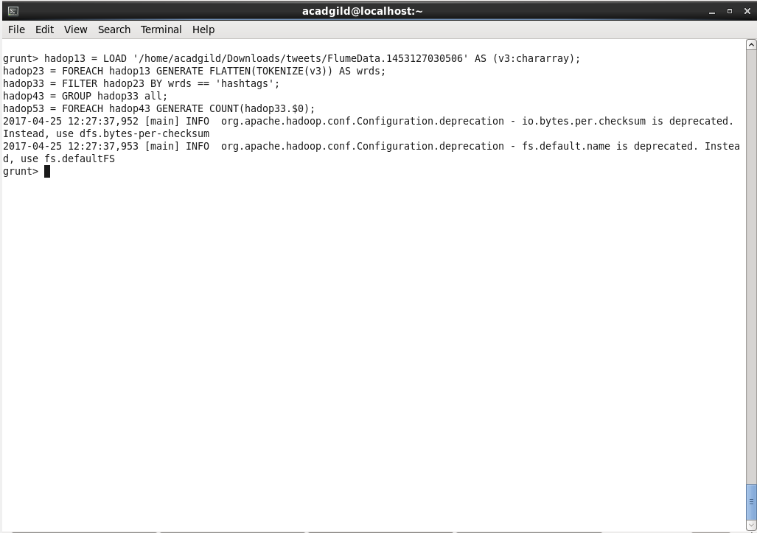

**Output:**

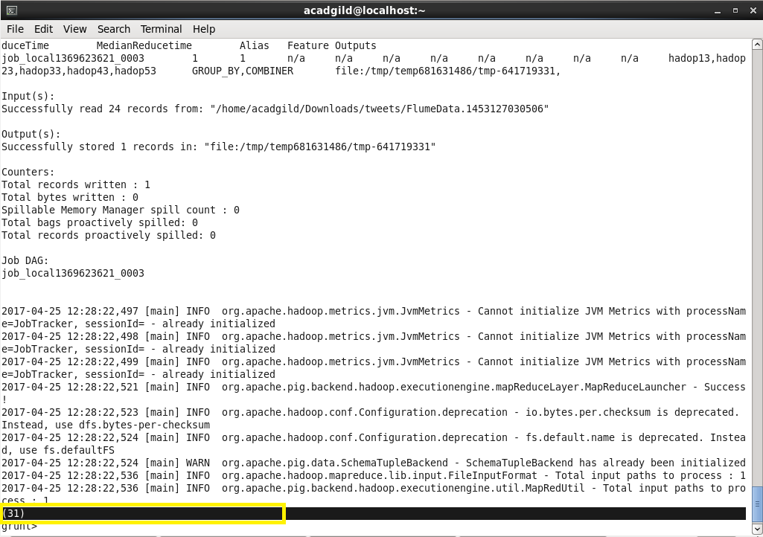

**Data 4: Flume Data – 1453127643423**

**Pig Command lines:**

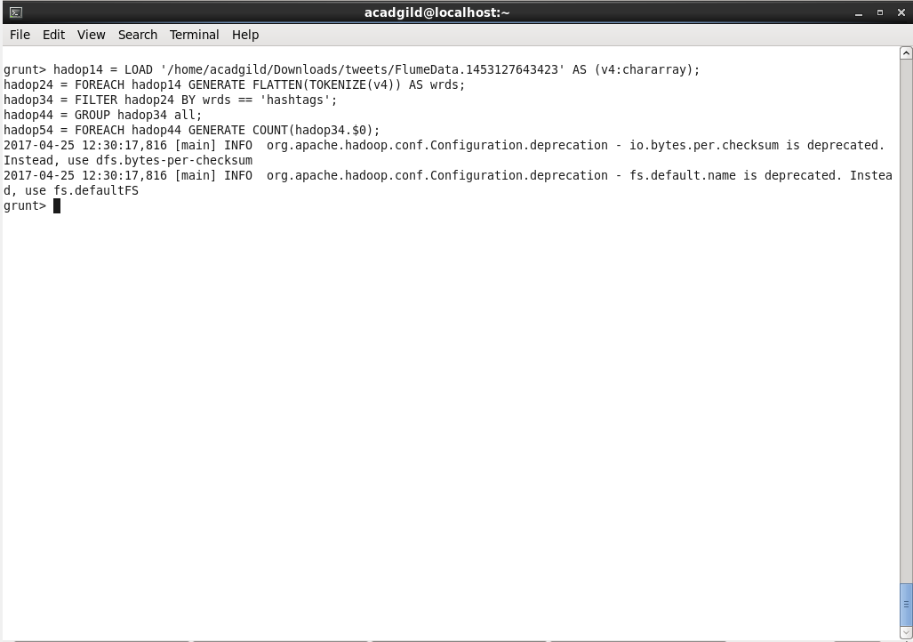

**Output:**

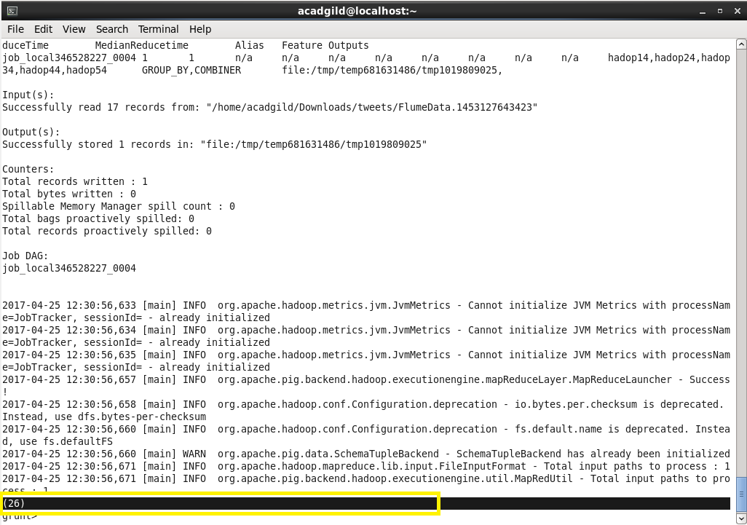

**Data 5: Flume Data – 1453128271497**

**Pig Command lines:**

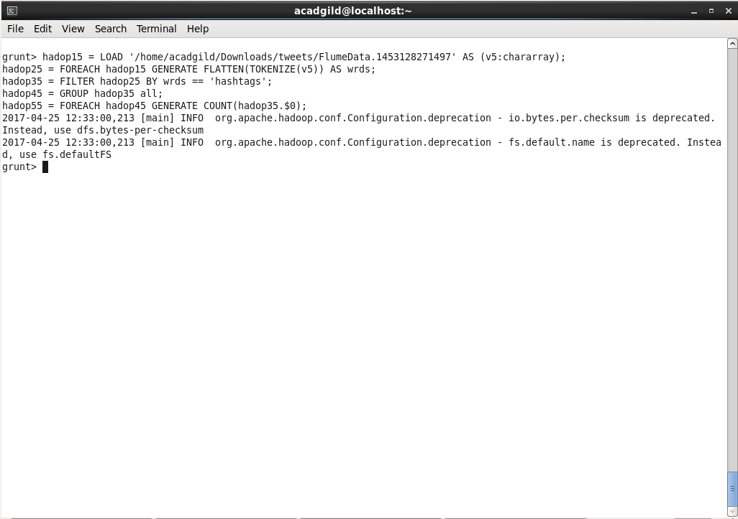

**Output:**

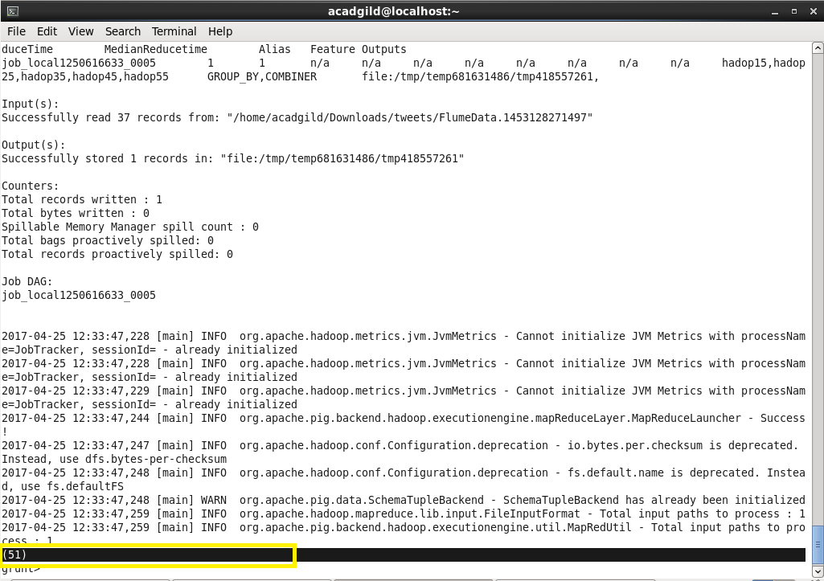

**Data 6: Flume Data – 1453128879259**

**Pig Command lines:**

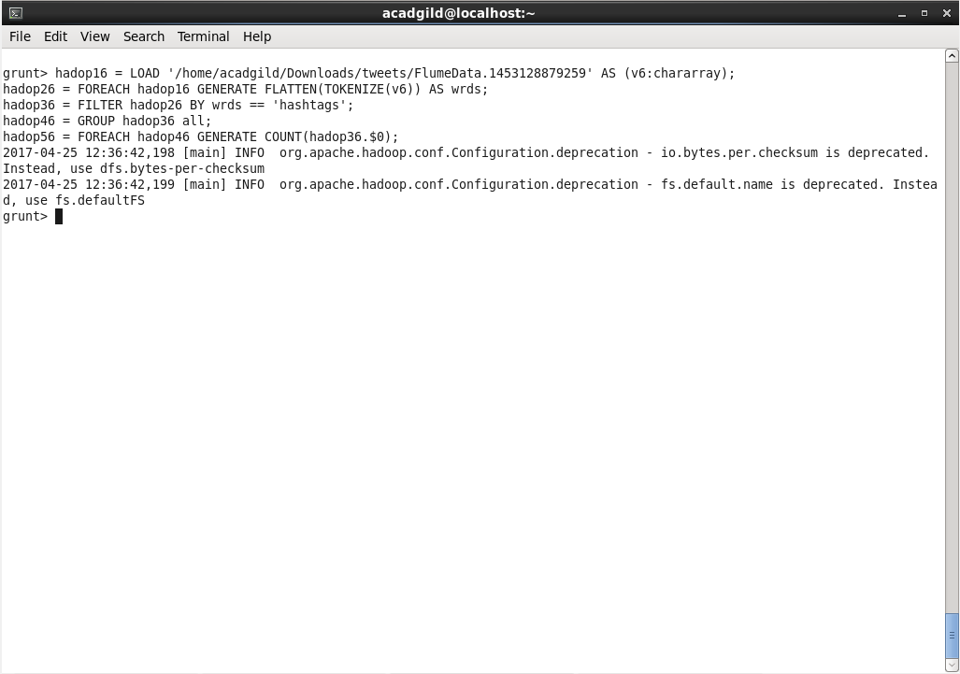

**Output:**

