**Session 12**

**Assignment 2**

**Create a flume agent that streams data from Twitter and stores it in the HDFS cluster.**

**Step 1: Creating a directory using mkdir command.**

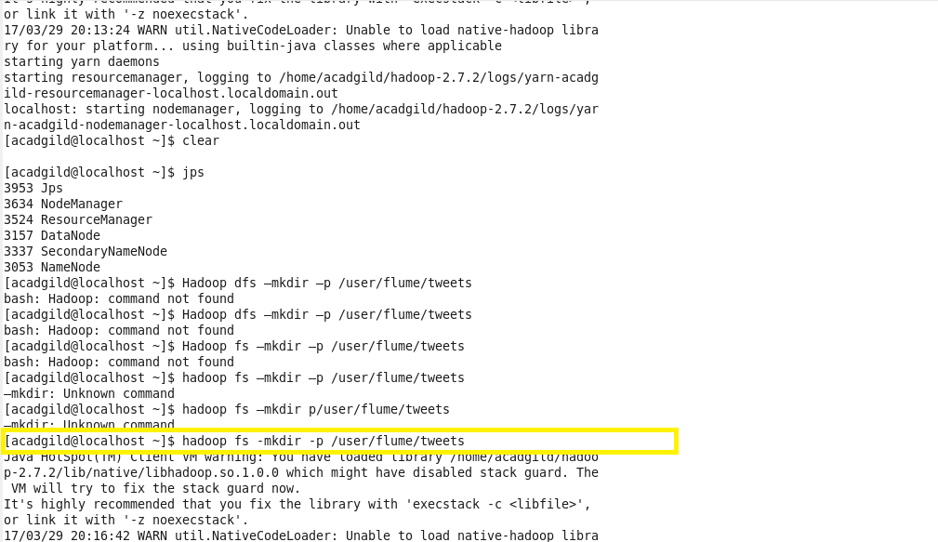

**STEP 2:**

**Editing the configuration file with the generated key, consumerSecret, accessToken and accessTokenSecret.**

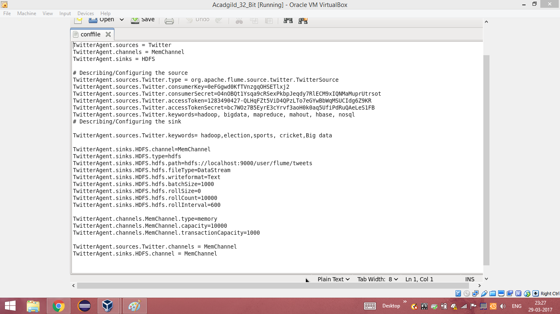

**STEP 3: Running flume in console.**

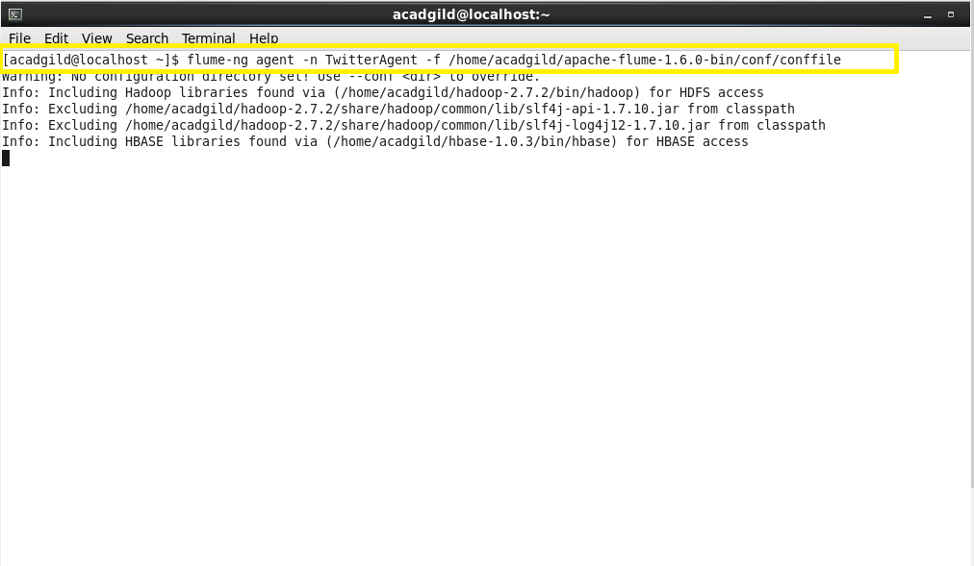

**Step 4: Listing the contents of the tweets folder**

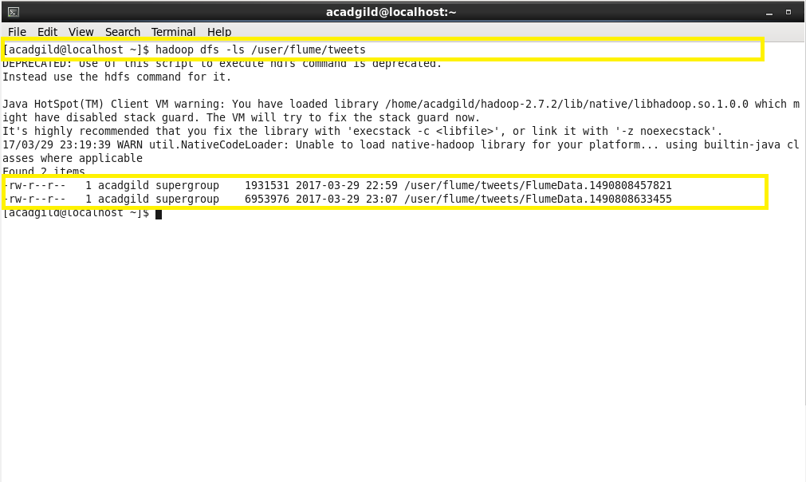

**Step 5: Reading the extracted data from twitter using ‘-cat command’**

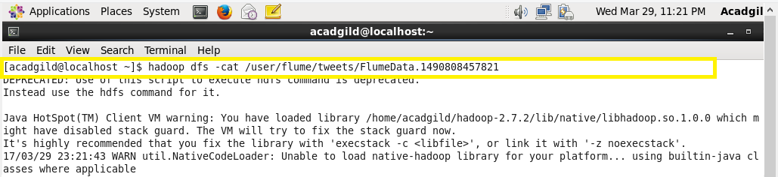

**Step 6: Extracted data from twitter**

