**Session 16**

**Assignment 2**

**Problem Statement:**

In many countries, the public telephone network has a single emergency telephone number (sometimes known as the universal emergency telephone number or the emergency services number) that allows a caller to contact local emergency services for assistance. This emergency number differs from country to country and typically consists of three digits numbers that can be easily remembered and dialed quickly. Some countries have a different emergency number for each of the different emergency services. Here we have two data sets; one is the data that the callers has given when they called the emergency helpline number.

**Question:**

Use reduce side join to join the two datasets and find what kind of problems are prevalent, and in which state?

**Driver Class:**

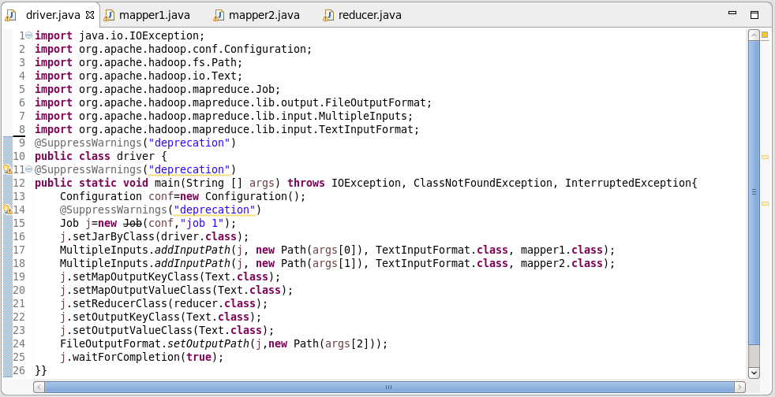

**Mapper Class 1:**

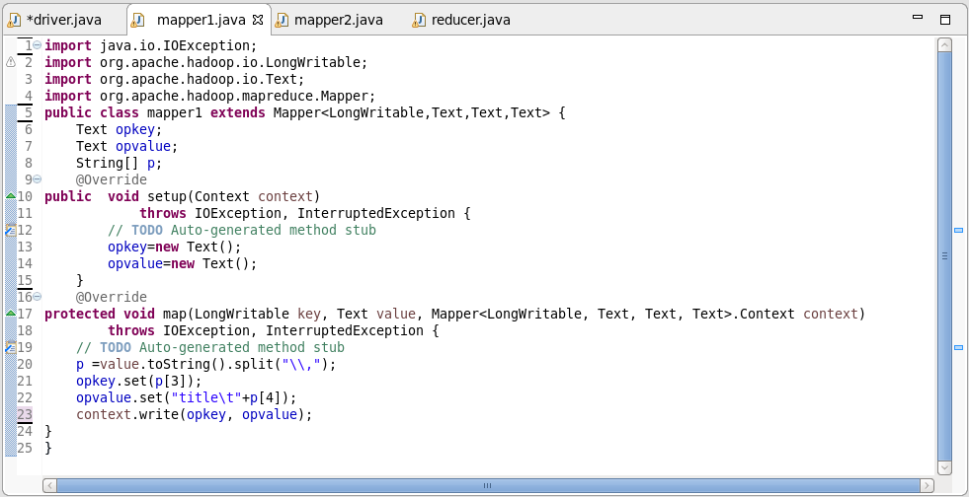

**Mapper Class 2:**

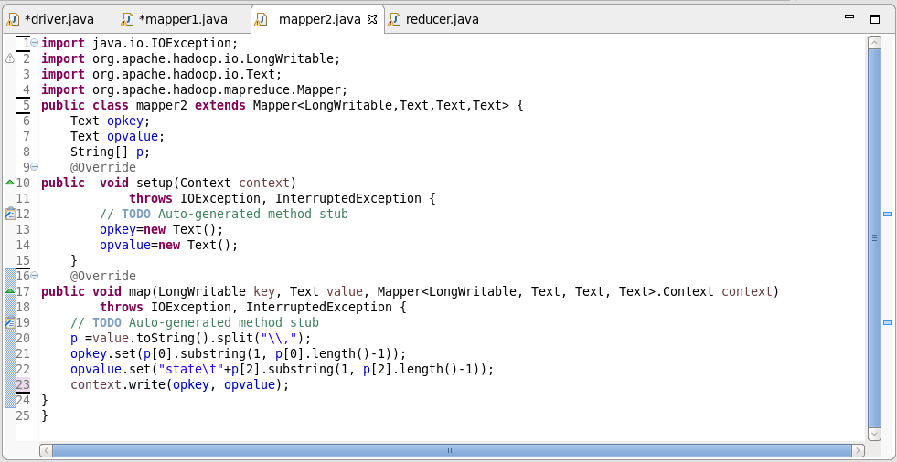

**Reducer Class:**

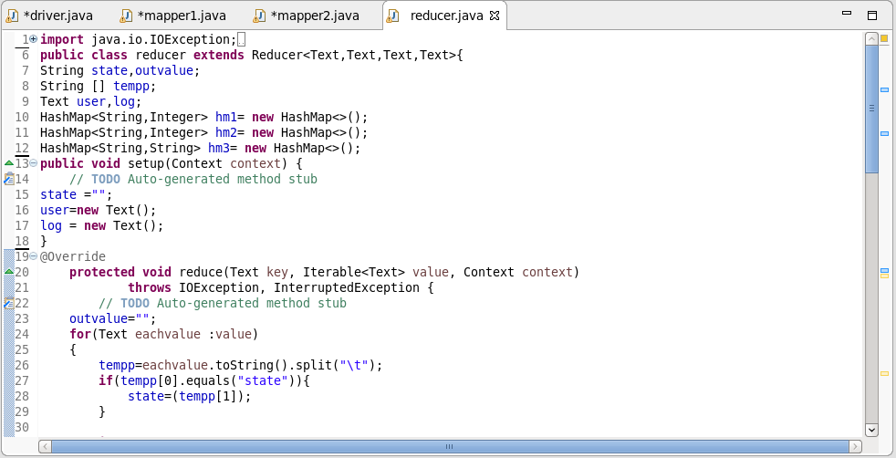

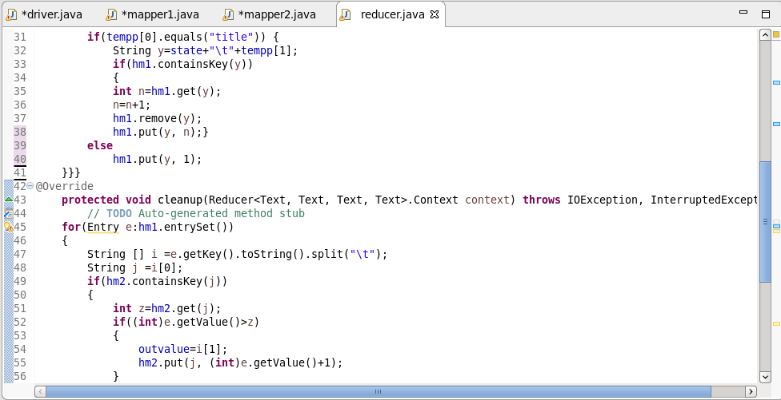

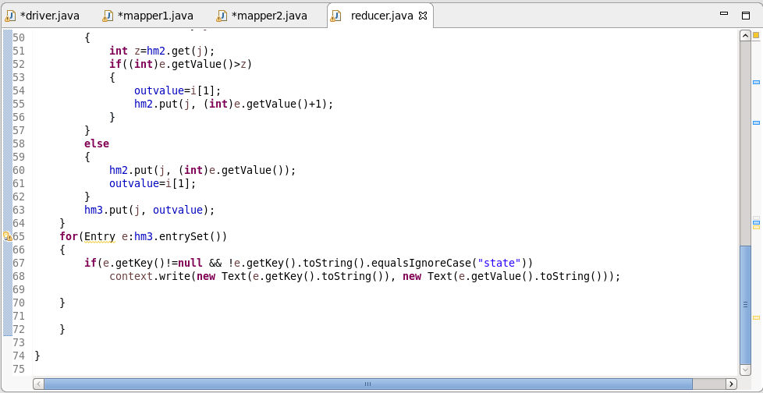

**Running Jar:**

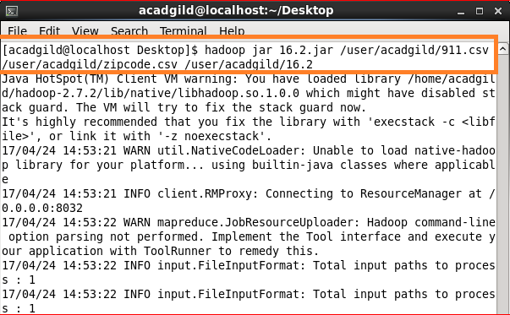

**Output:**

