**Session 16**

**Assignment 1**

Executing Machine and Sensor data analysis using Reduce side join and compare which join is faster in normal conditions.

**Driver Class:**

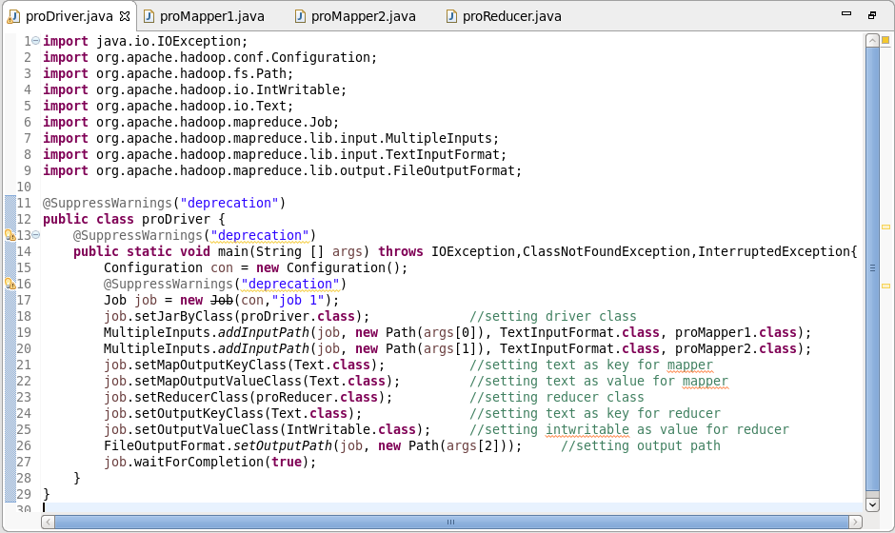

**Mapper Class 1:**

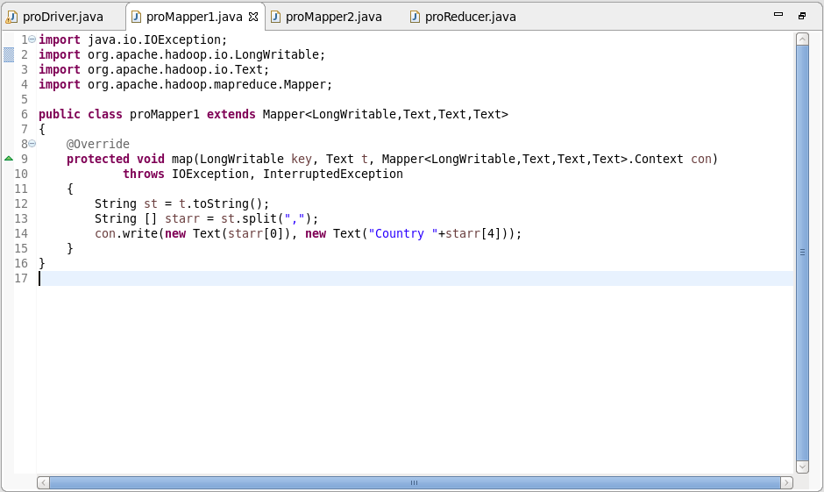

**Mapper Class 2:**

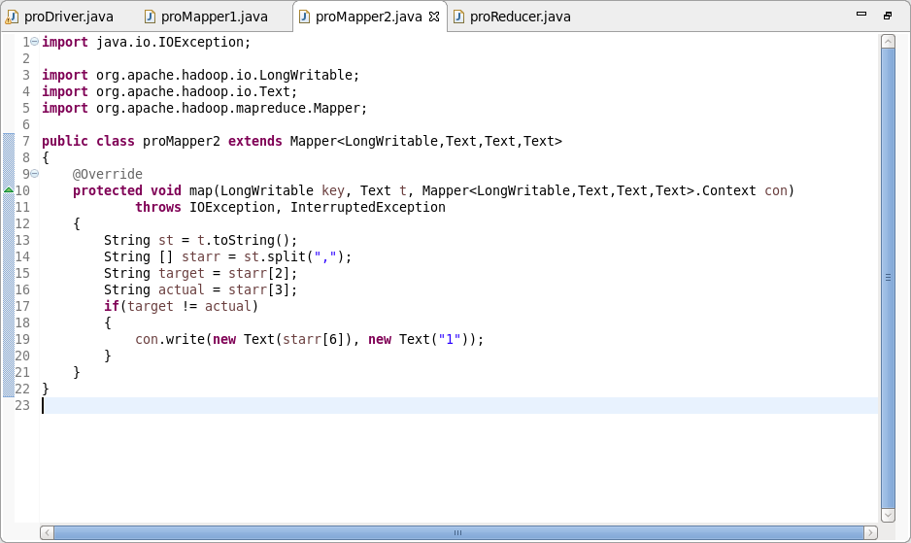

**Reducer Class:**

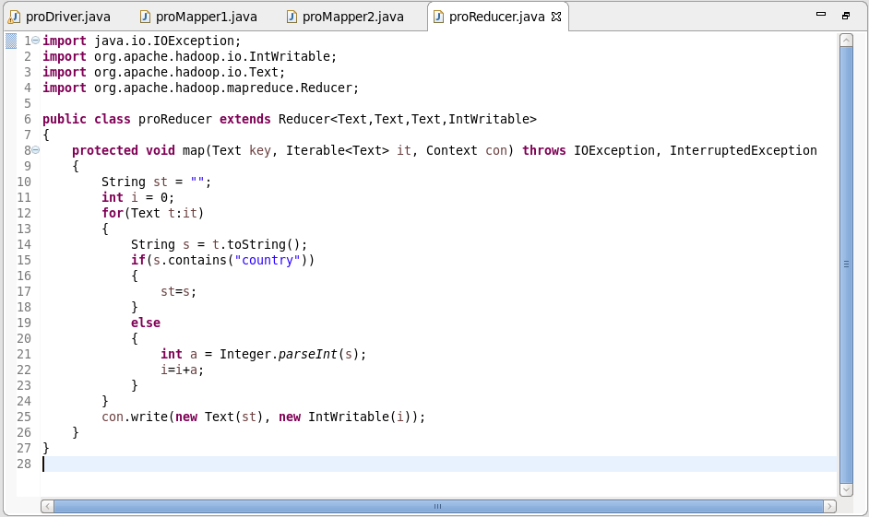

**Output:**

