**Session 16**

**Assignment 5**

Write a map reduce program to join the below given two datasets using map side join.

**Driver Class:**

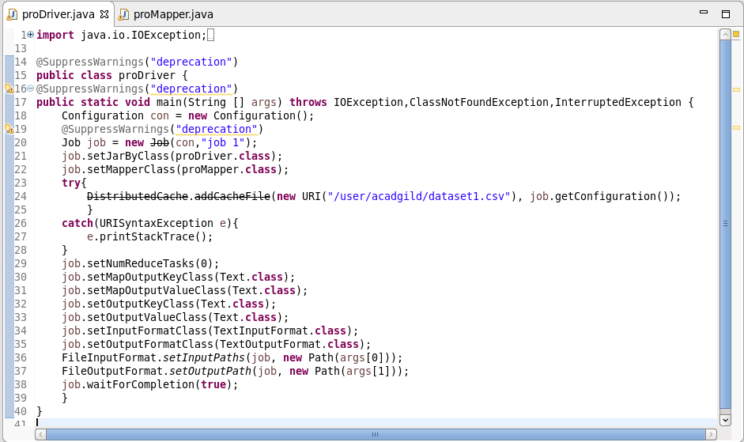

**Mapper Class:**

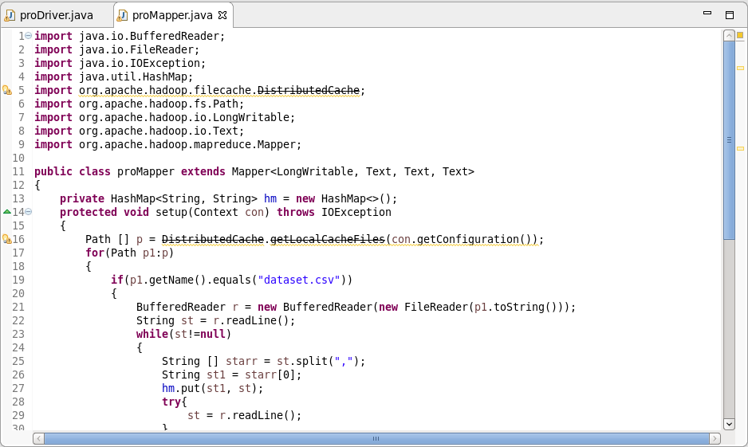

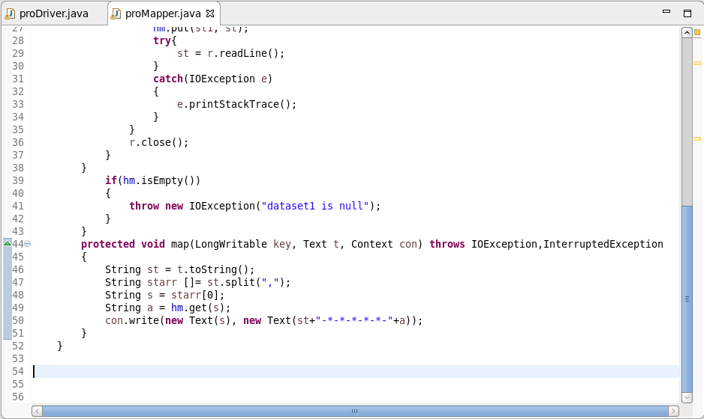

**Output:**

Since the output file is very long, a portion of the output is attached here.

