**Session 16**

**Assignment 6**

Write a map reduce program to join the below given two datasets using Reducer side join.

**Driver Class:**

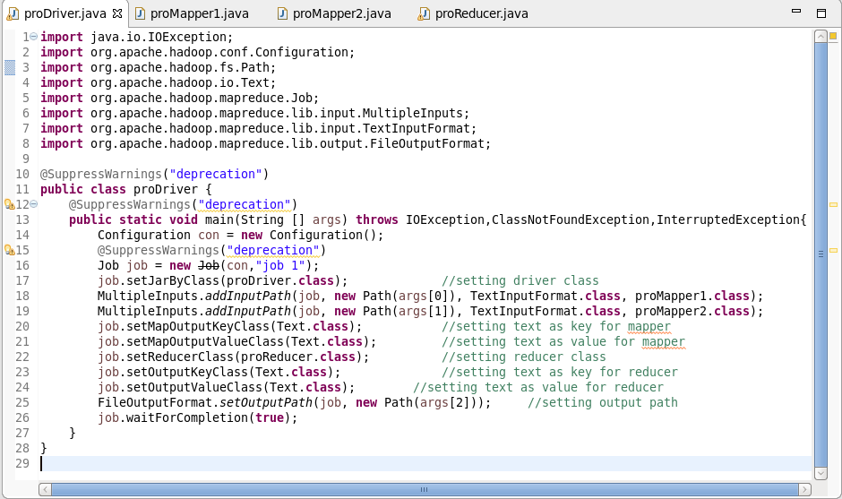

**Mapper Class 1:**

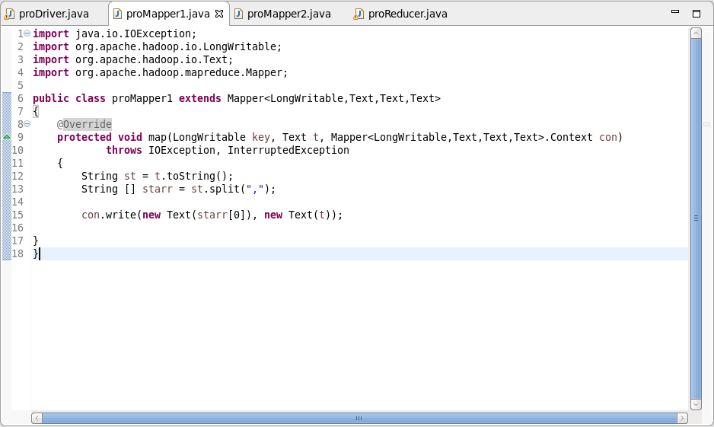

**Mapper Class 2:**

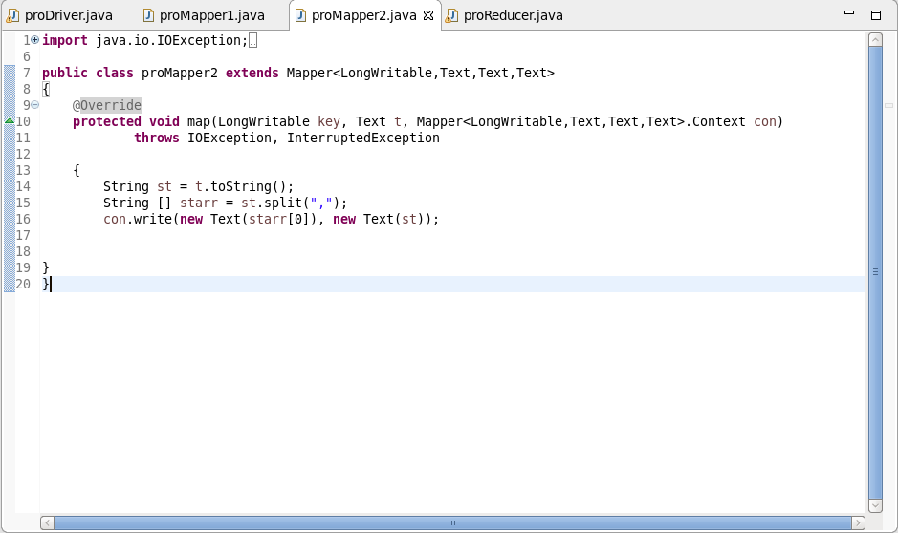

**Reducer Class:**

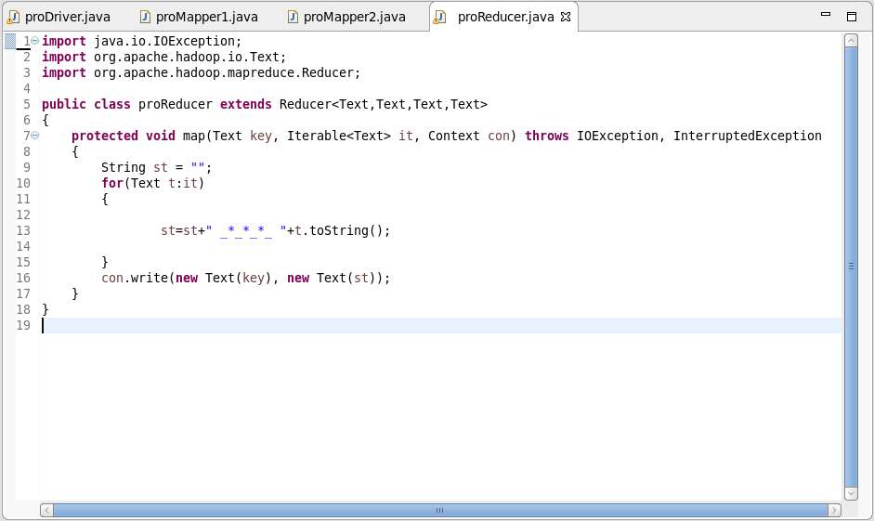

**Output:**

