**Session 17**

**Assignment 1**

Write a program that accepts the job-id as argument and returns a custom counter and a system counter (total records input to the map tasks) associated with that job.

**Driver Class:**

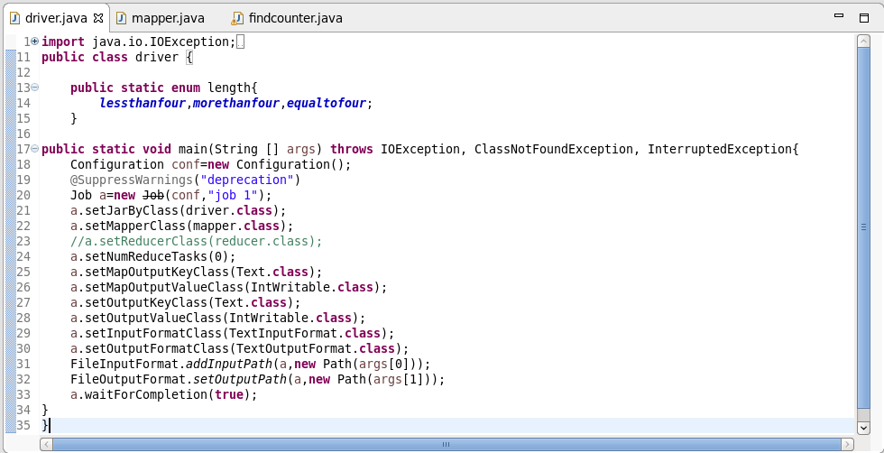

**Mapper Class:**

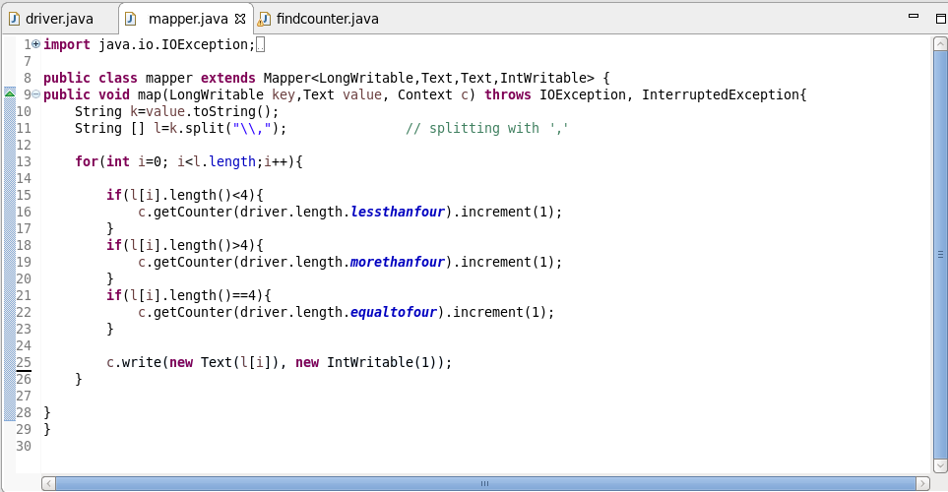

**FindCounter Class:**

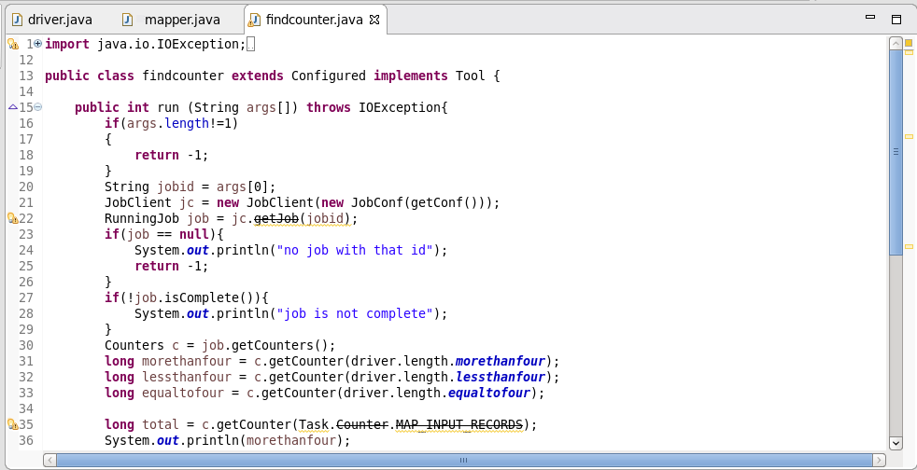

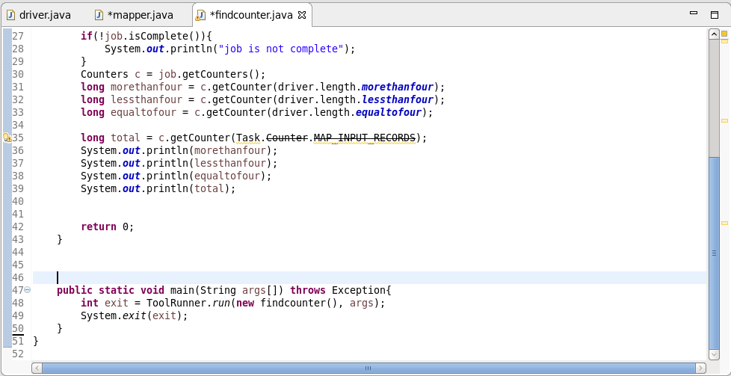

**Logic:**

* If the length of the word is greater than 4, morethanfour gets incremented with 1.
* If the length of the word is less than 4, lessthanfour gets incremented with 1.
* If the length of the word is equal to 4, equaltofour gets incremented with 1.
* While running jar file with ‘Driver Class’ as main class and arguments as input text file and output path, we will get the first o/p showing number of bytes read and written in the process.
* While running jar file with job id as argument, we will get the second o/p.

**First Output:**

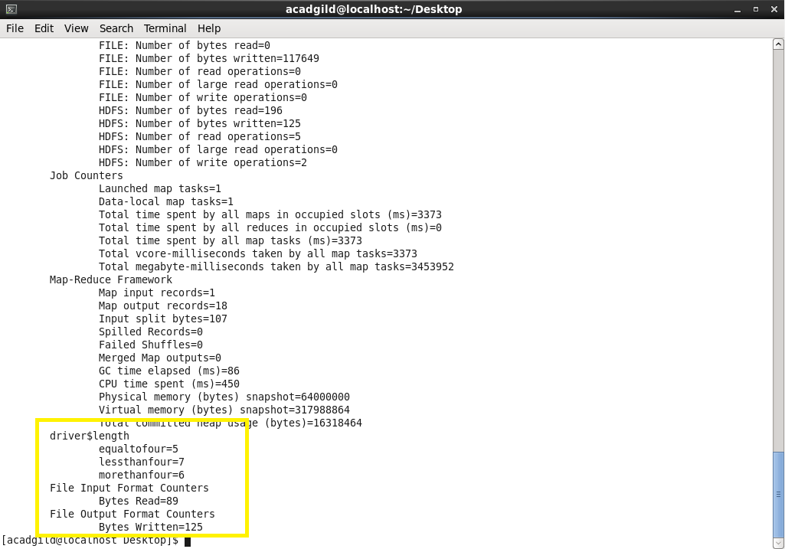

**Second Output:**

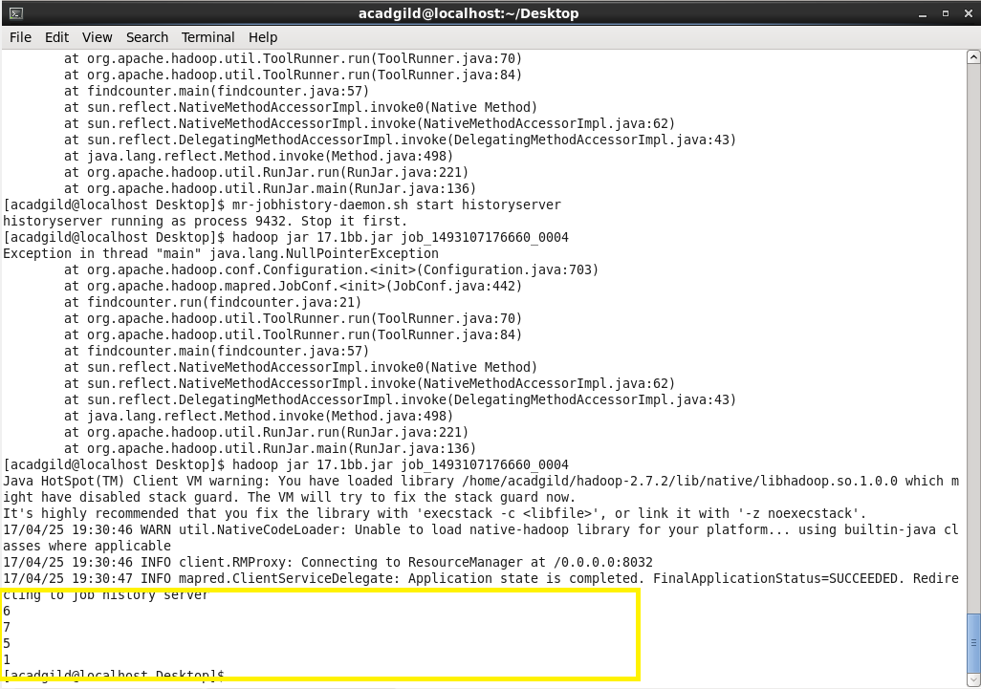

* Before running the second jar file, the history server was switched ON using
* **mr-jobhistory-daemon.sh start historyserver.**