**Session 17**

**Assignment 2**

Write a secondary sort program to generate the top 2 maximum temperatures corresponding to every year from the temperature dataset.

**Driver Class:**

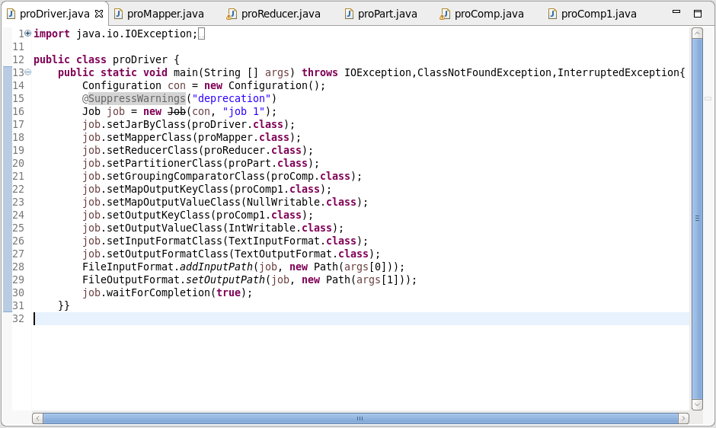

**Mapper Class:**

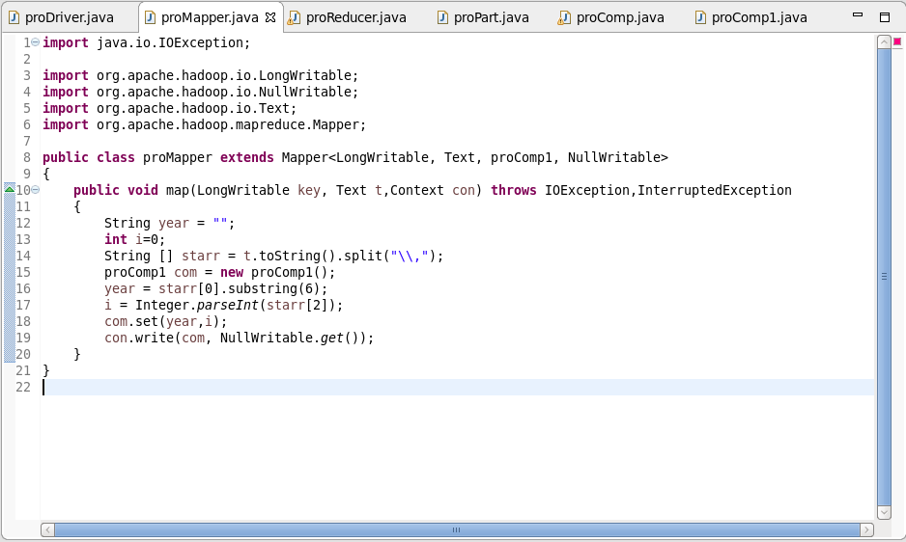

**Composite Key Class:**

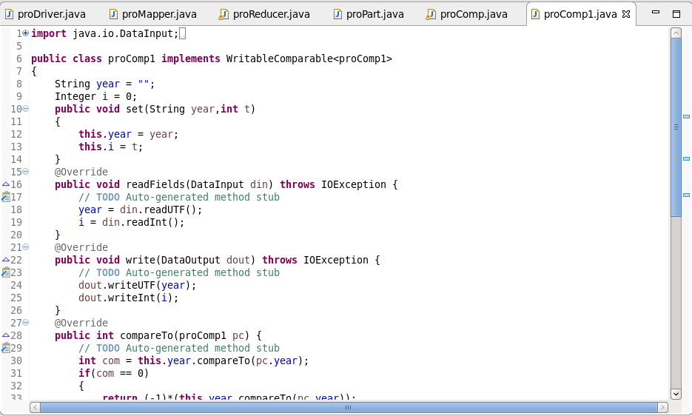

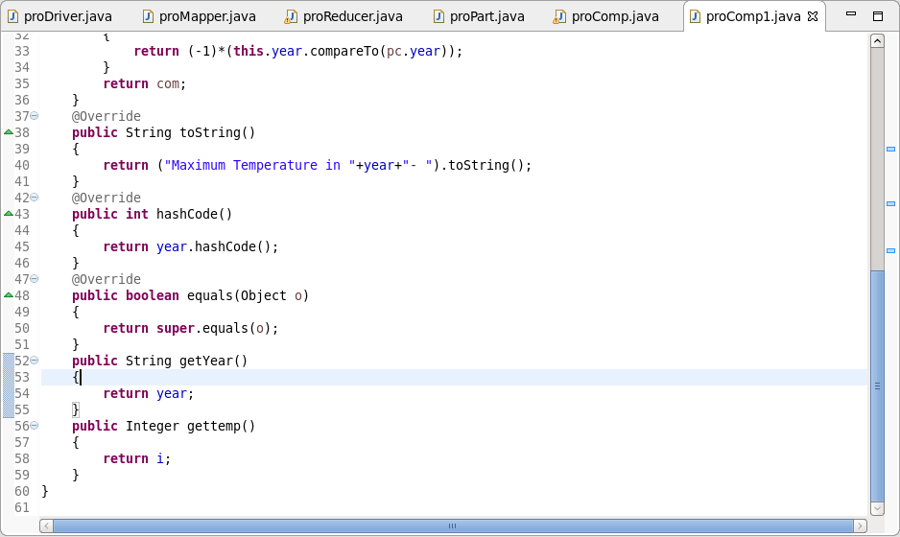

* Overriding the compareTo Method.
* Checking if year is same, if it is same then it will sort the temperature by descending.
* Overriding toString Method.
* To change the way, the composite key should be displayed.
* readFields and write fields is for serialization and deserialization.

**Partitioner Class:**

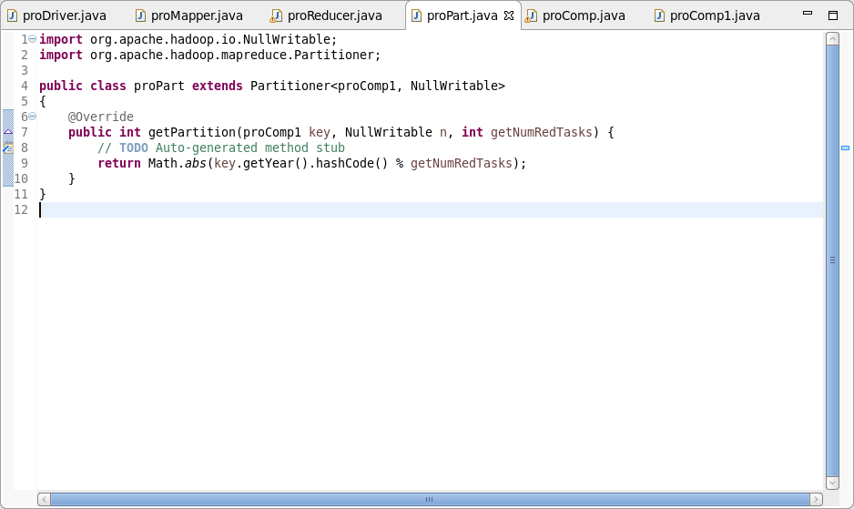

A partitioner is set to partition the dataset by the year part of the key and can guarantee that records for the same year go to the same reducer.

**Group Comparator Class:**

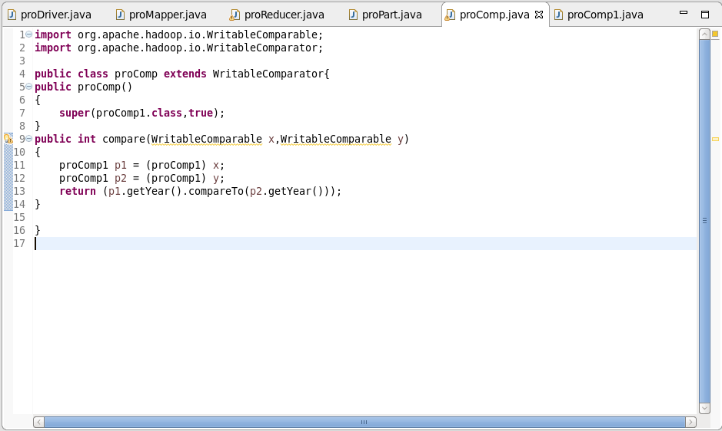

Group Comparator Class decides on which map output keys within the Reducer go to the same reduce method call.

**Reducer Class:**

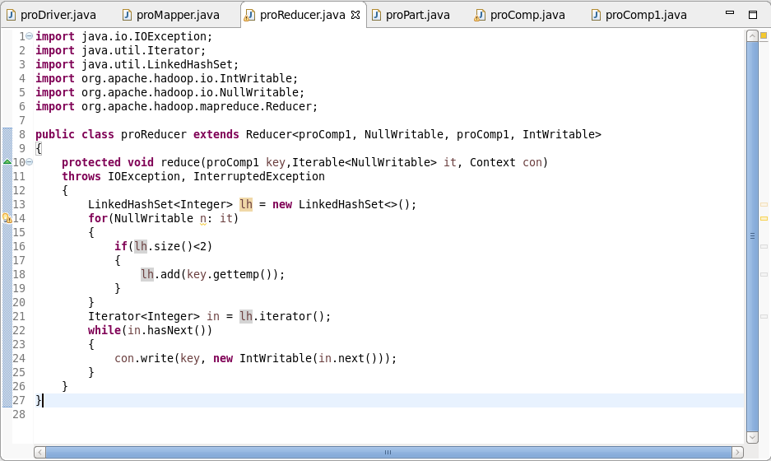

**Output:**

