**Session 17**

**Assignment 3**

Write a MapReduce job that takes configuration from command line (min.word.count). Based on the configuration, it should perform count of words from a document and produce only those words in the output whose count is greater than or equal to the configuration.

The Mapper class is included in the Driver class itself.

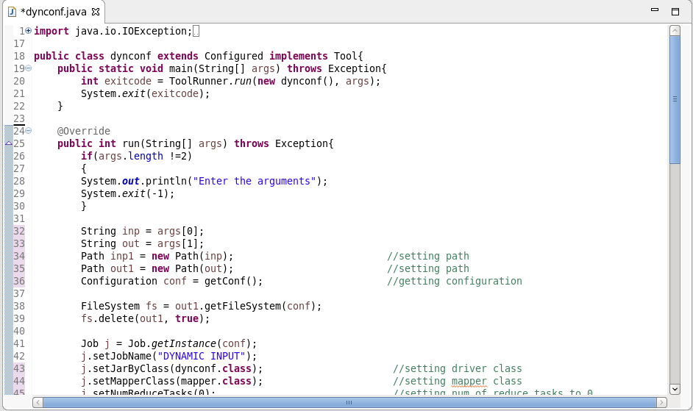

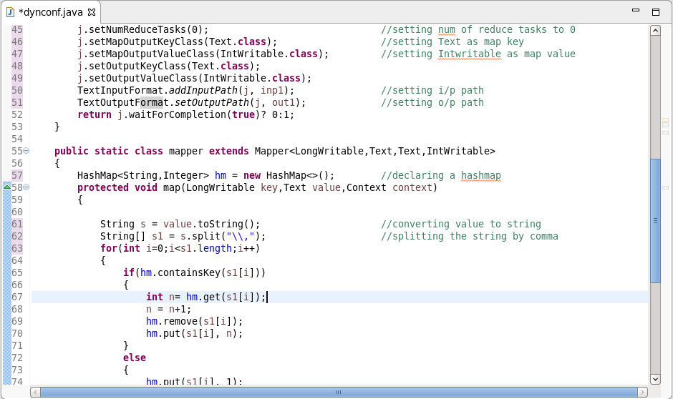

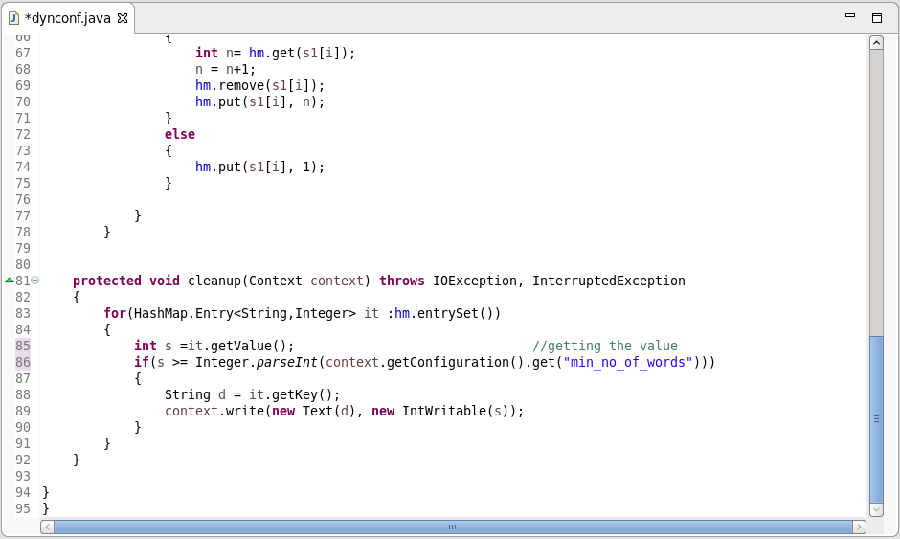

**Run Code:**

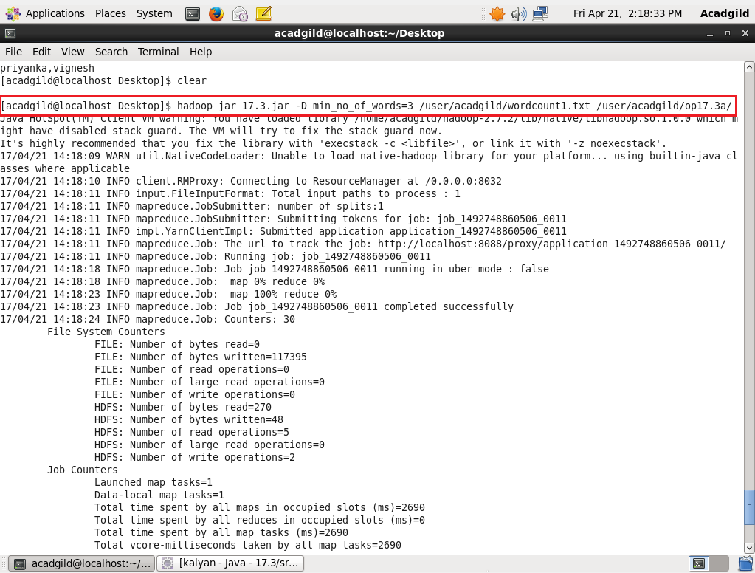

**Input File:**

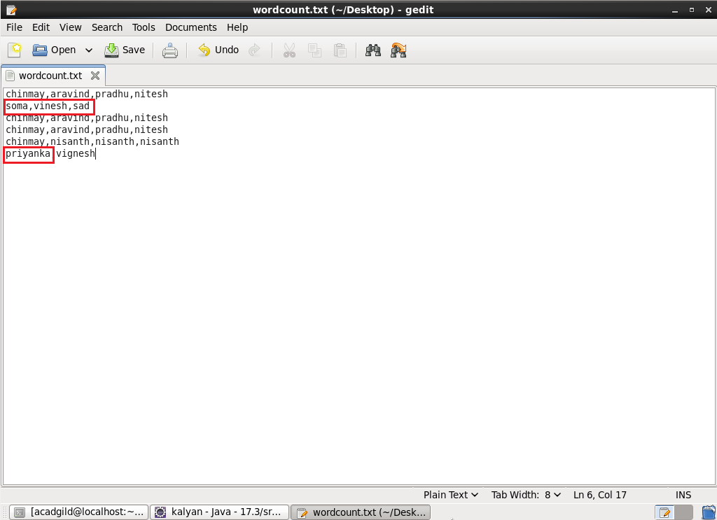

In the Input file, soma, vinesh, sad, priyanka occurs only once.

So this code has eliminated it since the minimum count is set as 3.

All other words that occurs thrice or more, it comes in the output.

**Output:**

