**Session 17**

**Assignment 5**

**Problem Statement:**

Write a map reduce program to design a custom counter to count number of people are affected with 'PULMONARY' disease and 'BRONCHITIS & ASTHMA' in the state 'CA'.

**Driver Class:**

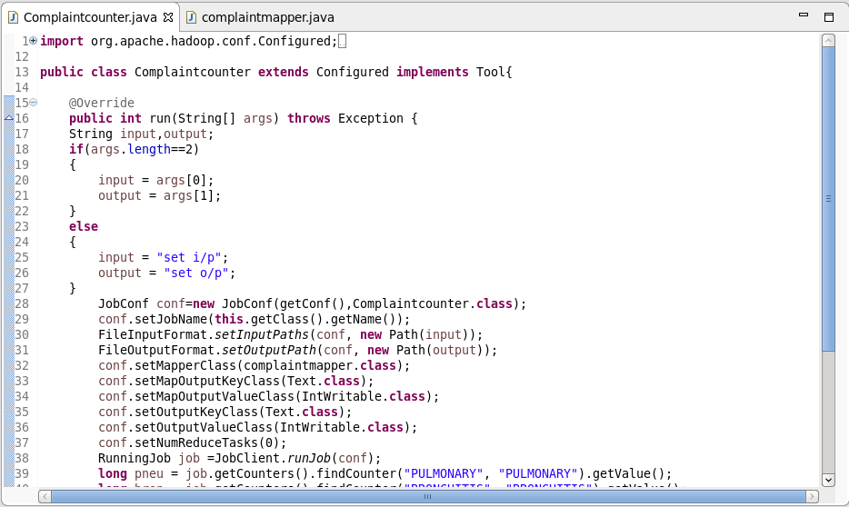

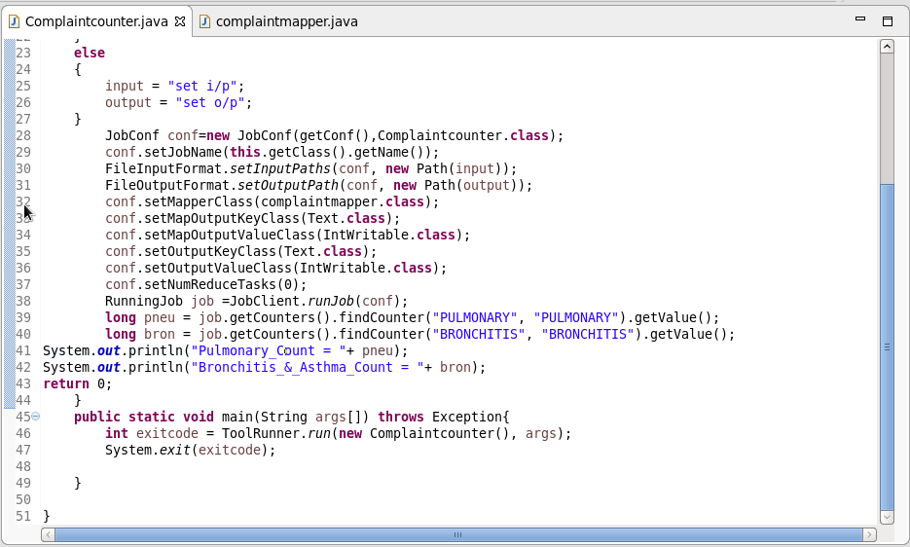

**Mapper Class:**

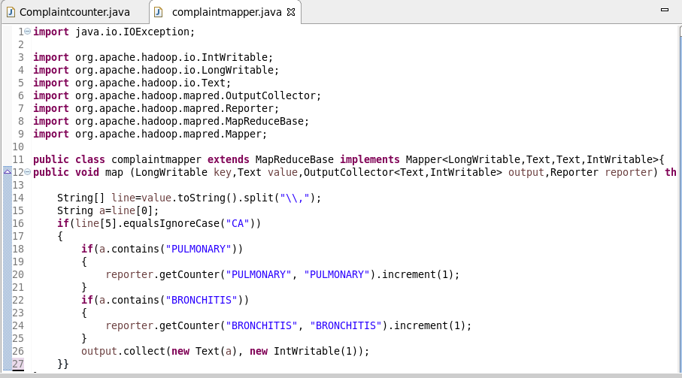

**Output:**

