**Session 18**

**Assignment 1**

**Part 1:**

**Problem Statement:**

Run a map only job on the word count program using static configurations.

**Driver Class:**

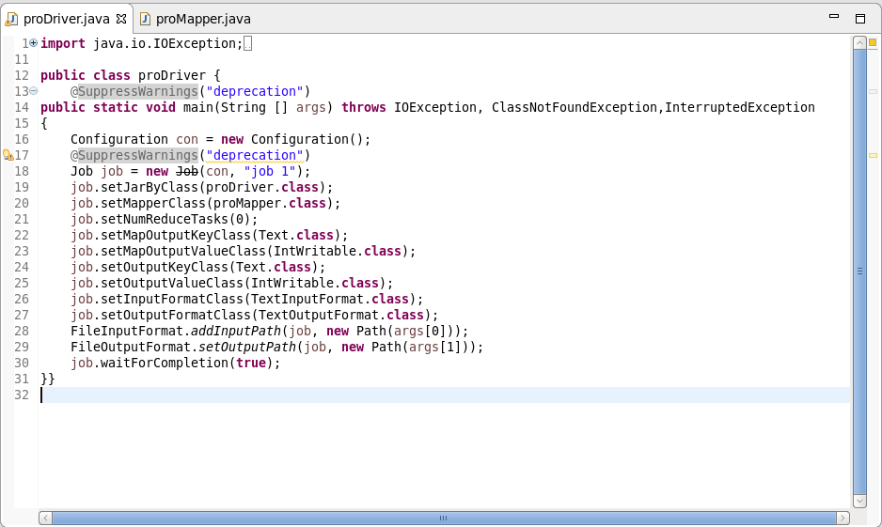

**NOTE:** The number of reducer is set as 0

**Mapper Class:**

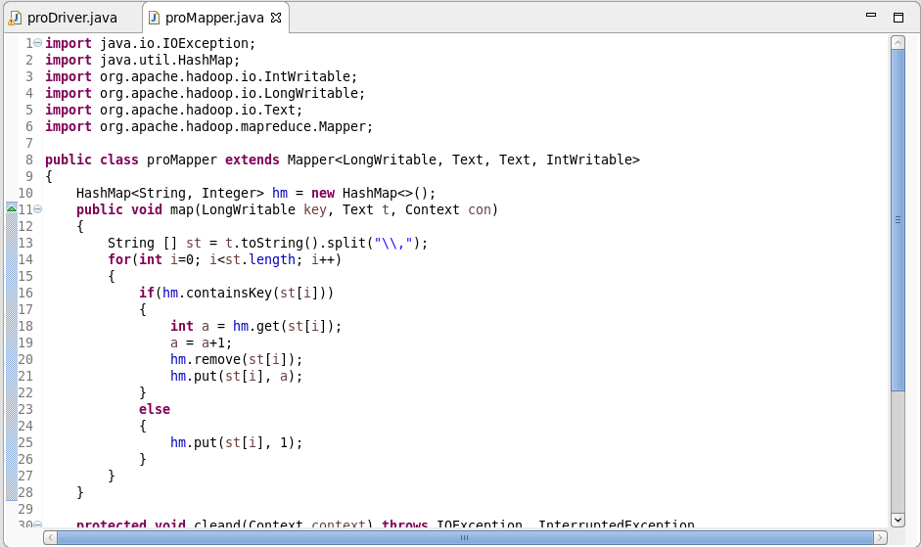

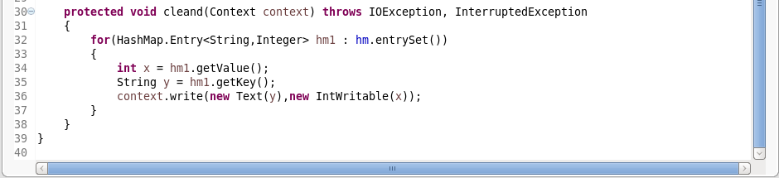

**Example:**

* Consider a word ‘Hadoop’
* Hashmap is used in Mapper. First time when a word ‘Hadoop’ enters the mapper it goes directly to the else statement and gets written as (Hadoop, 1) and when the word ‘Hadoop’ comes in again it goes to the ‘if’ statement since already ‘Hadoop’ is there in the hashmap.
* In ‘if’ statement the count gets increased and gets updated in the hashmap.

**Output:**

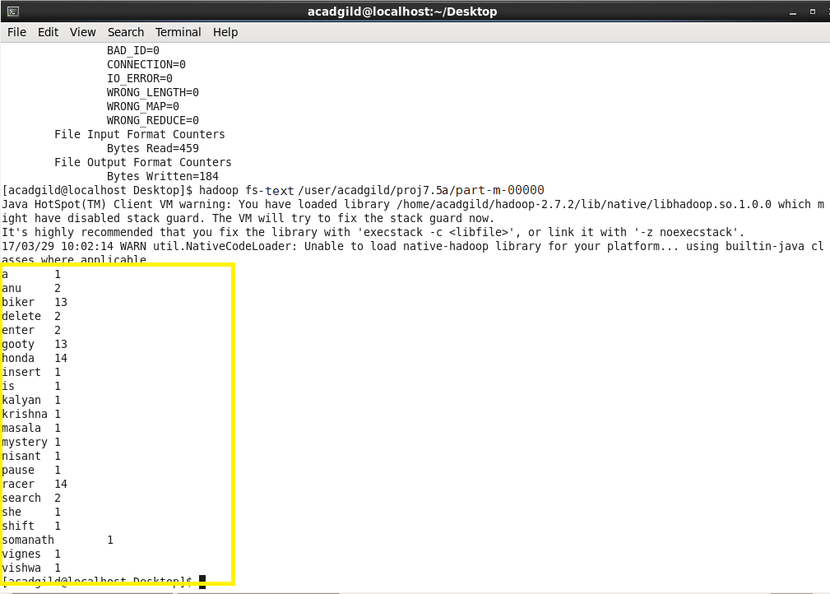

**Part 2:**

**Problem Statement:**

Run the map reduce word count program and set the number of reducers to 2 using static configurations.

**Driver Class:**

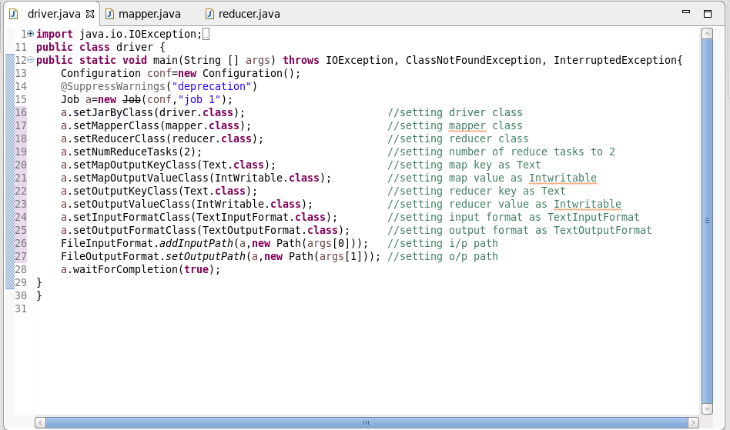

**Mapper Class:**

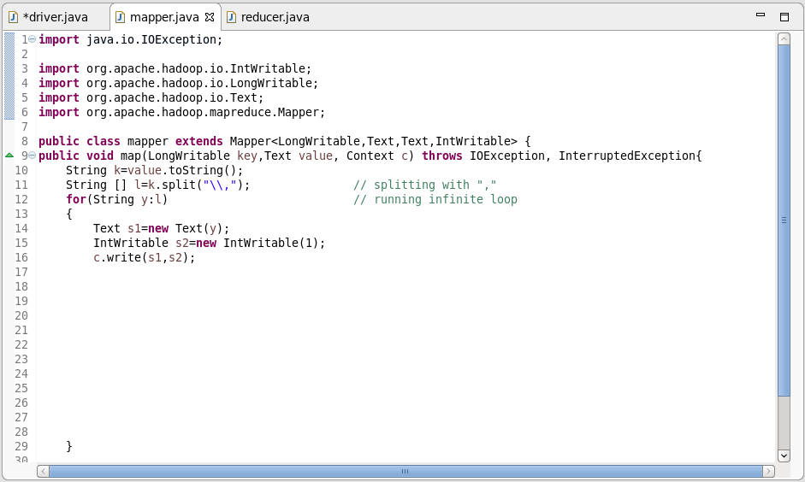

**Reducer Class:**

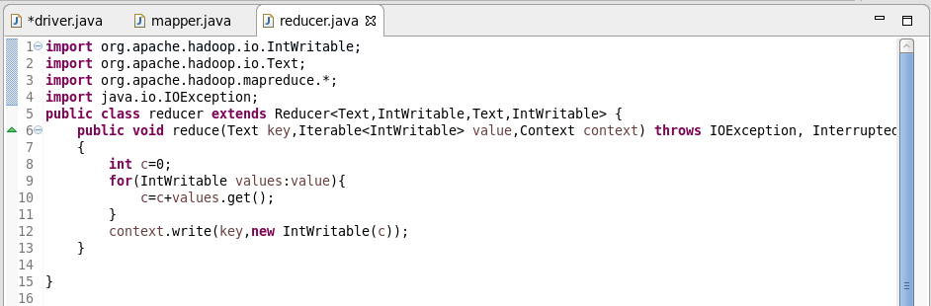

**Output:**

