**Session 18**

**Assignment 2**

**Part 1:**

Find out the top 10 destination people travel the most: Based on the given data, we can find the most popular destination that people travel frequently. There are many destinations out of which we will find only first 20, based on trips booked for particular destinations.

**Driver Class:**

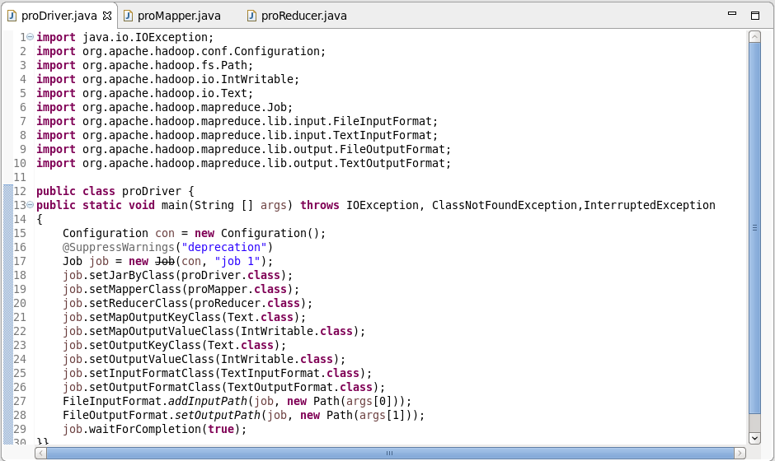

**Mapper Class:**

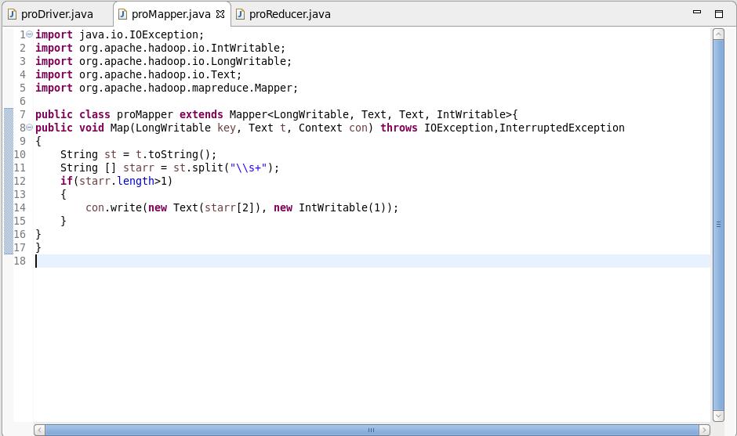

**Reducer Class:**

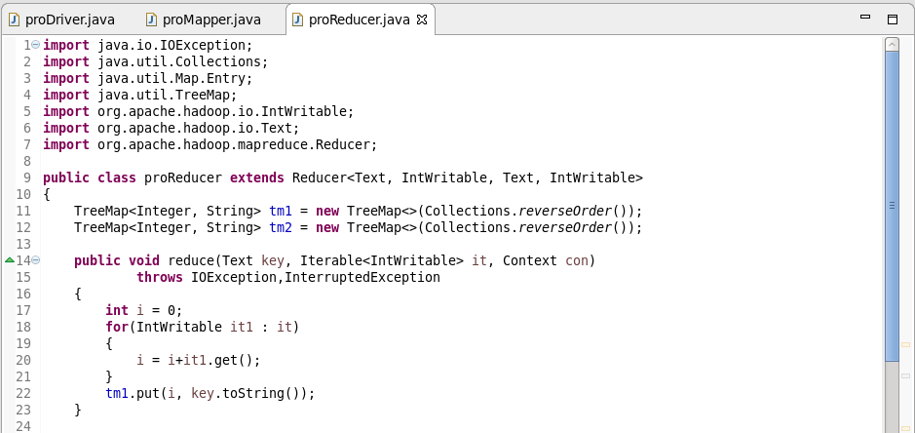

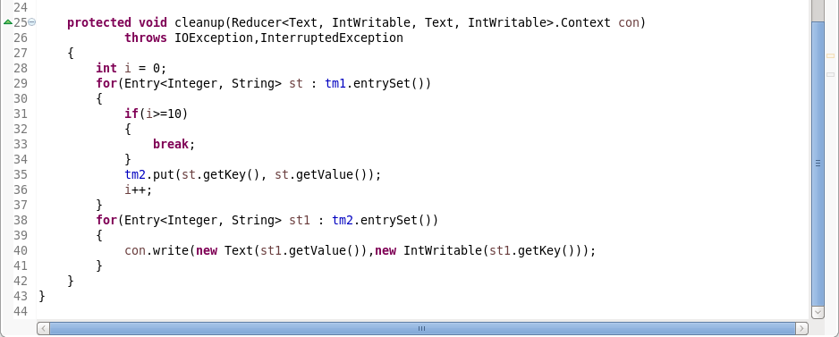

**Reducer Class Logic:**

* Counting the frequency of destination and putting it in TreeMap (tm1). By default, TreeMap stores the content based on ascending order, since I’ve mentioned reverse order TreeMap stores in descending order.
* Now we’ll have to display only top 10 destinations.so we’re storing only the top 10 destinations in second TreeMap (tm2).
* Finally displaying the top 10 frequently travelled destinations and their counts as output.

**Output:**

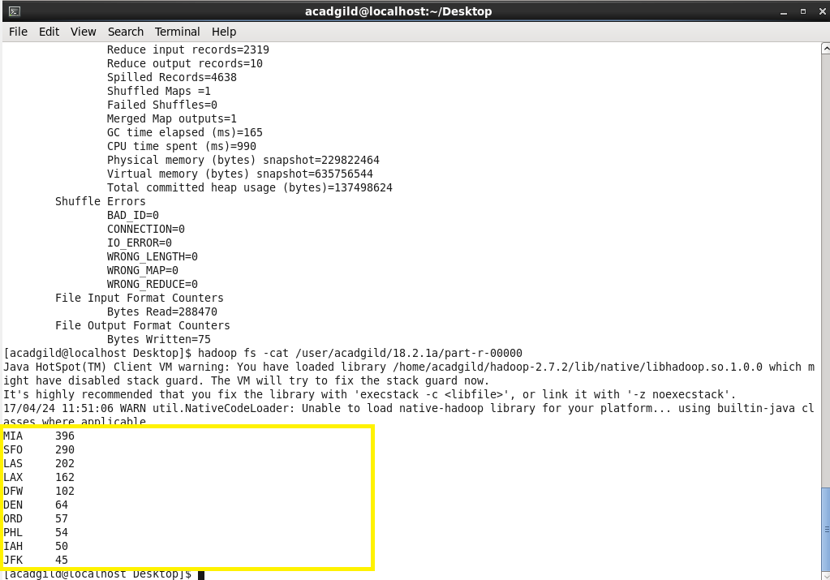

**Part 2:**

Find out the top 10 cities that generate high airline revenues for travel, so that the site can concentrate on offering discount on booking, to those cities to attract more bookings.

**Driver Class:**

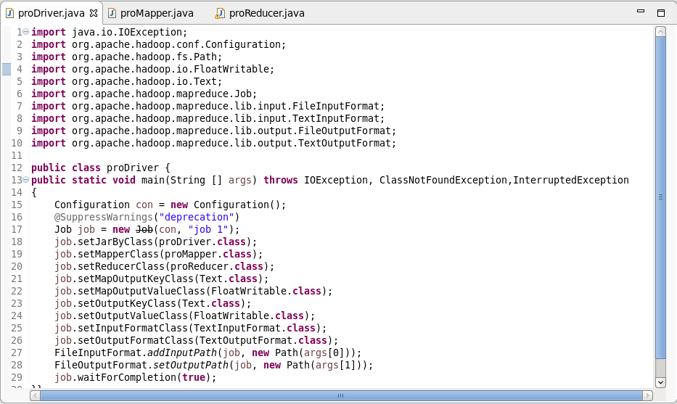

**Mapper Class:**

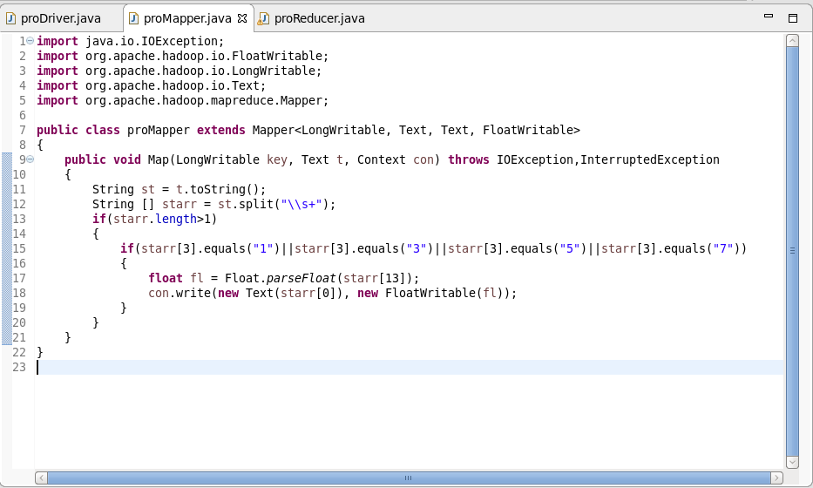

**Reducer Class:**

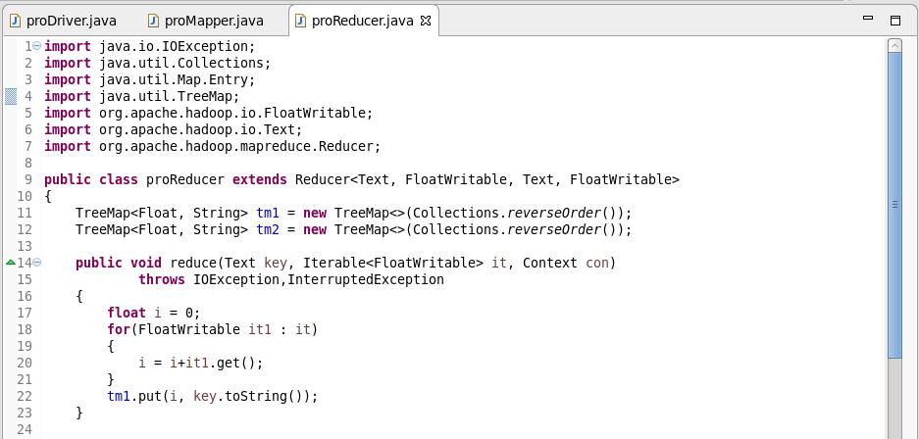

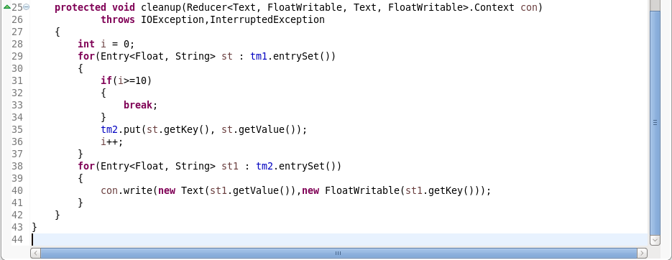

**Reducer Class Logic:**

* Adding the revenue of the trips and putting it in TreeMap (tm1). By default, TreeMap stores the content based on ascending order, since I’ve mentioned reverse order TreeMap stores in descending order.
* Now we’ll have to display only top 10 services which made high revenue. So we’re storing only the top 10 services in second TreeMap (tm2).
* Finally displaying the top 10 cities which made high revenues.

**Output:**

