**Session 18**

**Assignment 3**

Merge the small files in hadoop by following the below blog.

**Step 1:**

The files within the MergerFile directory is listed below using the command ‘fs –ls /path’.

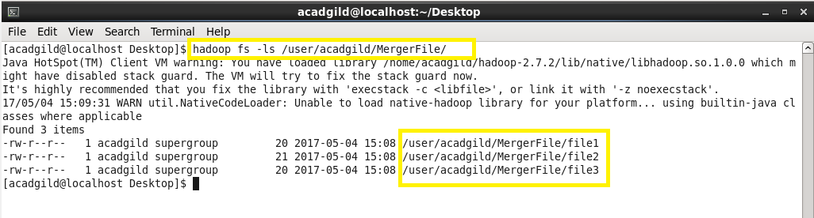

**Step 2:**

The content in the files are displayed using ‘–cat’ command.

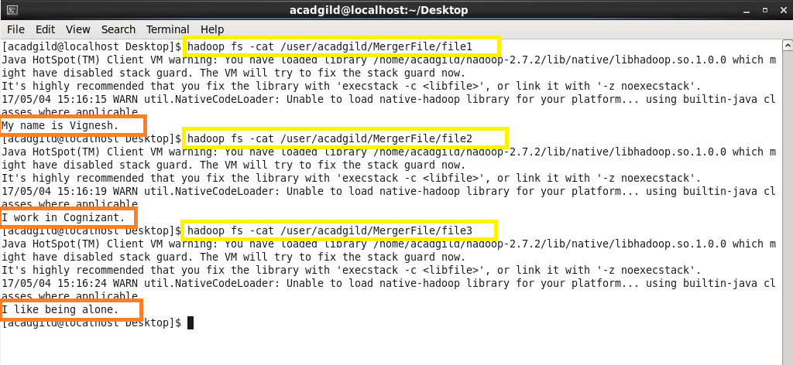

**Step 3:**

Using getmerge command, contents of all three files will be merged to form a new file and this is stored in a new file MergedText.txt which will be in local system (not in hdfs).

**Note:** Here nl refers to ‘new line’.

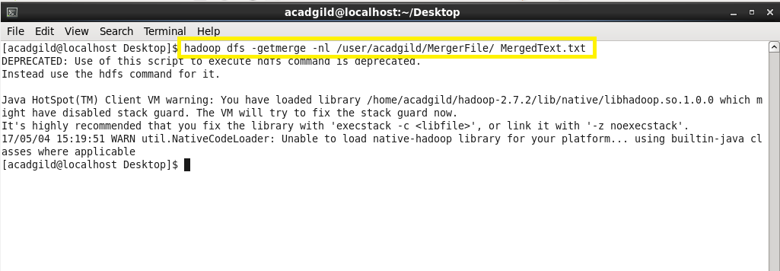

**Step 4:**

The merged file is shown using the ‘cat’ command.

