Session 20

Assignment 1

Problem Statement:

Enhance the MapReduce program of Task 8 (refer session 19, assignment 3) to use multiple reducers for sorting. The driver should accept three additional values: the minimum units sold, the maximum units sold and number of reducers to use.

Use units sold as key and company as value. Write a custom partitioner to divide the keys on the basis of range. Take minimum to be 0 and maximum to be 10. Divide them across 2 reducers.

DRIVER CLASS:

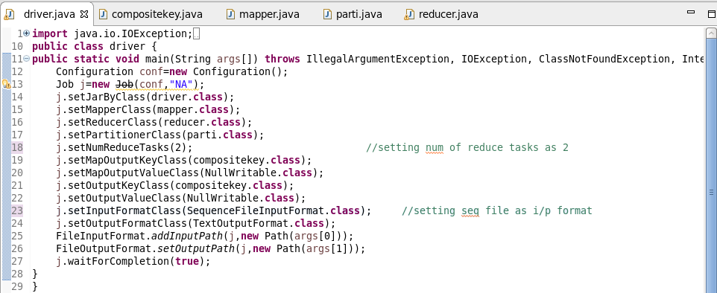

MAPPER CLASS:

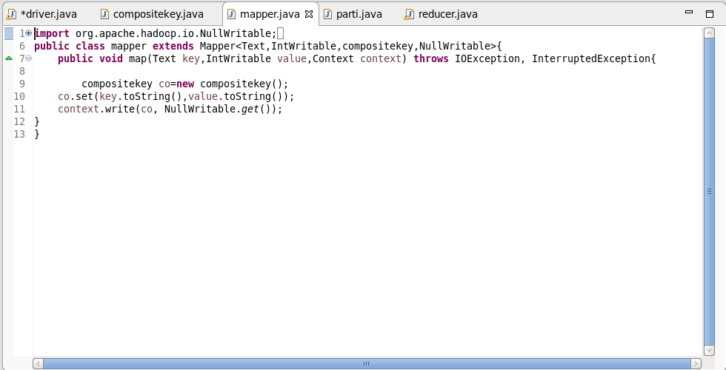

COMPOSITEKEY CLASS:

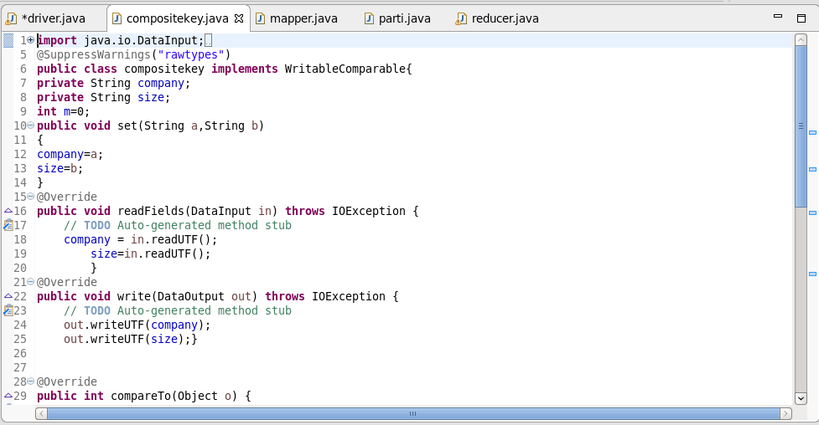

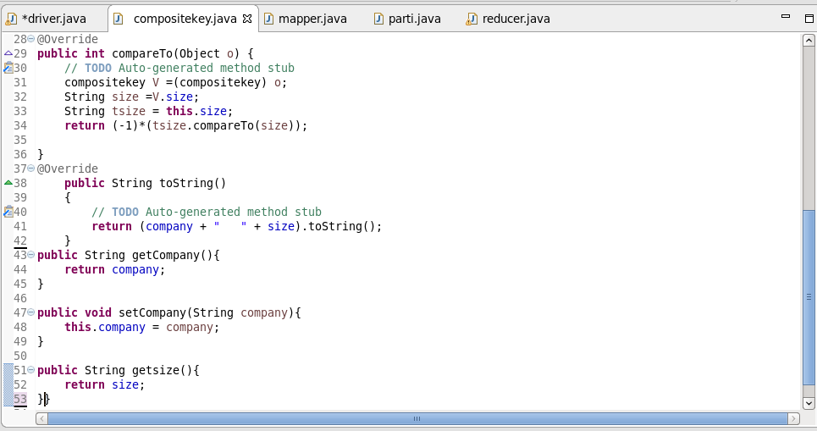

PARTITIONER CLASS:

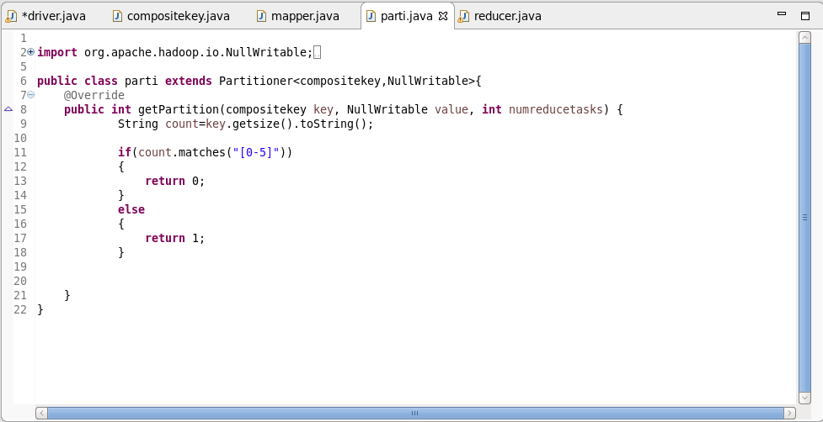

REDUCER CLASS:

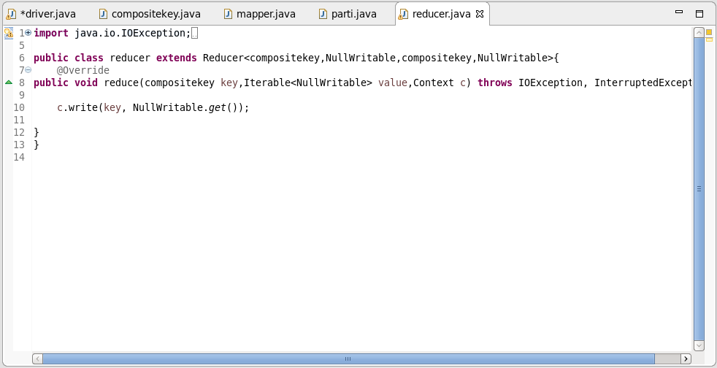

LOGIC:

* The output of assignment 7.1 will contain the sales details of all the companies. That output is used as input for this assignment.
* Since the minimum and maximum of the units sold been asked, two reducers are used. One reducer is for the companies who have made maximum sales (6-10) and the other one is for the companies who made minimum sales (0-5).
* In composite key, company and sales are taken into account and ordered by descending order using compareTo () method.
* Since partitioner is used, companies who sold TV’s more than 5 (6-10) will go to a reducer and companies who sold TV’s less than 6 (0-5) will go to another reducer.

OUTPUT:

