**Session 20**

**Assignment 2**

**Problem Statement:**

Enhance the task 8 (refer session 19, assignment 1) to calculate the top 3 state-wise sales for each company. You may use multiple reducers for this activity.

**Driver Class:**

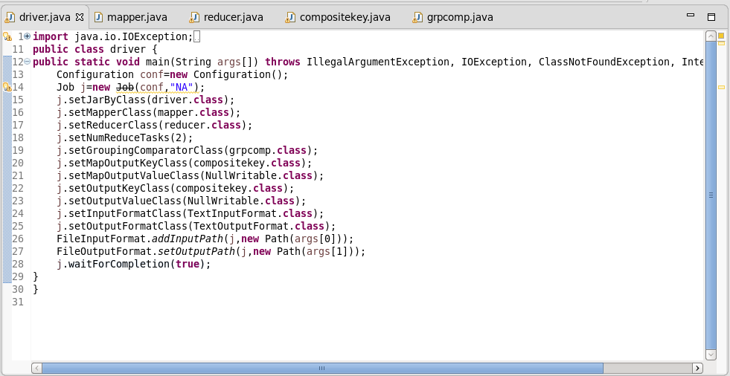

**Mapper Class**:

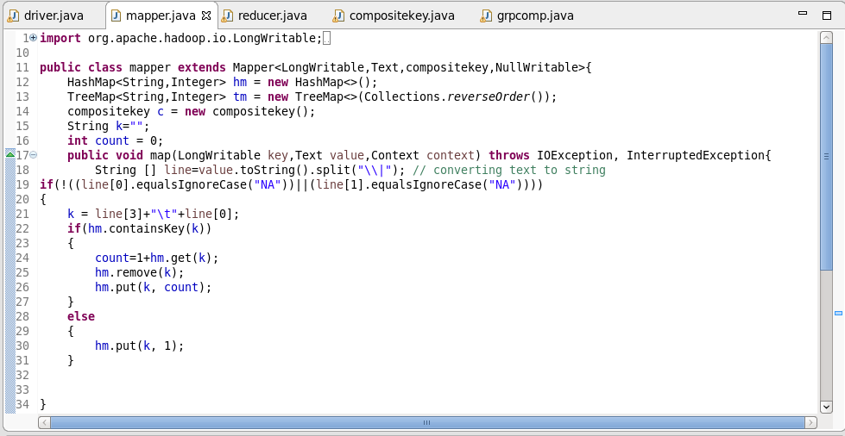

**Composite Key Class**:

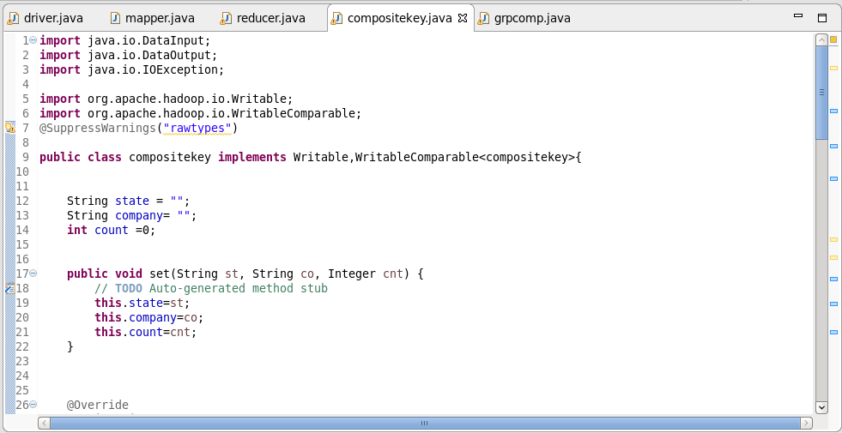

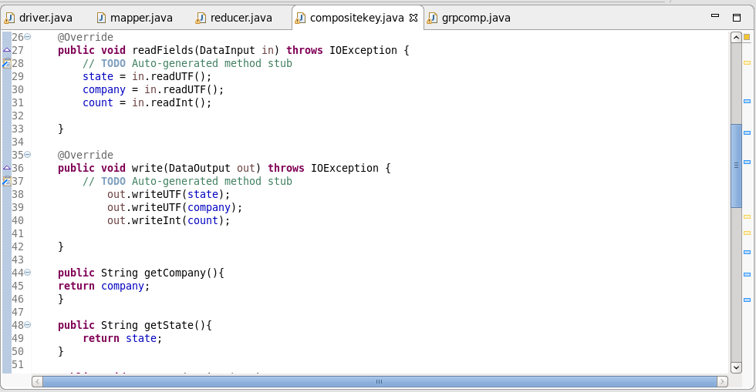

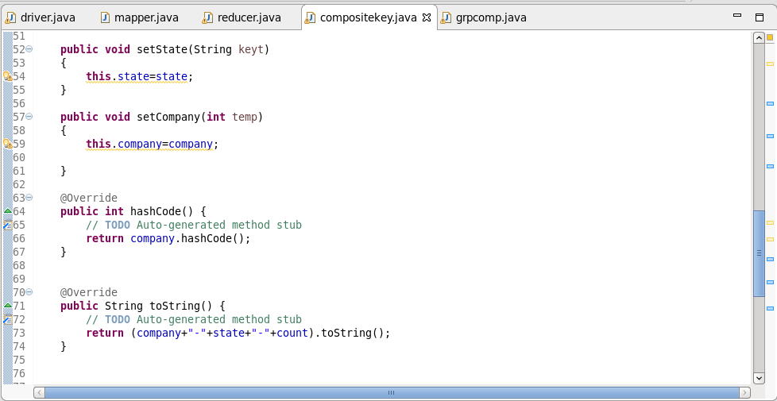

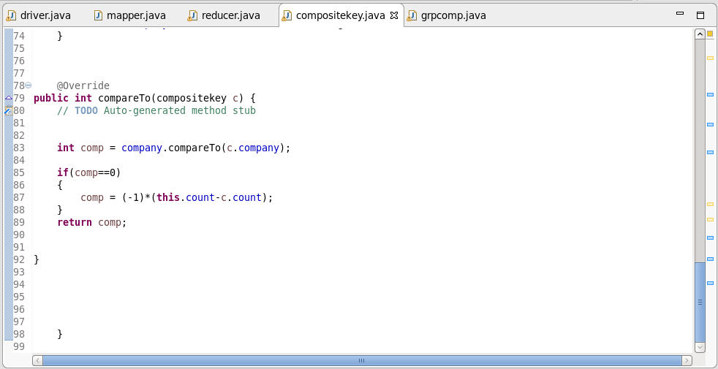

**Group Comparator:**

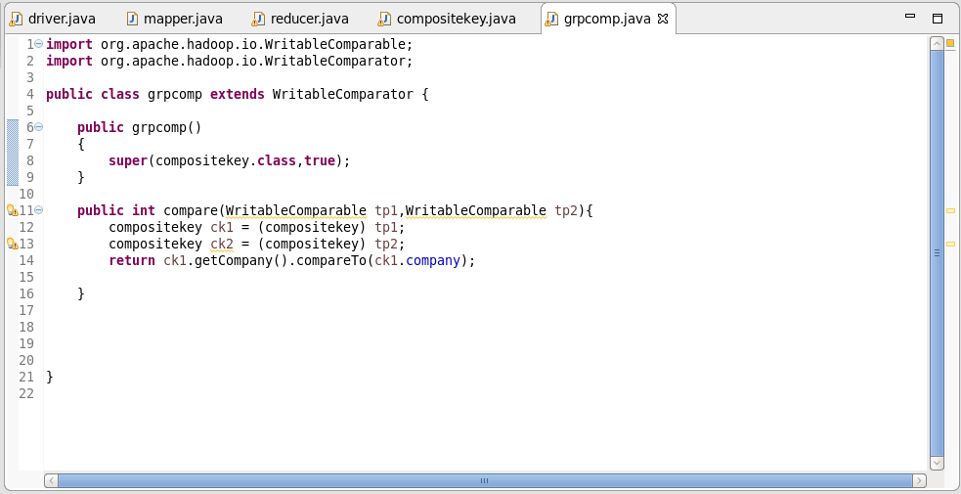

**Logic:**

* In the map method of the mapper, the input data is split by “|”.
* I’ve used hash map in mapper. If the key is already present in the hash map, the count will be increased by 1.
* Now we have the company and state as key and total unit sold as value in hashmap
* company, city, count are passed to composite key as key and nullwritable as value

Overriding HashCode():

* Since multiple reducers are used it is necessary that a particular company should go to particular reducer.
* Since default hash modulo partitioner is used. In hash code method, company is sent.

Overriding CompareTo() methods:

* By default it orders by ascending order, hence we multiply by -1 to get it ordered in descending order

Overriding ToString():

* It displays the company, state ,sales.

**Reducer Class:**

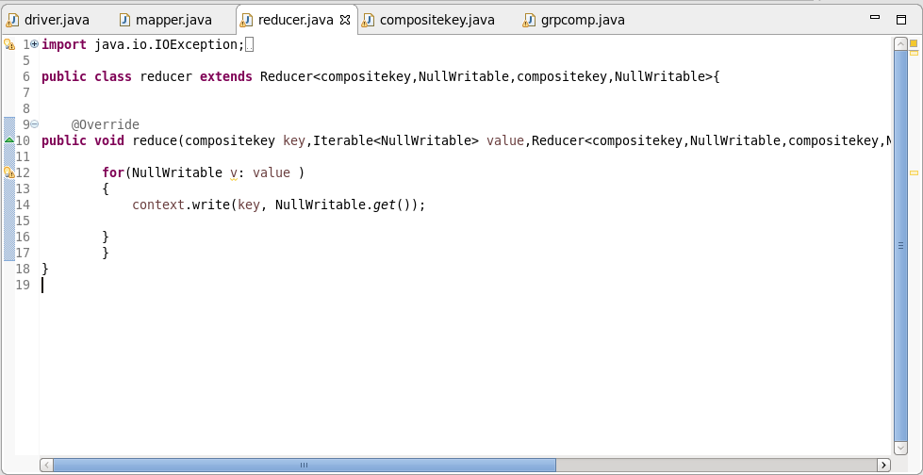

**Output:**

