**Session 22**

**ASSIGNMENT 1**

**Problem Statement:**

Write a Word count program and Store the result in Mysql db.

**Driver class:**

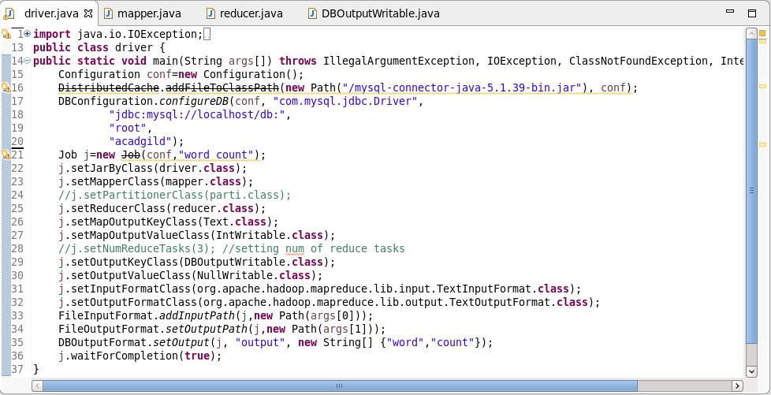

**Mapper class:**

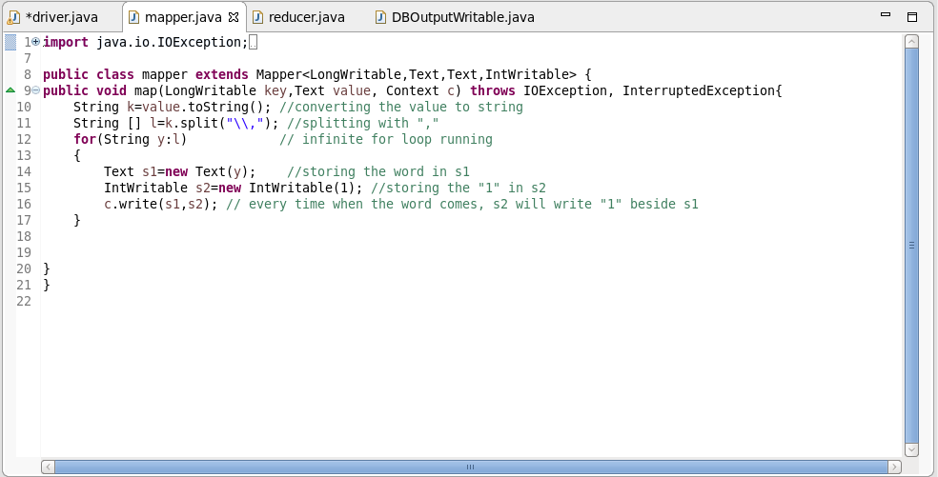

**Reducer class:**

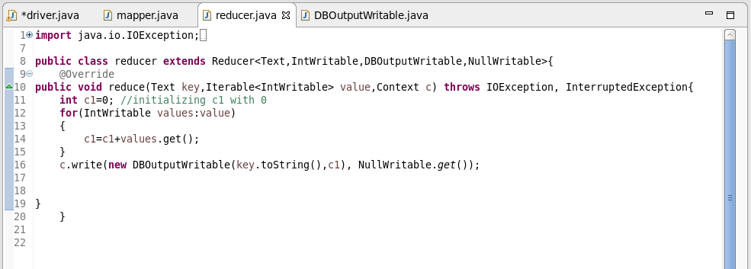

**DB Output Writable class:**

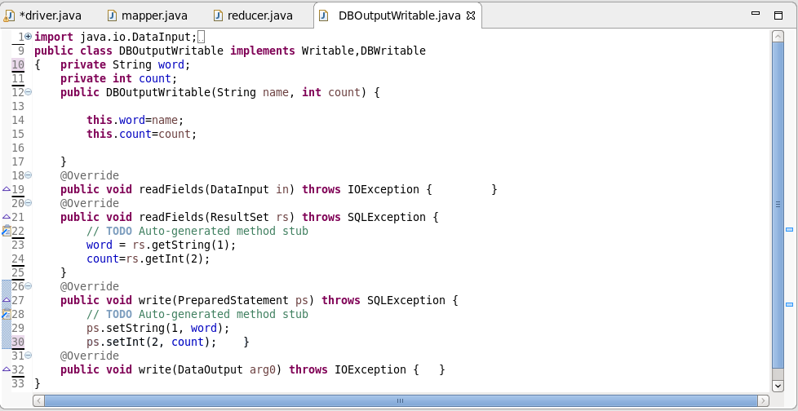

OUTPUT:

Successfully stored the obtained output in MySQL

