**Session23**

**Assignment 1**

**Problem Statement:**

Create a database named 'custom'.

Create a table named temperature_data inside custom having below fields: 1. date (mm-dd-yyyy) format 2. Zip code 3. Temperature.

The table will be loaded from comma (‘,’) delimited file.

Load the dataset.txt (which is ',' delimited) in the table.

**Codes Used:**

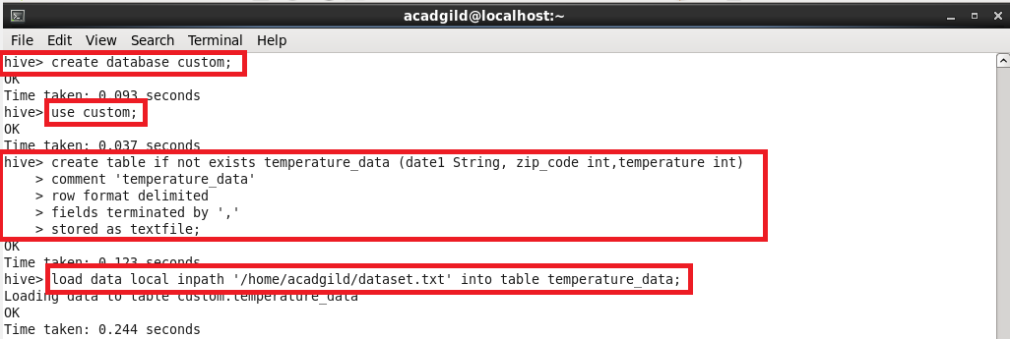

**Logic:**

**Step 1:** The database named ‘custom’ is created.

**Step 2:** The database custom is used to do the required process given in the problem statement.

**Step 3:** The table of name ‘temperature_data’ is created inside the database ‘custom’ with the fields date as date1, zip code as zip_code and temperature as temperature.

**Step 4:** The table is defined with the terms lie “comment” as “temperature_data”, delimited as row format, fields are terminated by comma(‘,’) and at last to store the table as text file.

**Step 5:** The tableis loaded with thetemperaturedataset from the text file ‘dataset.txt’.

**Output:**

The data inside the table is displayed using the command “select * from table_name;”

