**Session 24**

**Assignment 3**

**Problem Statement**

Calculate the number of employees corresponding to each skill from the table 'employee' which is loaded in the Demo.

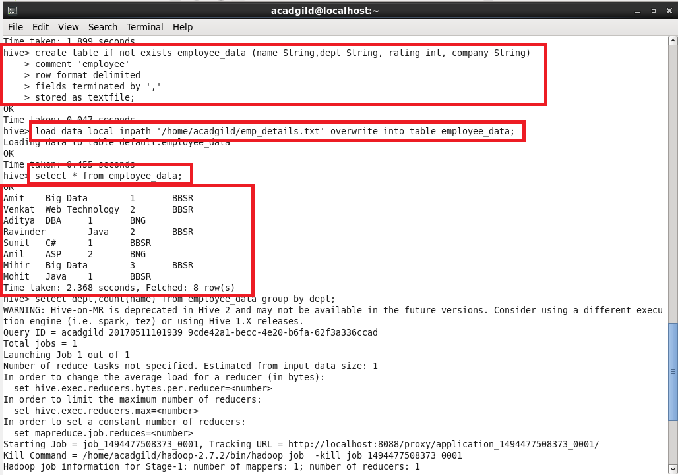

**NOTE:** 1. Here the employee details data set is stored in the table ‘employee_data’ with columns:-name, dept (skill), rating and company.

2. The output is obtained by using select statement with the count of name which is grouped by the data skill (dept).

**Output:**

