**Session 24**

**Assignment 4**

**Part 1:**

**Problem Statement:** Write a hive query find the average age of male and female persons died in the titanic tragedy.

**Commands Used:**

The table named ‘titanic_tragedy’ is created with the desired fields and stored as a textfile.

Then the data from ‘TitanicData.txt’ is loaded into the created table.

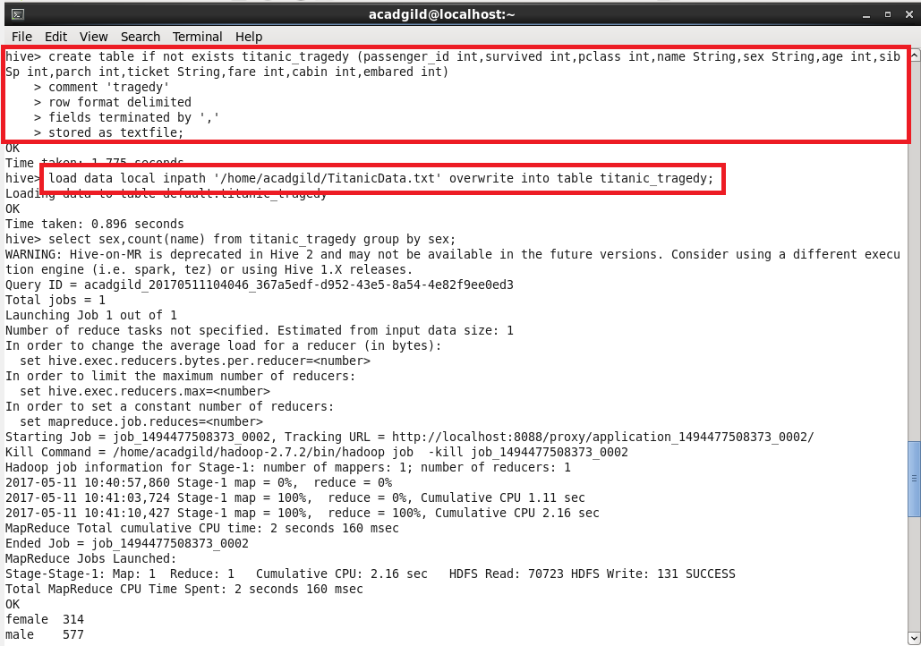

**Output:**

The desired output is obtained by taking average of age by grouping the data in the table.

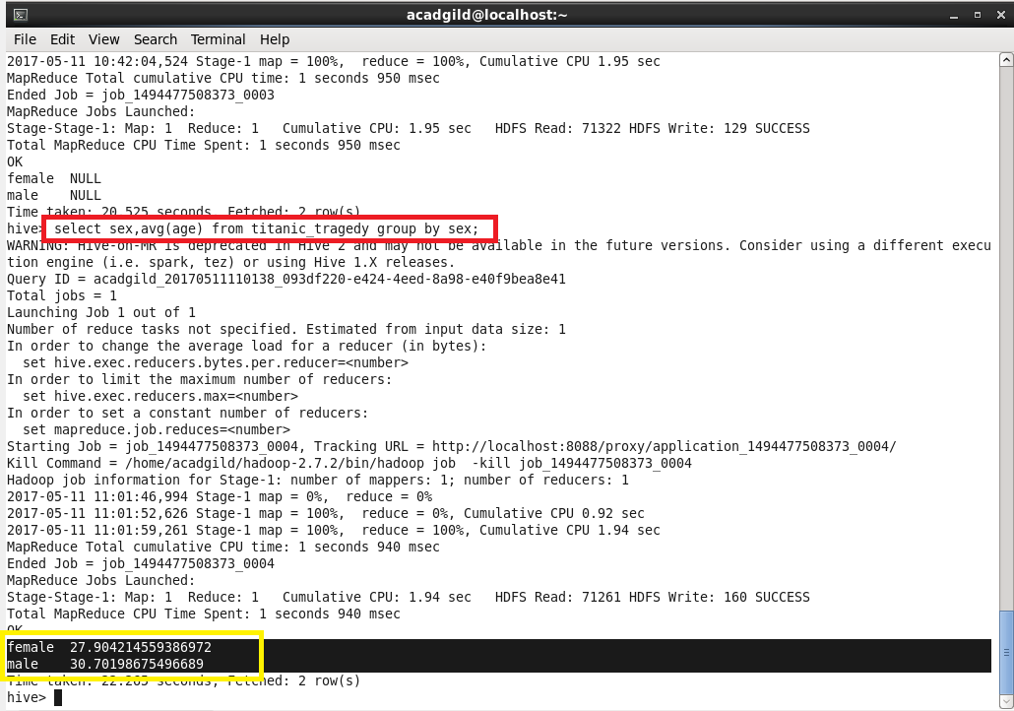

**Part 2:**

**Problem Statement:** Write a hive query to find the number of people died and survived in each class.

The required output can be obtained by grouping the data by pclass and survived and counting the dataset in the whole.

