**Session 24**

**Assignment 6**

**Problem Statements:**

**Part 1:**

Write a hive query to find the minimum temperature observed in a given weather station in a particular year.

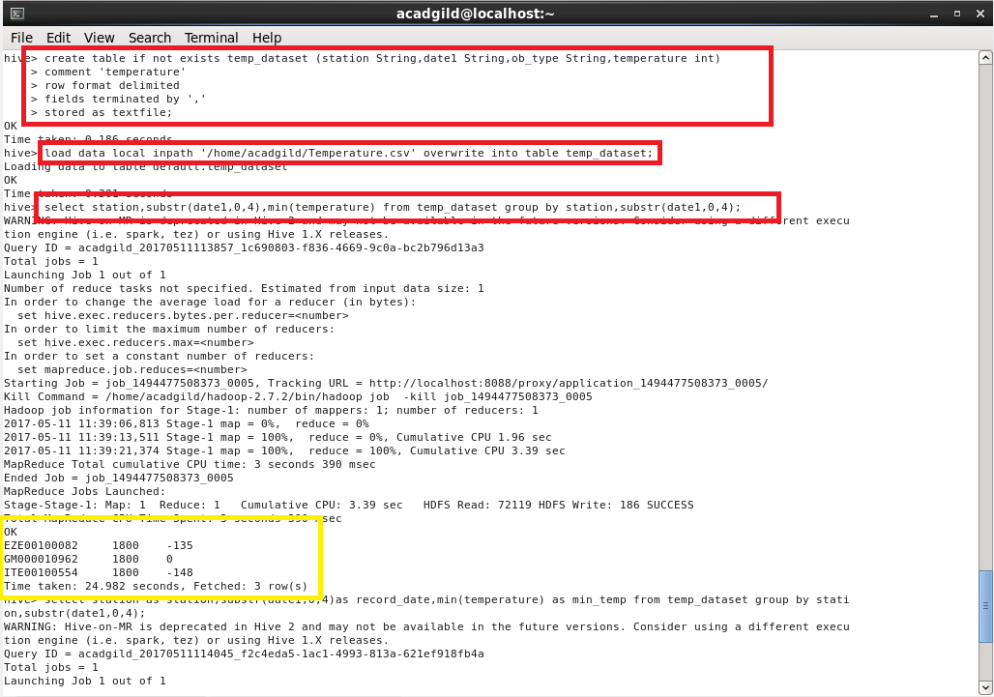

The output is obtained by selecting the station, year by using SUBSTR (sub-string) and minimum temperature by using MIN from the table which is grouped by station and the year.

**Part 2:**

Write a hive query to find the maximum temperature observed in a given weather station in a particular year.

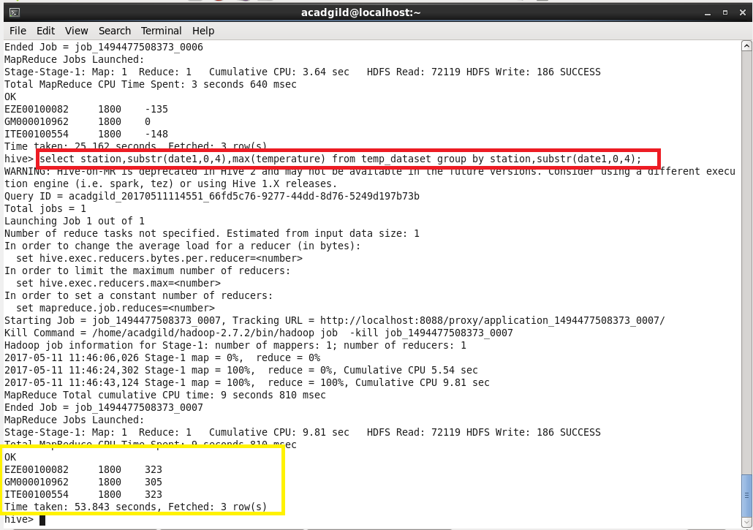

The output is obtained by selecting the station and the year from date using SUBSTR (sub-string) and maximum temperature using MAX command from the table that is grouped by station and particular year.

**Part 3:**

Write a hive query to find the number of readings given by each weather station according to the dataset.

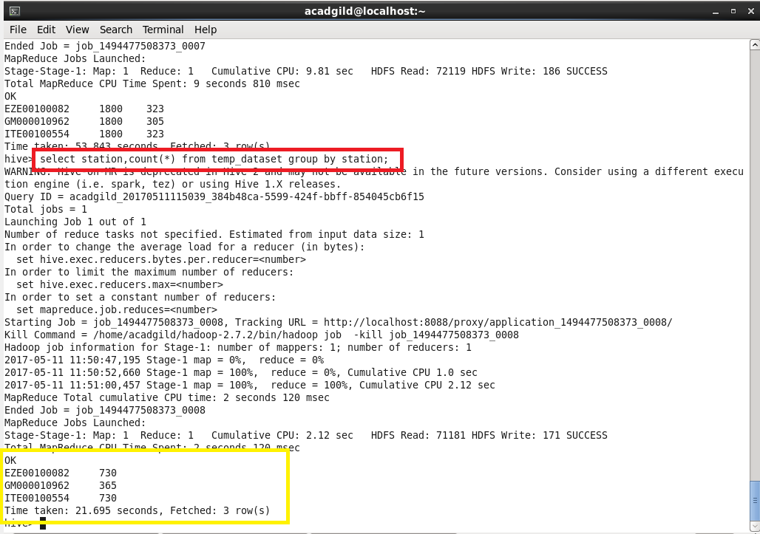

The output is obtained by selecting station and count of all the fields from the table which is grouped by station.