**Session 25**

**Assignment 1**

**Part 1:**

**Problem Statement:** Write a Hive program to find the number of medals won by each country in swimming.

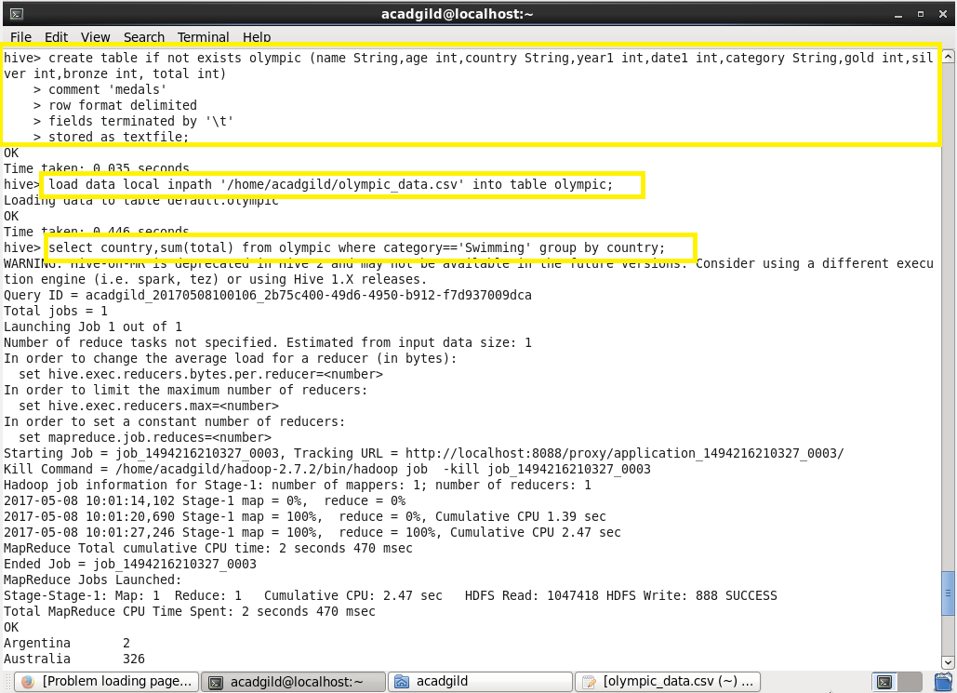

**Output:**

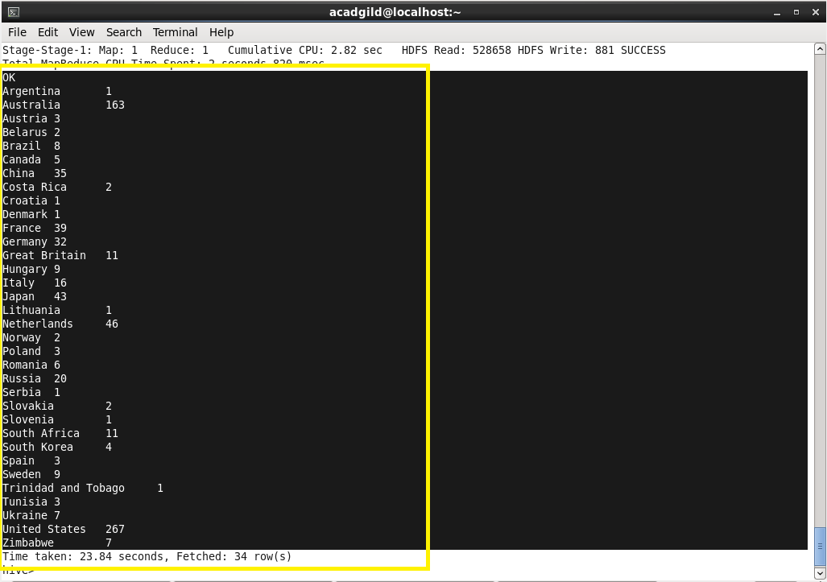

**Part 2:**

**Problem Statement:** Write a Hive program to find the number of medals that India won year wise.

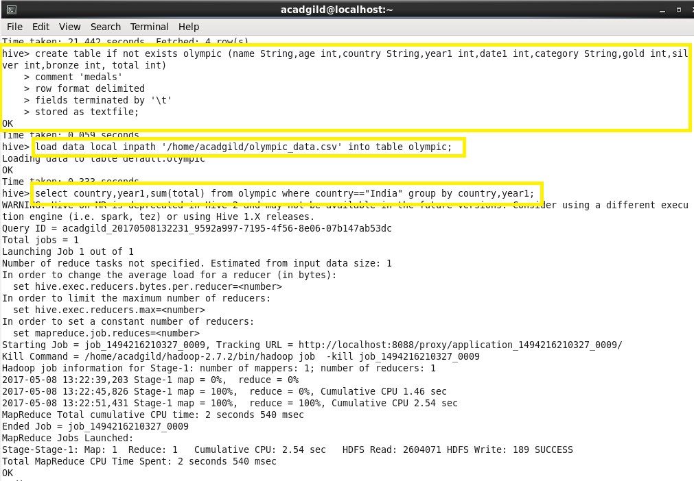

**Output:**

