**Session 25**

**Assignment 2**

**Part 1:**

**Problem Statement:** Write a Hive Program to find the total number of medals each country won

**Commands Used:**

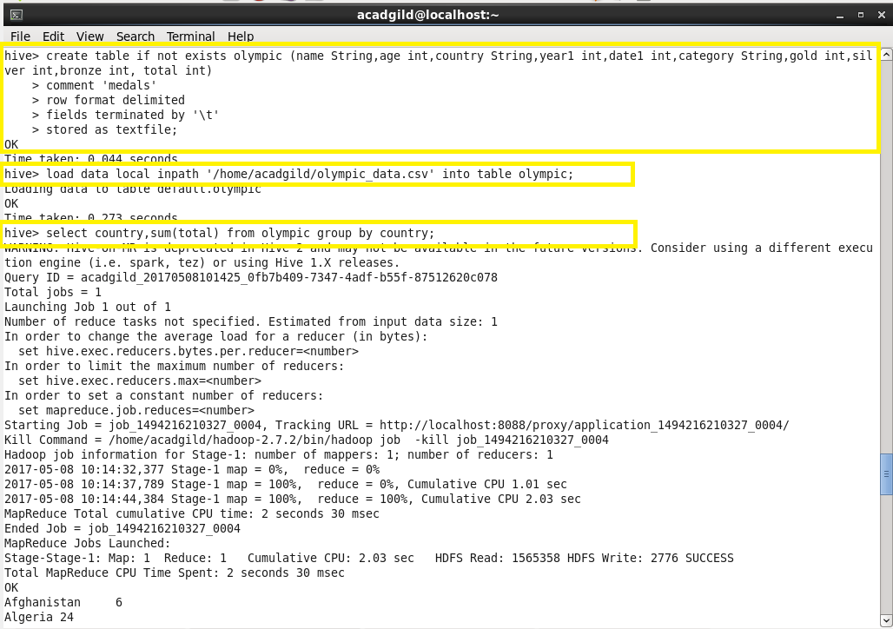

**Outputs:**

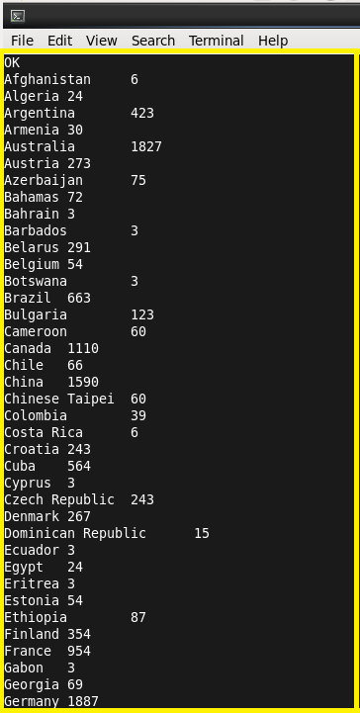 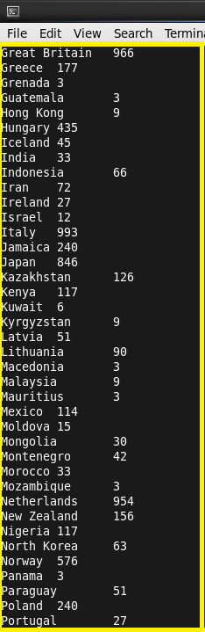

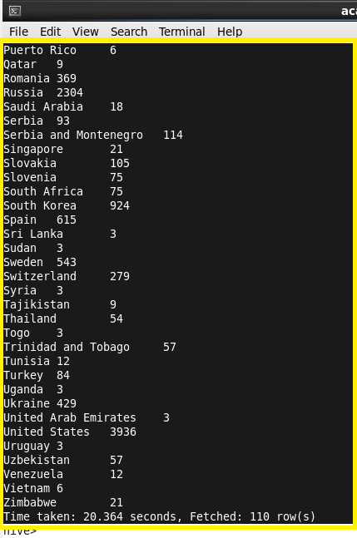

**Part 2:**

**Problem Statement:** Write a Hive program to find the number of gold medals each country won

**Commands Used:**

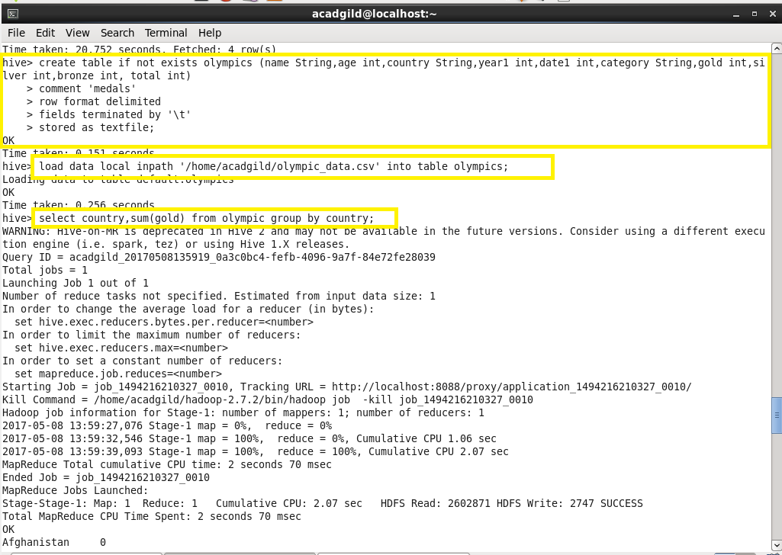

**Outputs:**

