**Session 25**

**Assignment 4**

**Part 1:**

**Problem Statement:** Write a hive query to find the top 20 destination people travel the most.

**NOTE:** The location travelled by all categories (adult, infant, youth and children) are added and stored as ‘tot’ in order to sort the data.

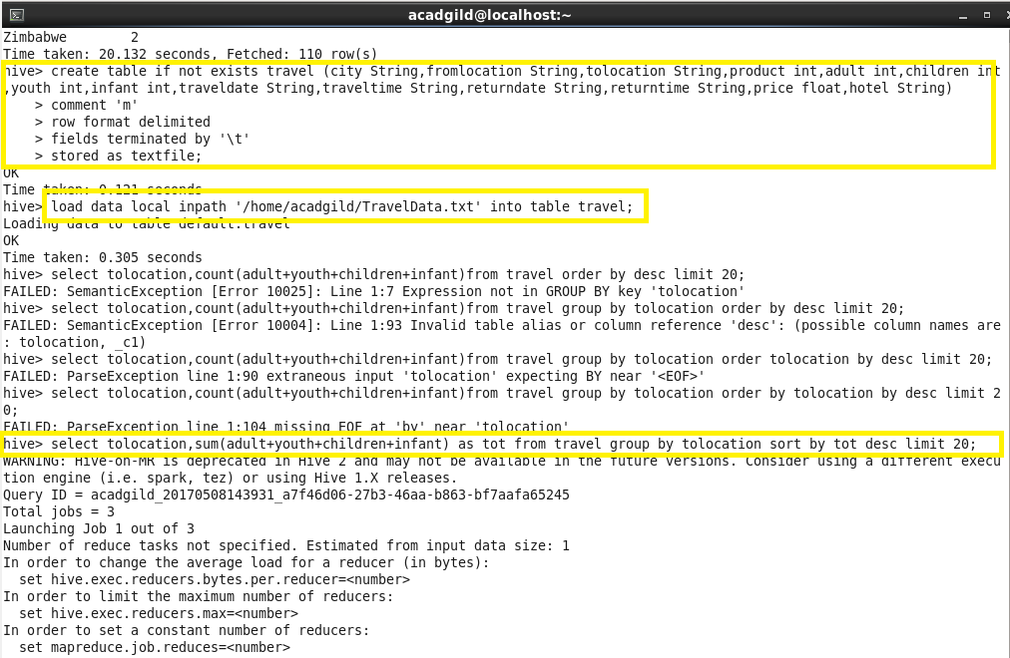

**Output:**

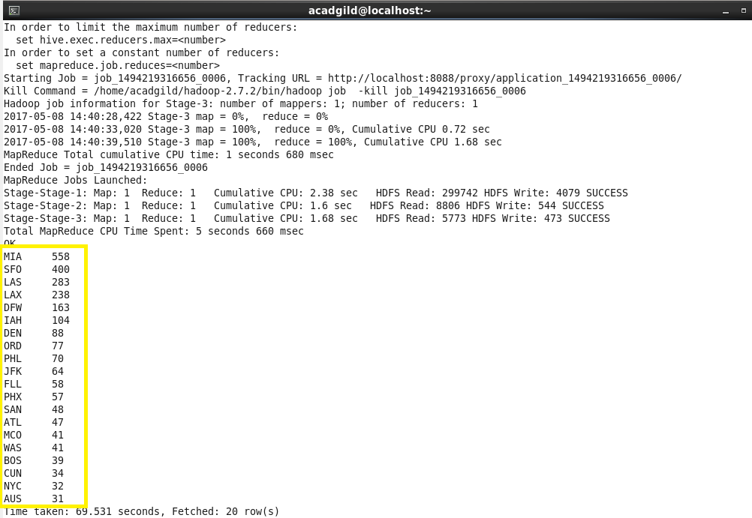

**Part 2:**

**Problem Statement:** Write a hive query to find the top 20 locations from where people travel the most.

**NOTE:** The location travelled by all categories (adult, infant, youth and children) are added and stored as ‘tot’ in order to sort the data.

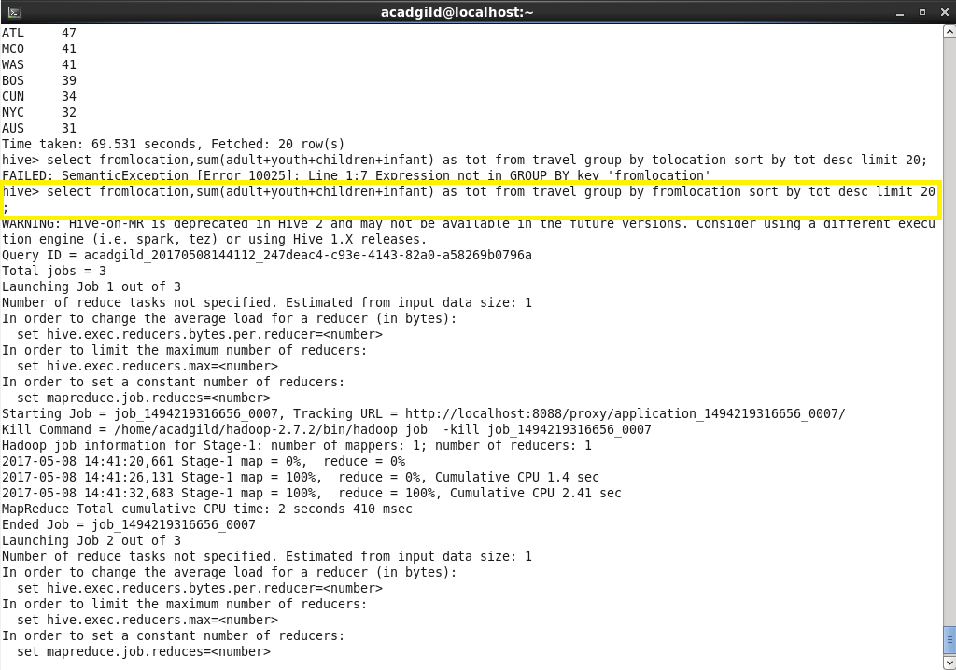

**Output:**

