**Session 25**

**Assignment 5**

**Part 1:**

**Problem Statement:** Write a hive query to list top 5 residency details which lie in the budget of 600000-1200000, an area more than 1450, sold after 17th may, min bedroom 3 and, min bathroom 2.

**Commands used and Output:**

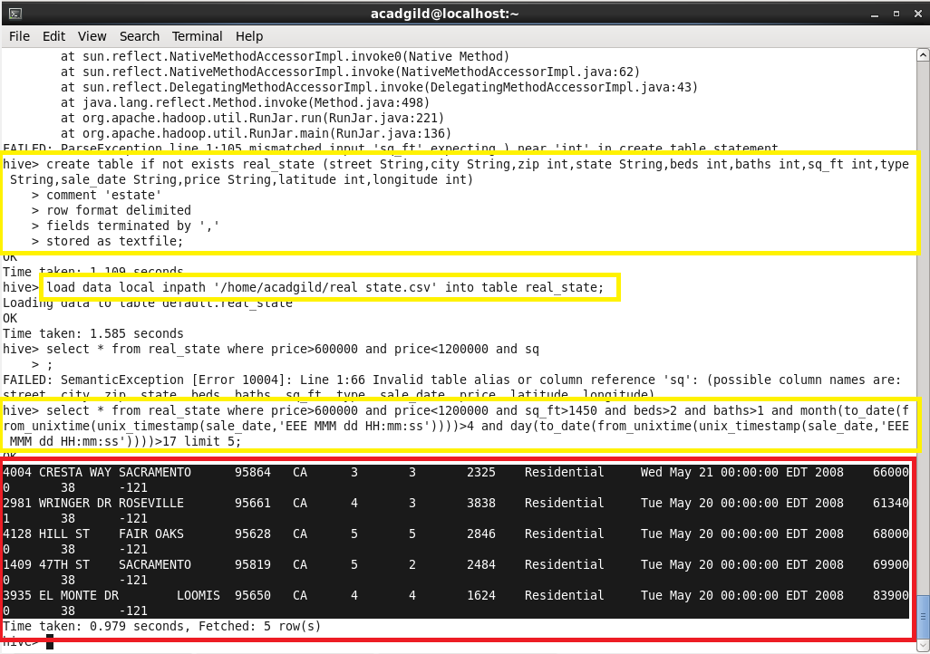

**NOTE:** The yellow box shows the commands used to obtain the desired output.

The red box shows the obtained output for the given details.

**Part 2:**

**Problem Statement:** Write a hive query to separate list of residential apartments with more than 2 beds. Also include columns in following order city, baths, sq feet, price, flat type, beds respectively.

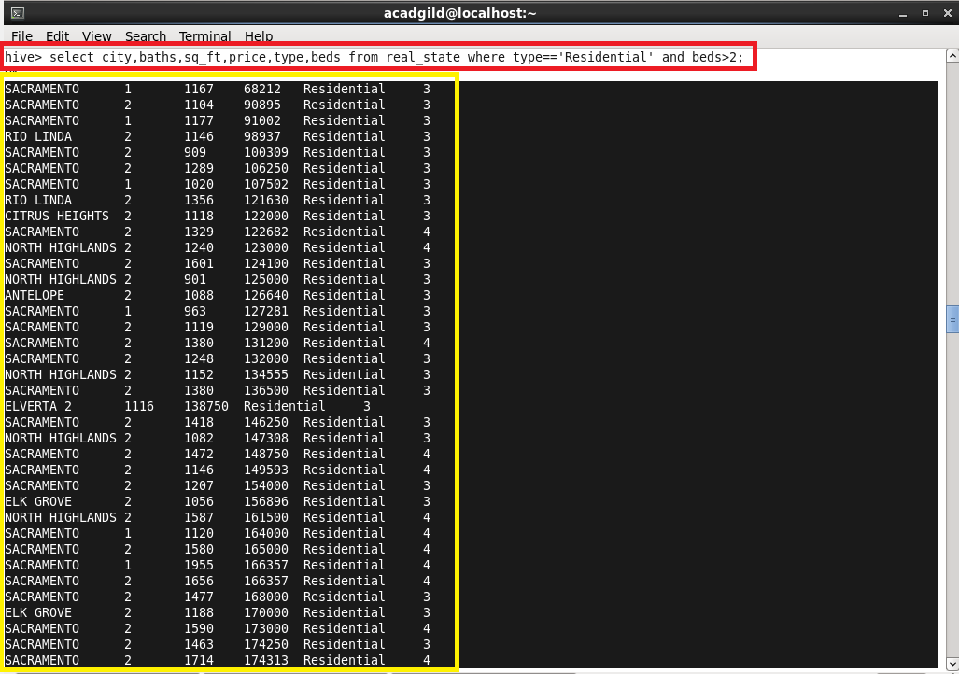

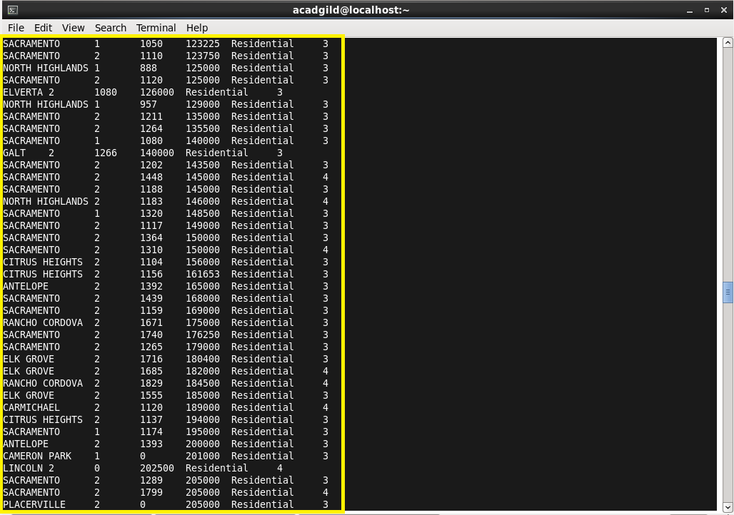

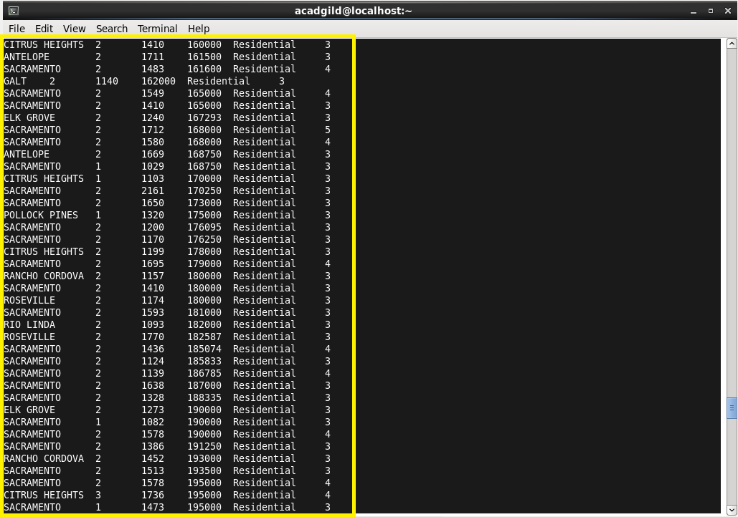

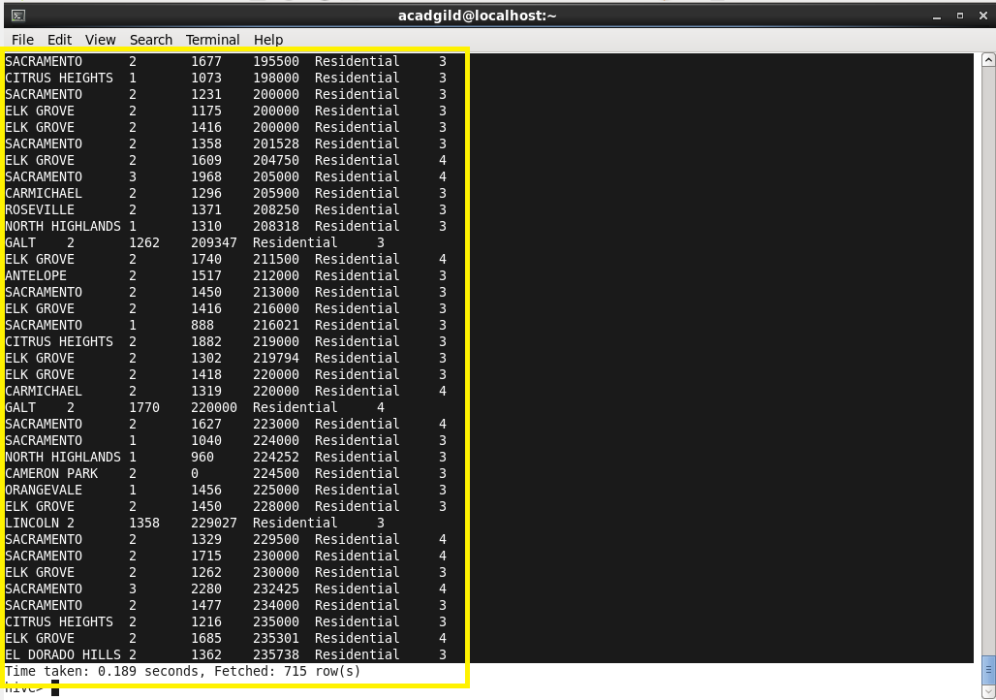

**NOTE:** Half of the output is displayed above as the actual output is of 715 rows.

The command line used is highlighted with red box.

The output obtained is highlighted with yellow boxes.