**Session 25**

**Assignment 6**

**Part 1:**

**Problem Statement:** Write a hive query to find the city wise list all the Condos which is not less than ten thousand.

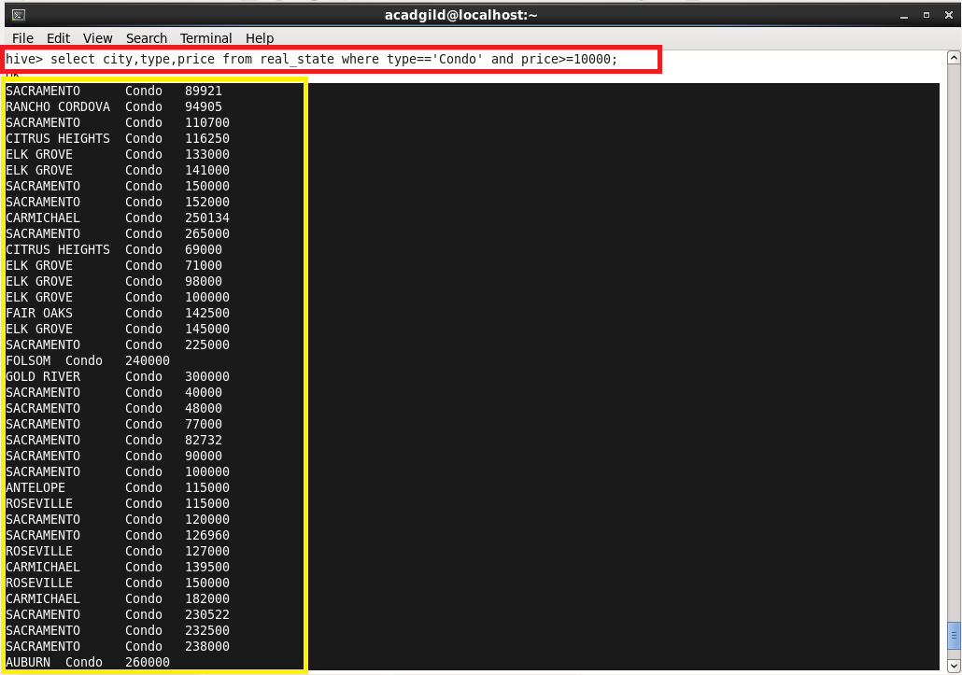

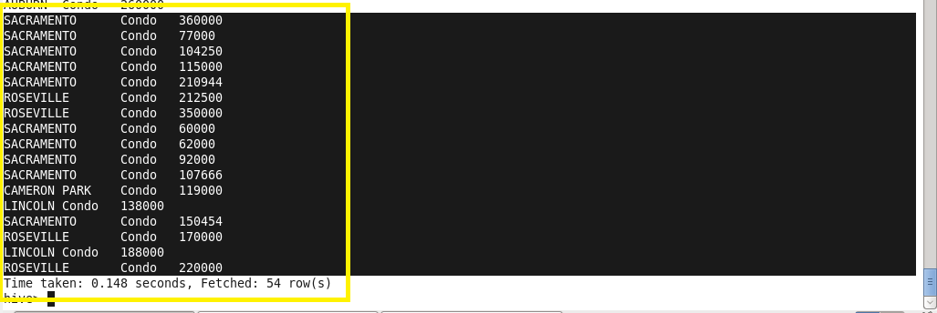

**NOTE:** The command line used is highlighted with red box.

The output obtained is highlighted with yellow boxes.

**Part 2:** Write a hive query to find which is the cheapest Condo in CA. Name the city, street and price for the Condo.

**Command Used:**

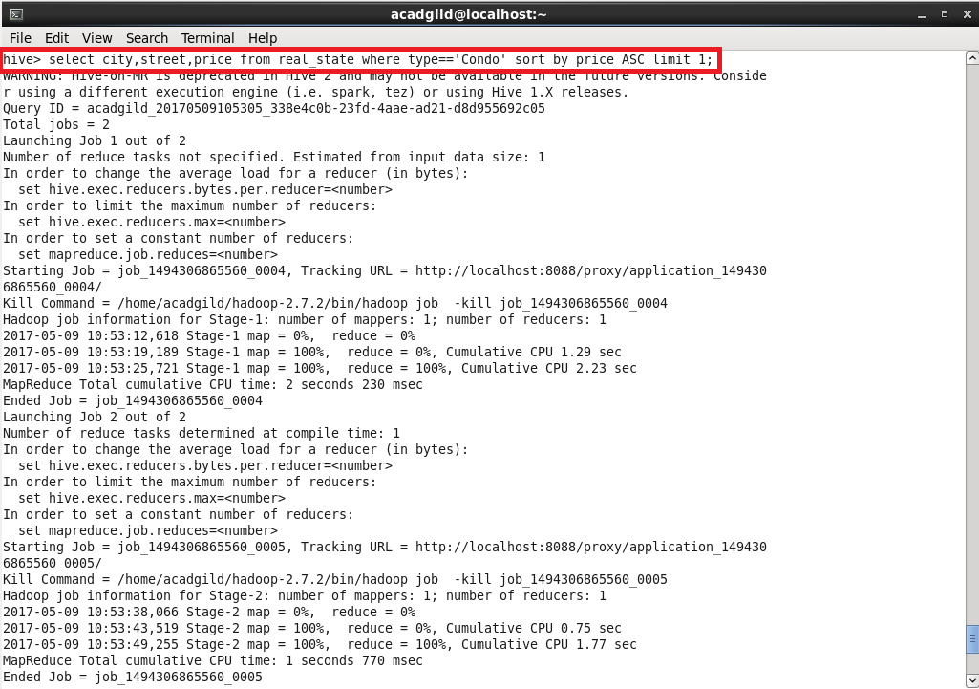

**Output:**

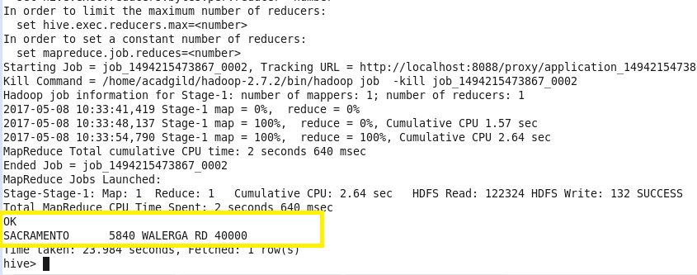

Part 3: Write a hive query to list top 5 residency details which lie in the budget of 60000-120000, an area more than 1450, sold after 17th may, min bedroom 3 and, min bathroom 2.

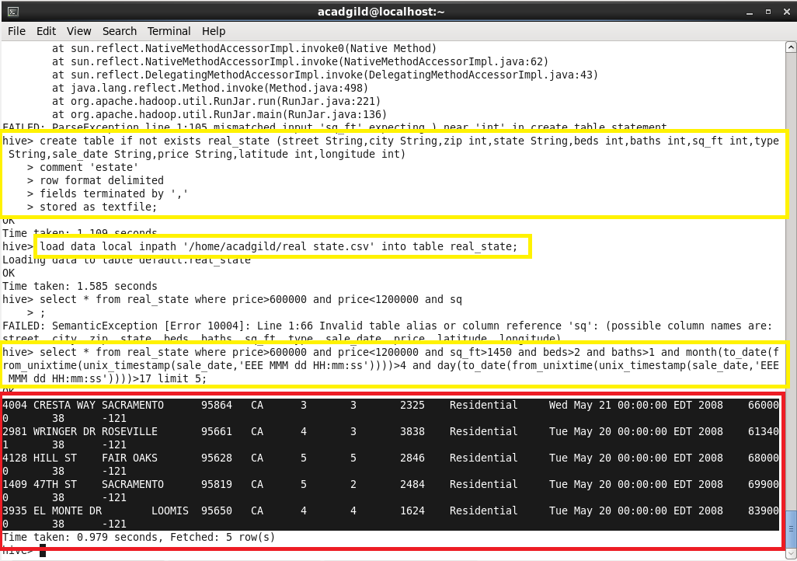

**NOTE:** The yellow box shows the commands used to obtain the desired output.

The red box shows the obtained output for the given details.

**Part 4:** Write a hive query to separate list of residential apartments with more than 2 beds. Also include columns in following order city, baths, sq feet, price, flat type, beds respectively.

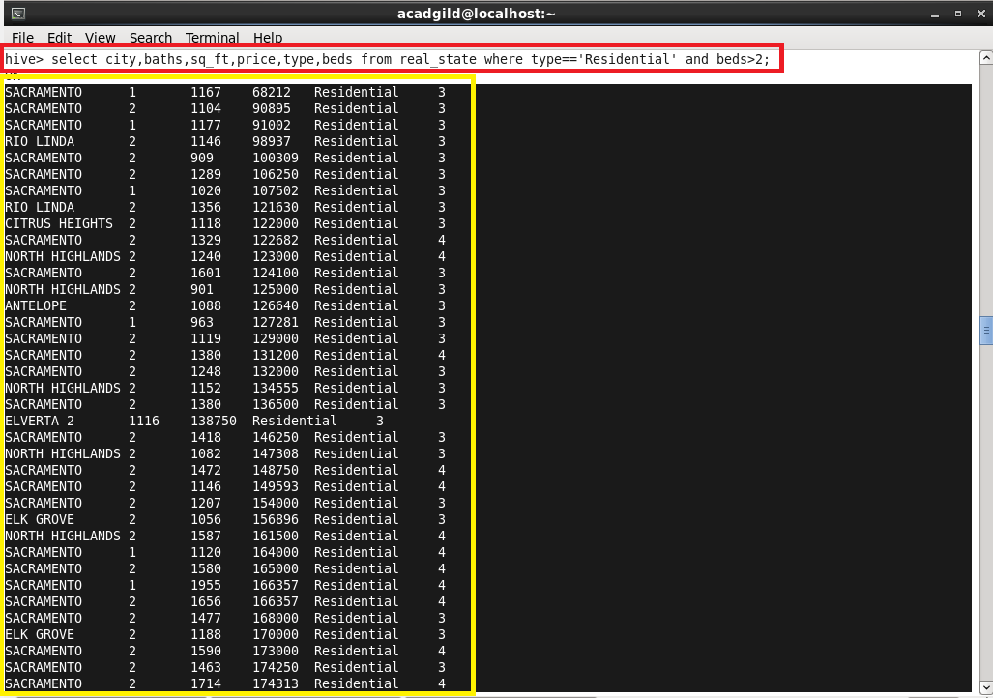

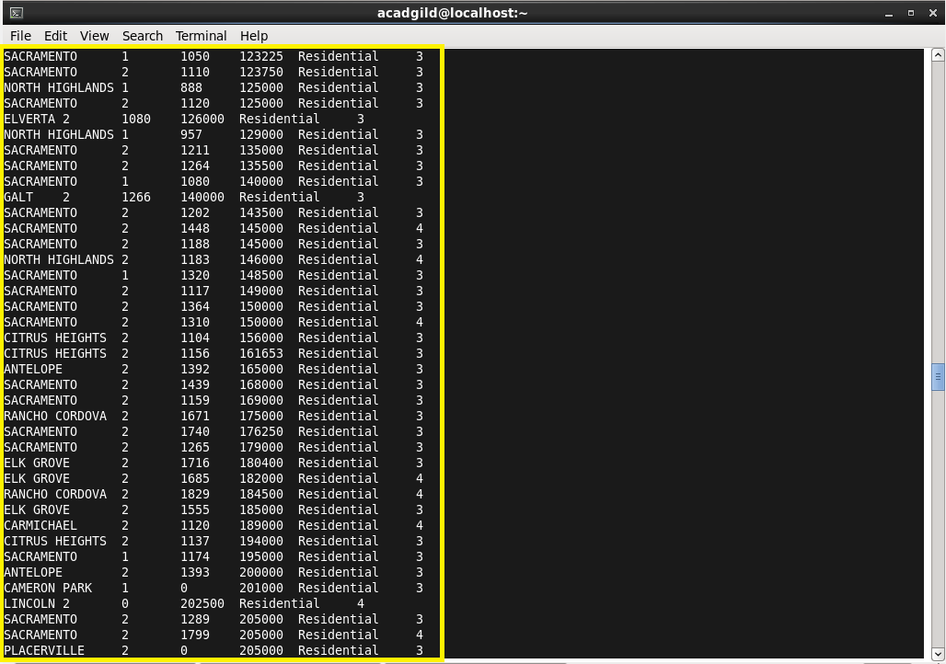

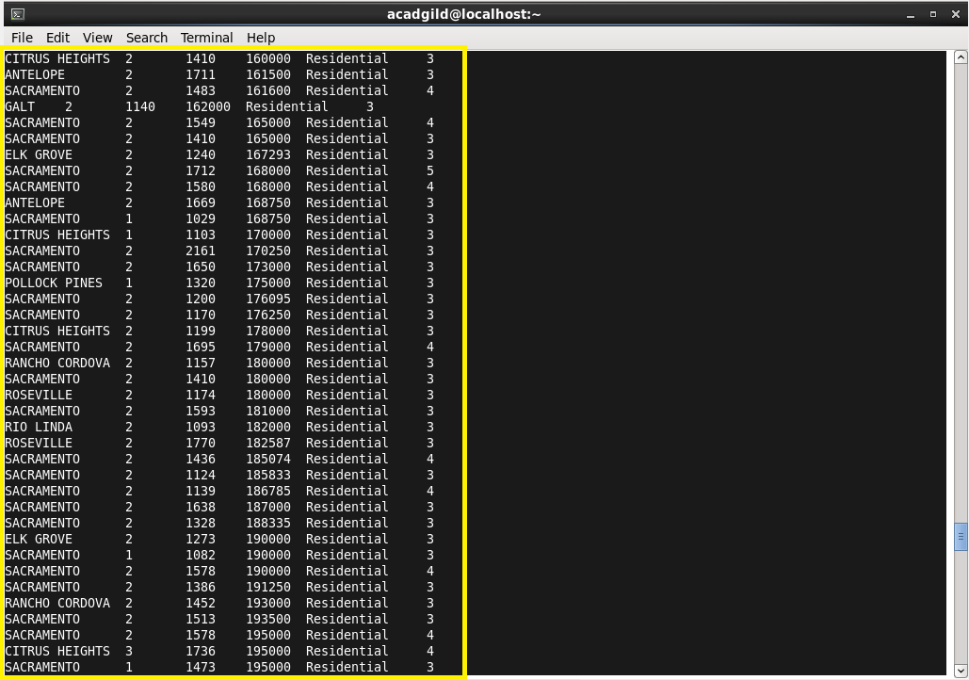

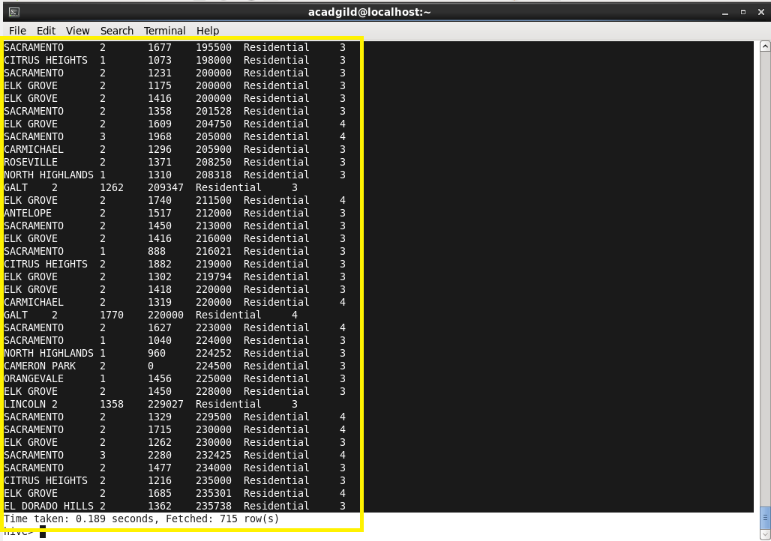

**NOTE:** Half of the output is displayed above as the actual output is of 715 rows.

The command line used is highlighted with red box.

The output obtained is highlighted with yellow boxes.