**Session 26**

**Assignment 3**

**Problem Statement:**

* Create table Real Estate in Hive database, with all the columns present in dataset.
* Load dataset into table Real Estate.
* Using Dynamic partition get separate lists of residential apartments with more than 2 beds and include columns in following order City, Baths, Sq_feet, Price, flat_type, Beds respectively.

**Step 1:**

**Creating the table Real Estate:**

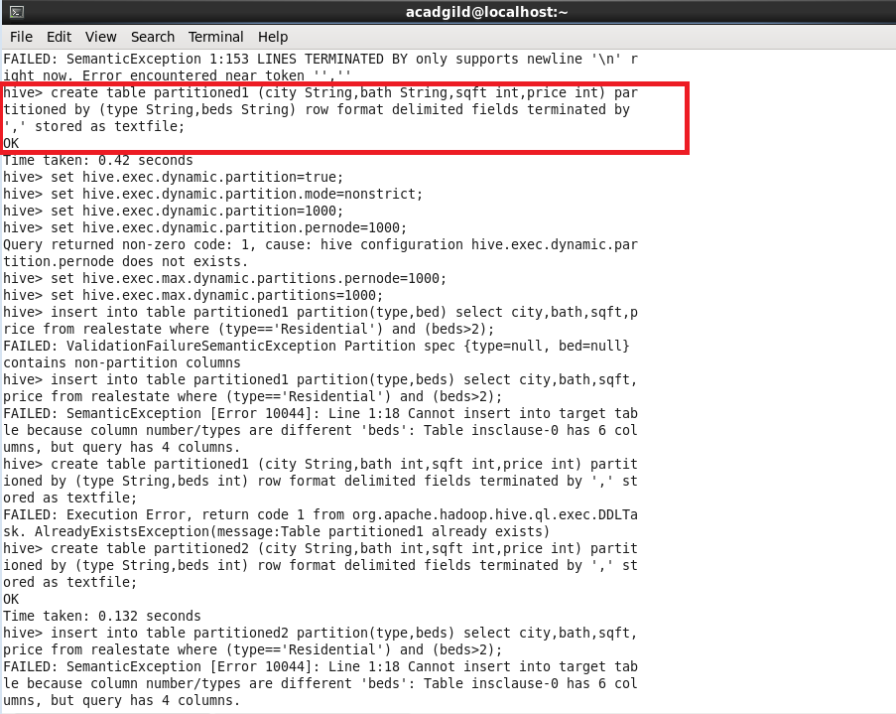

**Step 2:**

**Loading the data into the table using partition:**

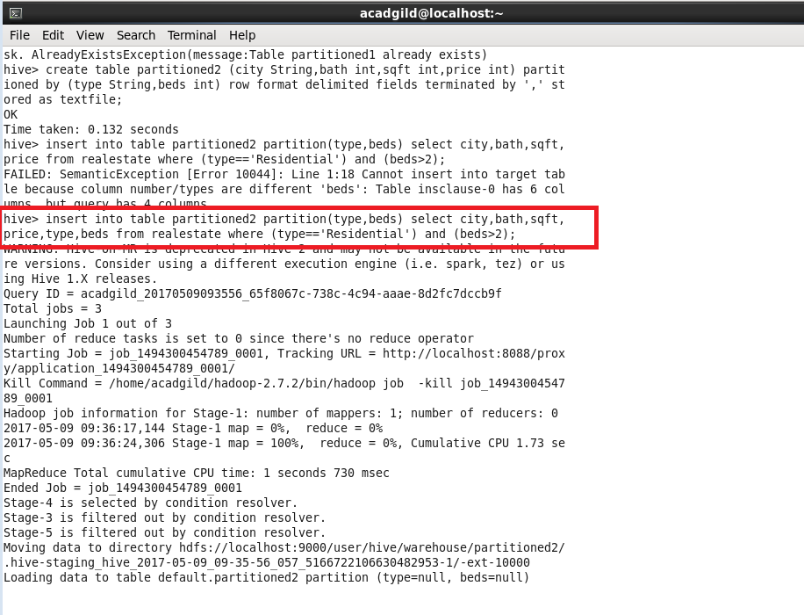

**Step 3:**

**Displaying the partitions of the table:**

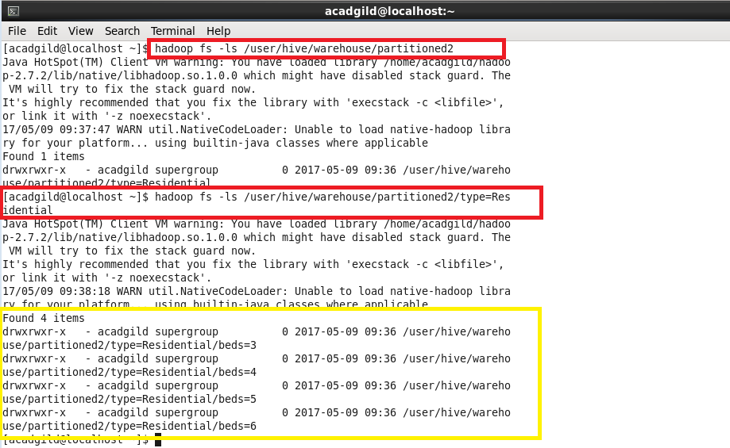

**Outputs:**

**Part 1:**

Displaying the data for the partition “**beds=3**”

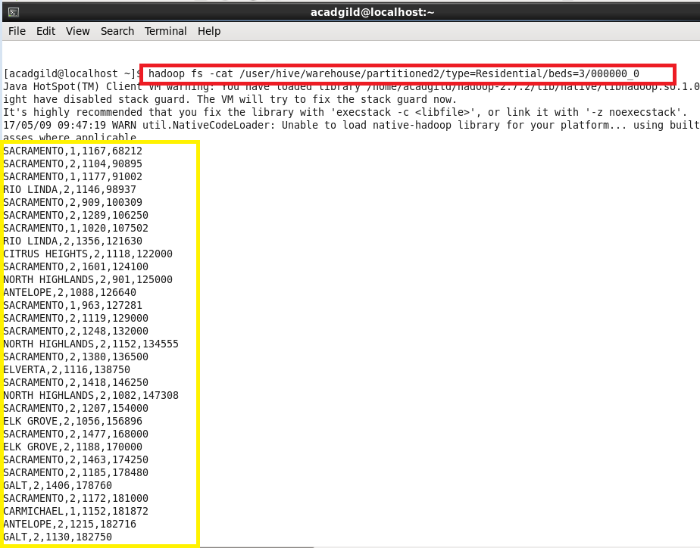

**Part 2:**

Displaying the data for the partition “**beds=4**”

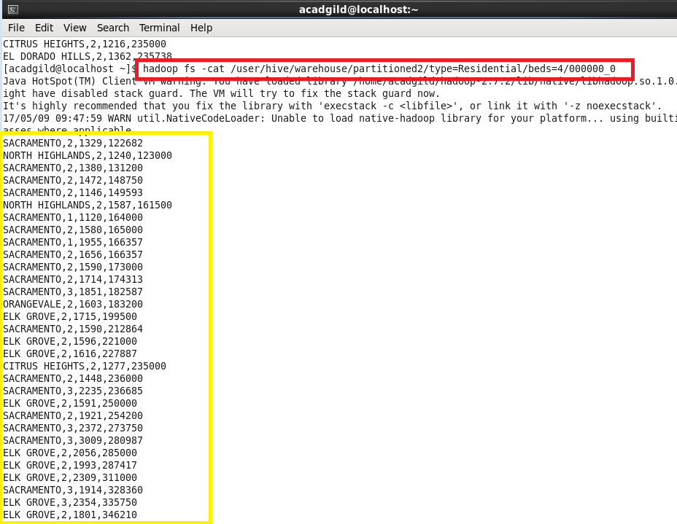

**Part 3:**

Displaying the data for the partition “**beds=5**”

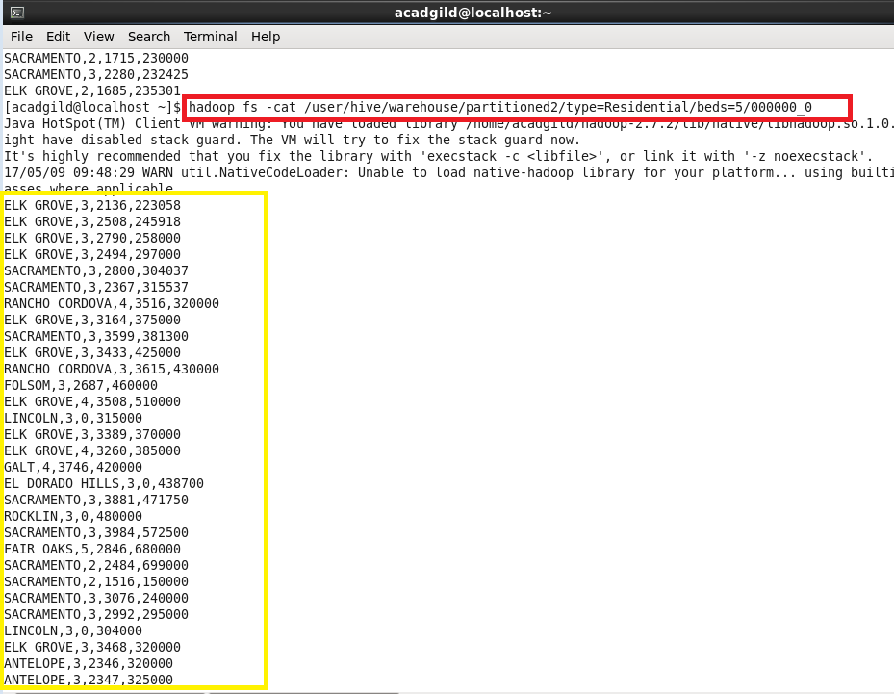

**Part 4:**

Displaying the data for the partition “**beds=6**”

