**Session 26**

**Assignment 4**

**Problem Statement:**

Implement view in hive by following the steps in the below blog.

**From the blog,**

**Step 1:**

Create a table and load the data.

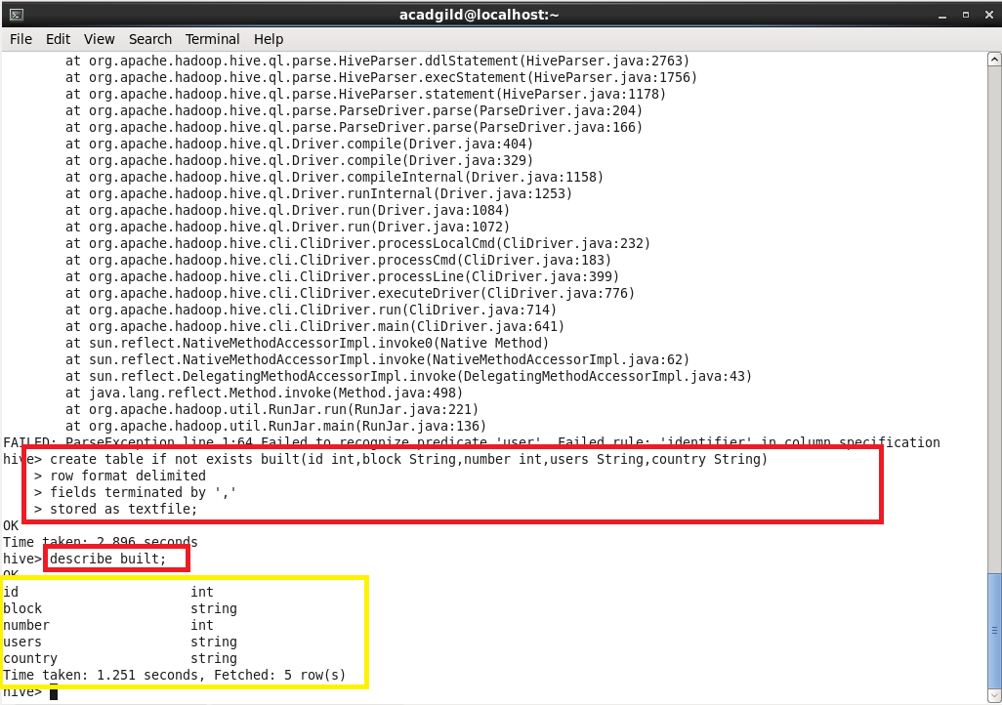

**Step 2:**

Create a view and store the data from the table created:

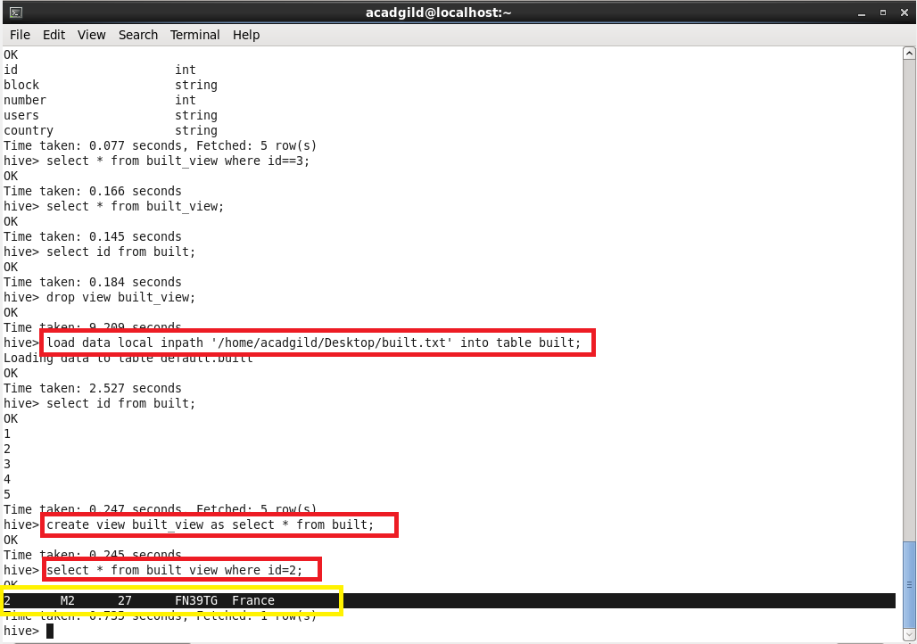

**NOTE:** Here the data corresponding to the ‘id = 2’ is displayed.

**Objective:**

* The main objective for creating a view of a table is to simplify some of the complexities of using a larger table into more Flat structure.
* For instance, if you have a table that has 100 columns, but only five columns in that table is required then a View with those five columns can be created.
* Here in this dataset there is no complexity since there are only 5 columns. So all the columns are being included.
* Retrieved the data using select statement from the view