**Session 29**

**Assignment 1**

**Problem Statement:**

Write a hive UDF that implements functionality of string concat_ws (string SEP, array). This UDF will accept two arguments, one string and one array of string. It will return a single string where all the elements of the array are separated by the SEP.

**Step 1:** Java code to return all elements of the string separated by separator.

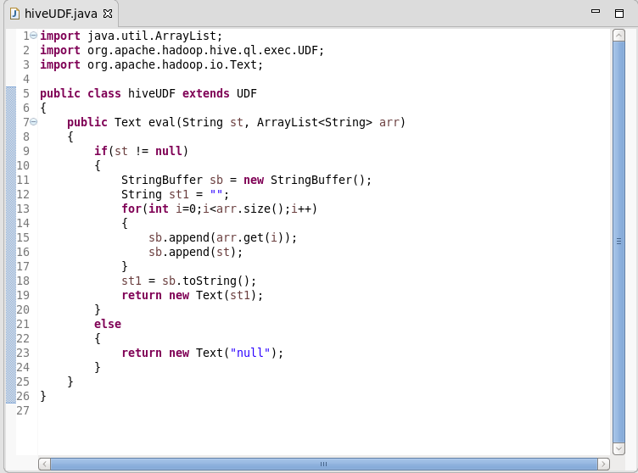

**Step 2:** Adding jar to the hive shell.

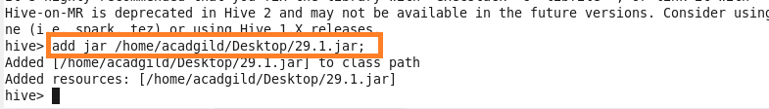

**Step 3:** Creating temporary function ‘concat’ and a table with string and string array as contents.

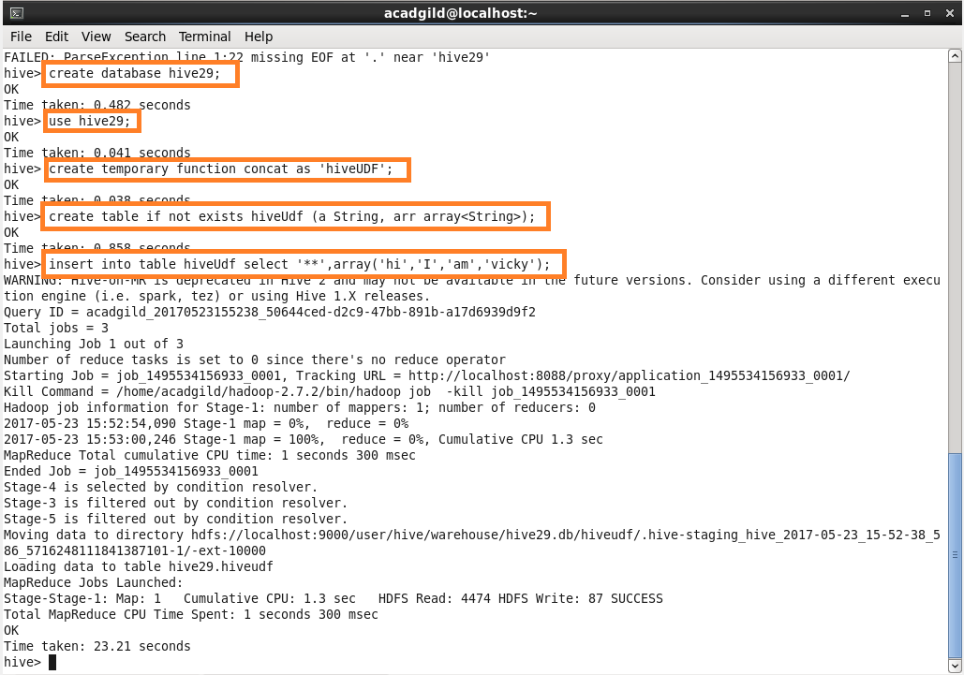

**Step 4:** Describing the table “hiveUdf”:

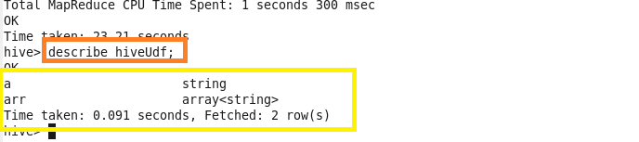

**Step 5:** Using the temporary function “concat”:



