**Session 29**

**Assignment 2**

**Problem Statement:**

Write a hive UDAF to find the largest integer in a column. Use your own dataset for the above problem statement and attach the steps performed, codes used with the result.

**Step 1:** Writing java code to find largest integer in a selected column.

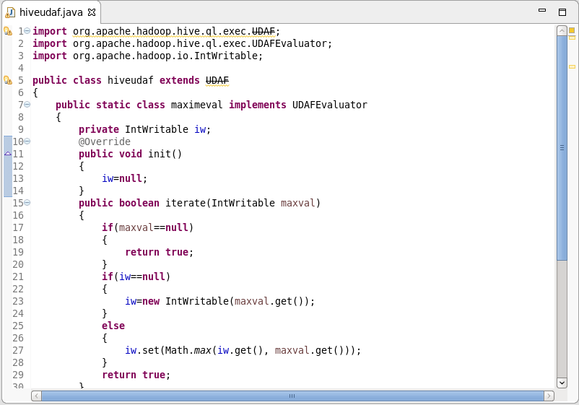

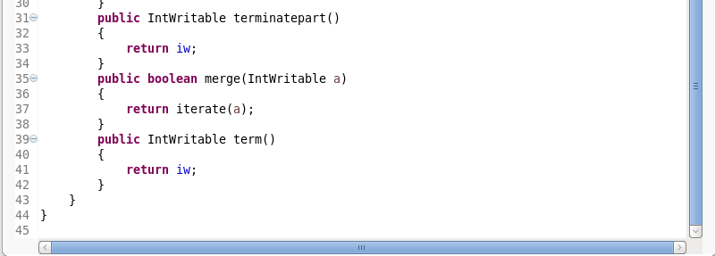

Methods used to write UDAF function:

1. init() – This method initializes the evaluator and resets its internal state. We are using new column in the code below to indicate that no values have been aggregated yet.
2. iterate() – This method is called every time there is a new value to be aggregated. The evaulator should update its internal state with the result of performing the aggregation (We return true to indicate that the input was valid).
3. terminatepart() – This method is called when Hive wants a result for the partial aggregation. The method must return an object that encapsulates the state of the aggregation.
4. merge() – This method is called when Hive decides to combine one partial aggregation with another.
5. term() – This method is called when the final result of the aggregation is needed.

**Step 2:** Adding jar to the Hive shell.

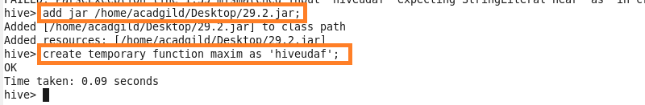

**Step 3:** Customer table is used for this problem.

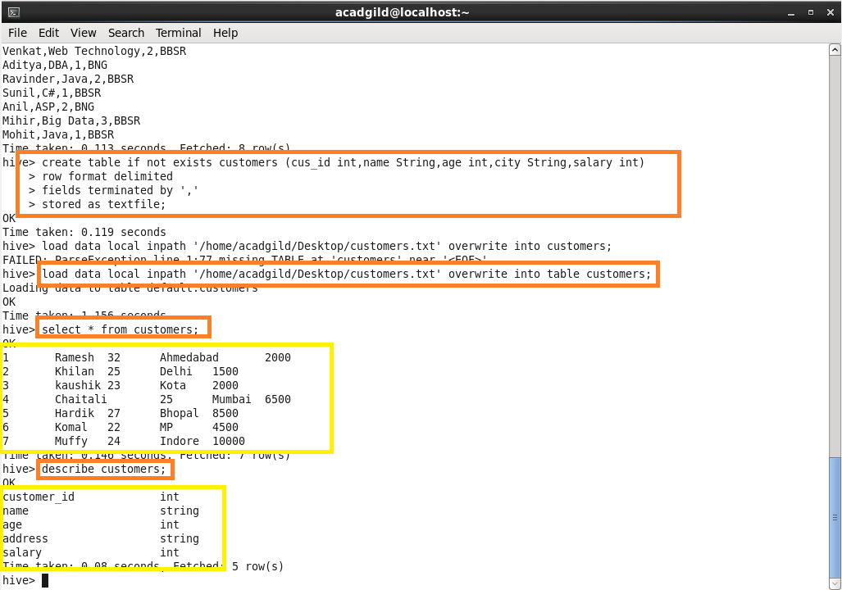

**Step 4:** Using maxim temporary function to find the maximum salary.

