**Session 32**

**Assignment 3**

**Problem Statement:**

Write a Java client API to perform following operations:

* Use HBase Admin class and create the table named ‘company’ with one column family name ‘Details’.
* Create the method name ‘insert’ and use put class to insert records to ‘company’ table.

**Step 1:** Writing Java code to create a table in HBase

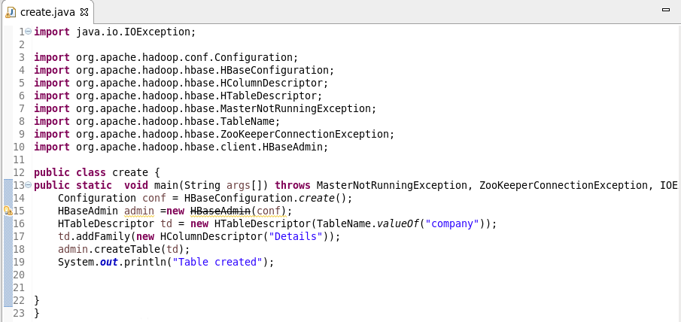

**Step 2:** Table created in HBase by running the Java code (Run as Application) in Eclipse.

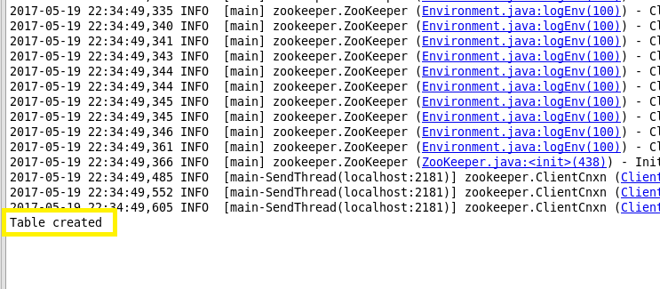

**Step 3:** Showing the Tables created in HBase Using ‘List’ Command.

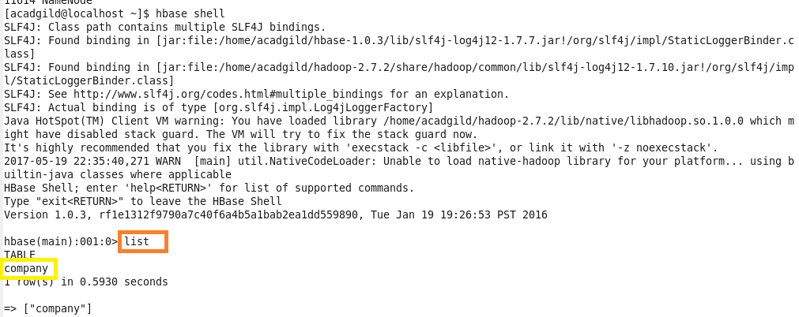

**Step 4:** Writing Java Code to insert data into the Table created “Company”

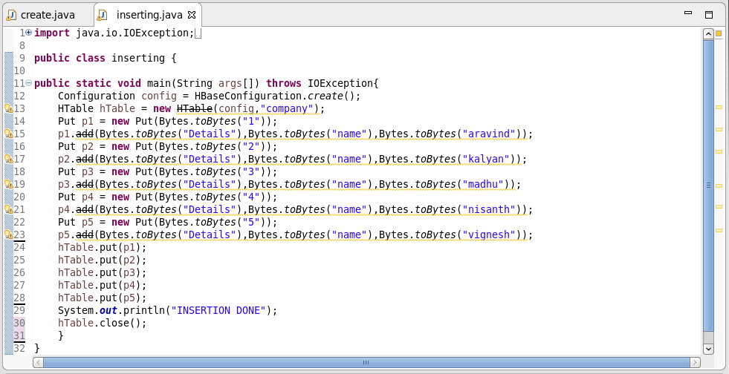

**Step 5:** Running the Java code in Eclipse (Run as Application)

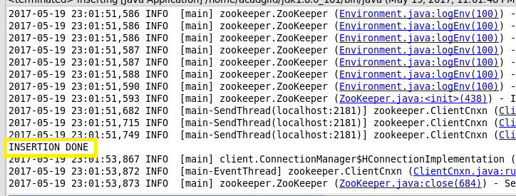

**Step 6:** To Check the Insertion, “Scan” Command is used.

