**Session 33**

**Assignment 1**

**Problem Statement:**

Write Java client API to perform following operations:

* Create the method name get record and use get class to retrieve one record at a time record from company table.
* Create the method name display and use scan class to display all records from company table.

**Part 1:**

Create the method name get record and use get class to retrieve one record at a time record from company table.

**Step 1:** Writing java code to get only names from the table “customer”.

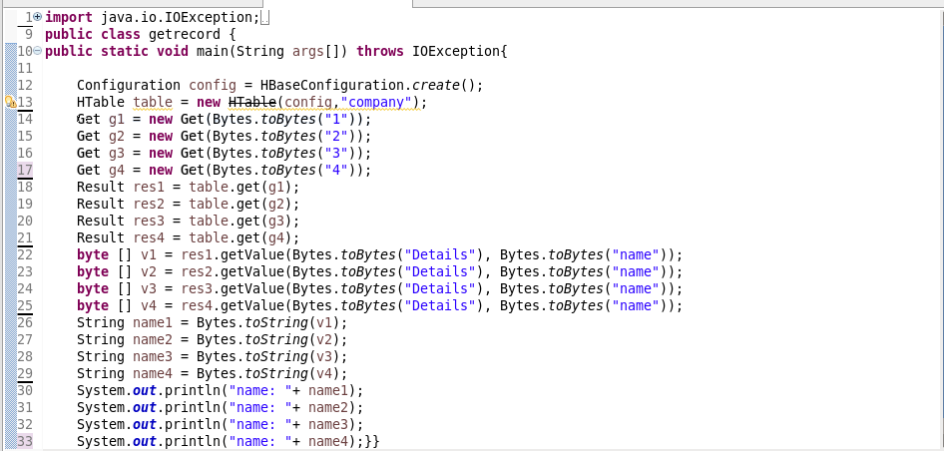

**Step 2:** Listing the names from the table ‘customer’

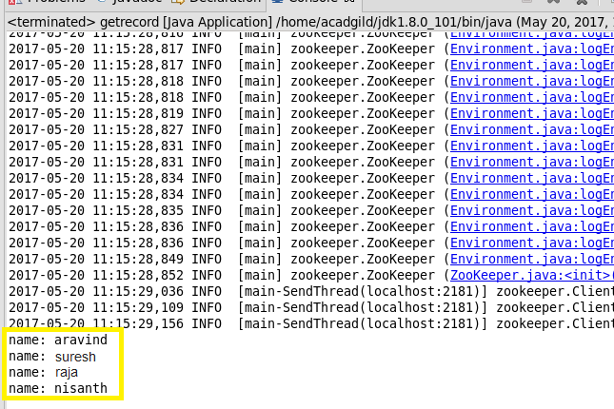

**Step 3:** Checking the contents of the table “company” using ‘scan’ command

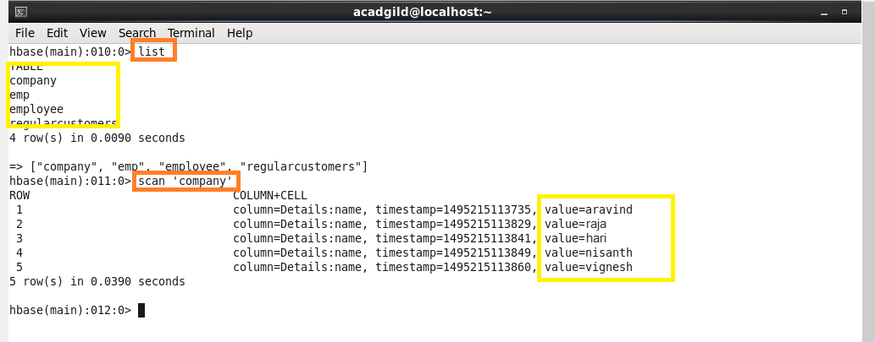

**Part 2:**

Create the method name display and use scan class to display all records from company table.

**Step 1:** Writing java code by using scan class to display all records from the table “company”.

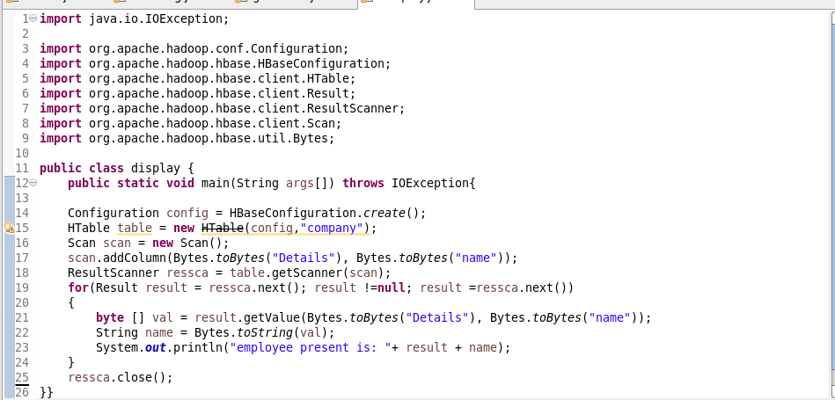

**Step 2:** Running java code (run as application) in eclipse

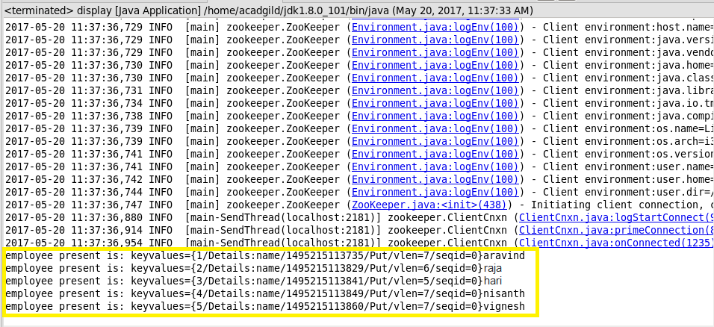

**Step 3:** checking the contents of the table “company” using ‘get’ command.

