**Session 33**

**Assignment 2**

**Problem Statement:**

* Integrate HBase with Hive
* Load Data (Bulk Load) from Hive table to HBase Table
* Explain the procedures and code implemented with screenshots.
* Note: Candidates should Load their own data into HBase table.

**Step 1:** Creating the table “cust35” and loading data into that table in HIVE.

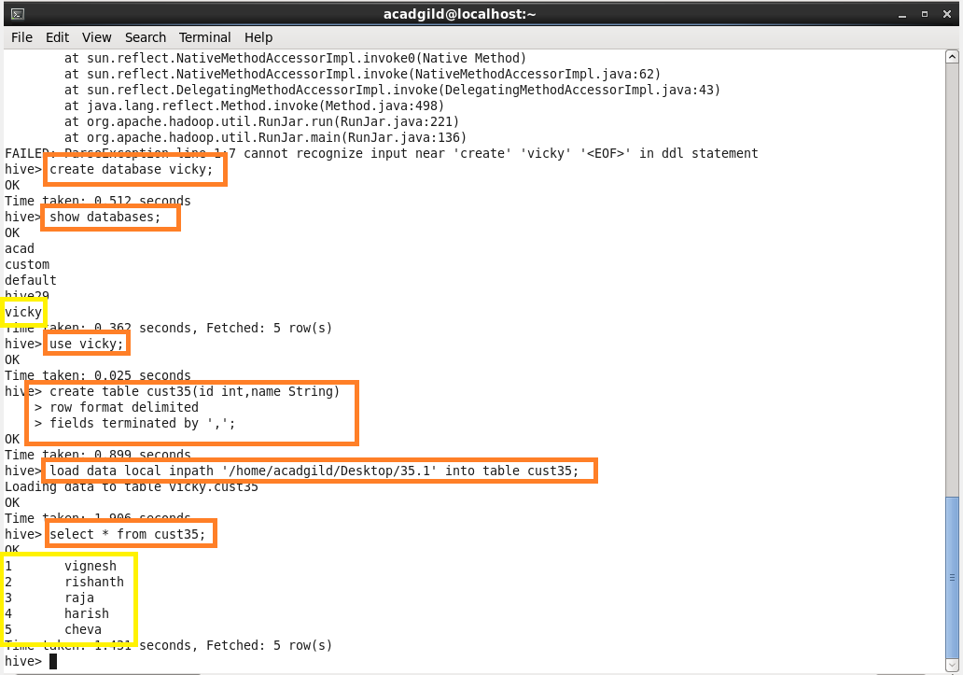

**Step 2:** Creating a table ‘cust35a’ with ‘details’ as column family in HBase.

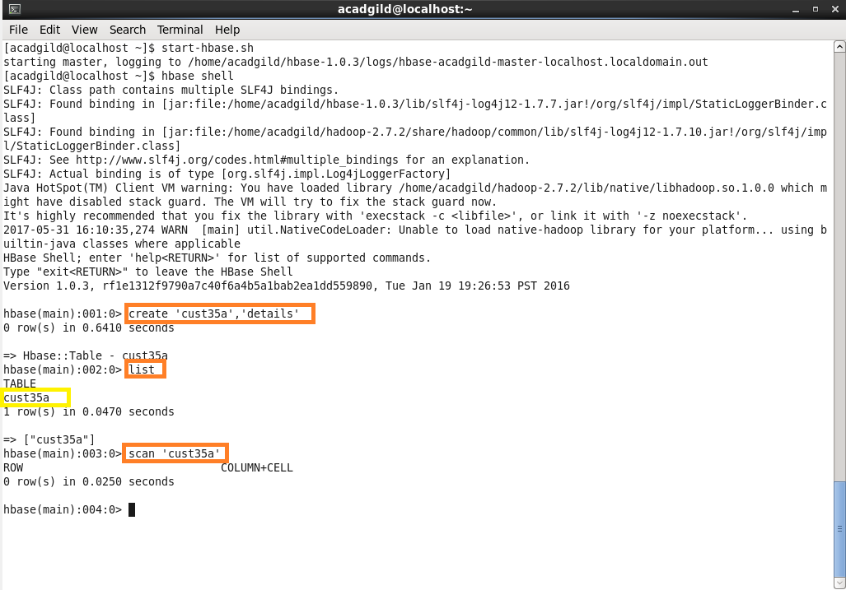

**Step 3:** Creating external table ‘hbase_hive’ and loading data into it from Hive

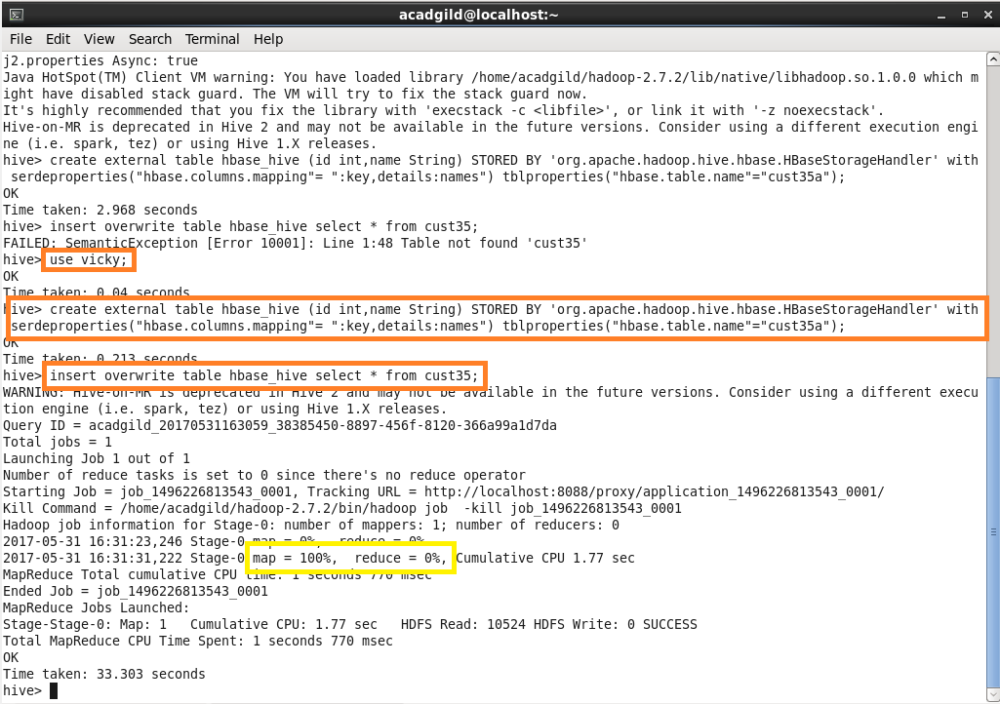

**Step 4:** Data automatically gets transferred from Hive to HBase

