Session 35

ASSIGNMENT 1

Problem Statement:

Part 1:

* Create an employee table in MySQL and columns as Emp_id, Emp_name, Emp_sal.
* Import the employee table contents into the HDFS directory using Sqoop.

Step 1: Creating a database and table in MySQL and inserting data into the table.

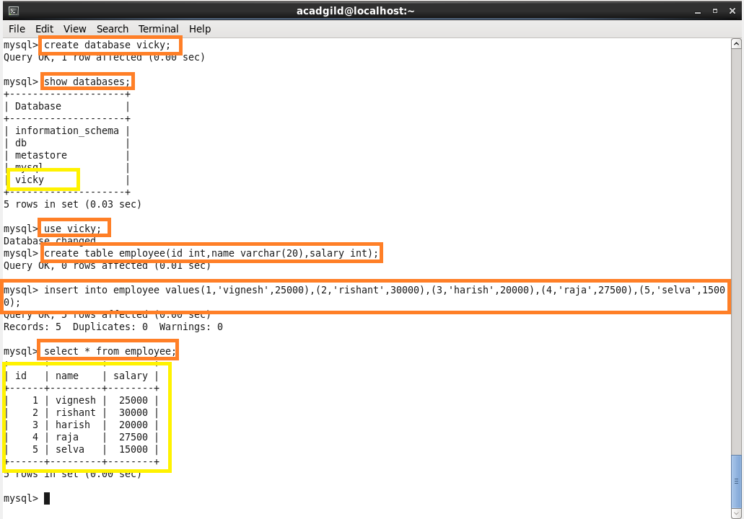

**Step 2:** Displaying the contents of the table ‘employe1’

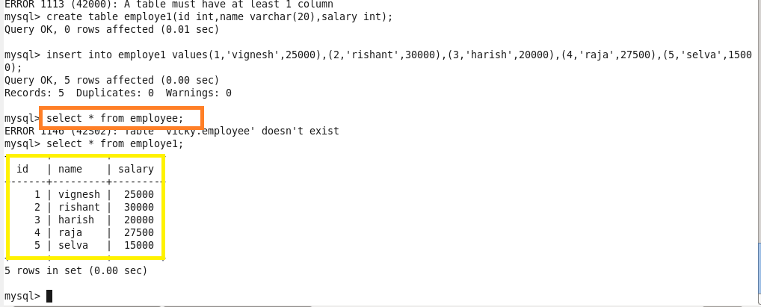

**Step 3:** Importing the data in MySQL to HDFS by using Sqoop.

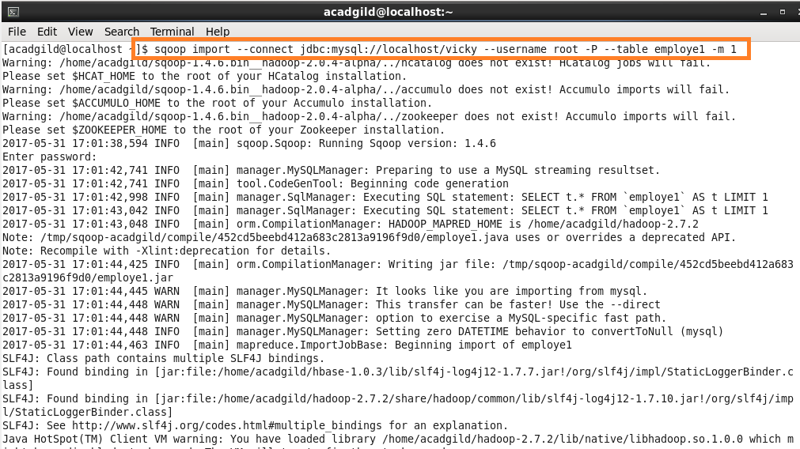

Step 4: Successfully imported the data to HDFS from MySQL.

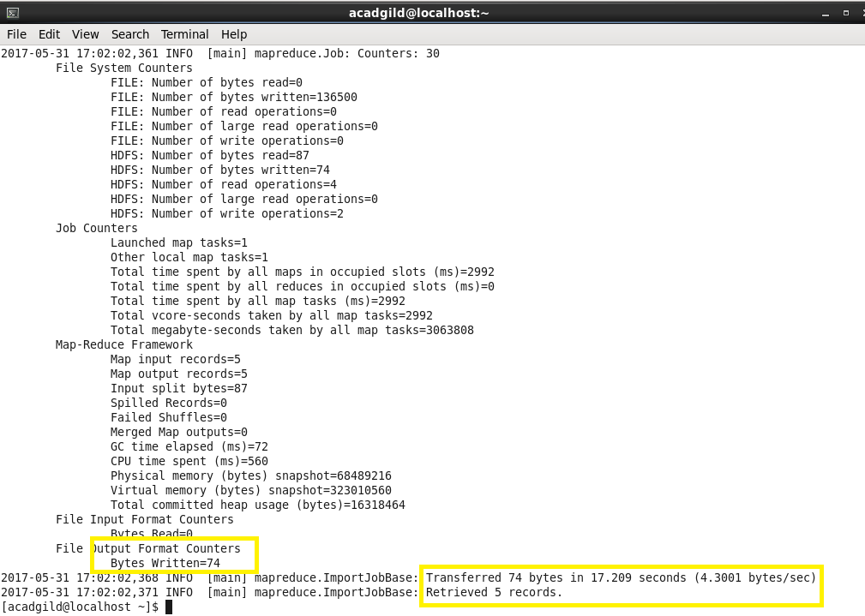

Step 5: Listing the files and reading the file using ‘ls’ and ‘cat’ command

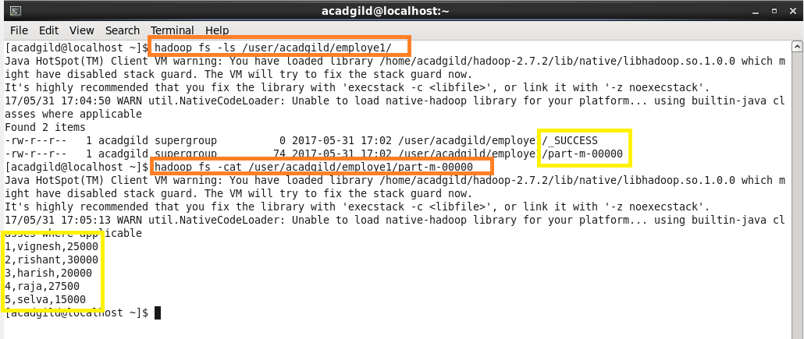

Part 2:

* Create an ‘employe2’ table in MySQL and Export employee details file from HDFS directory to MySQL table employee2 using Sqoop.
* Explain the procedures performed, Share the screenshots of commands and results for the same.

**Step 1:** Creating “employe2” table and keeping it empty to import data from HDFS

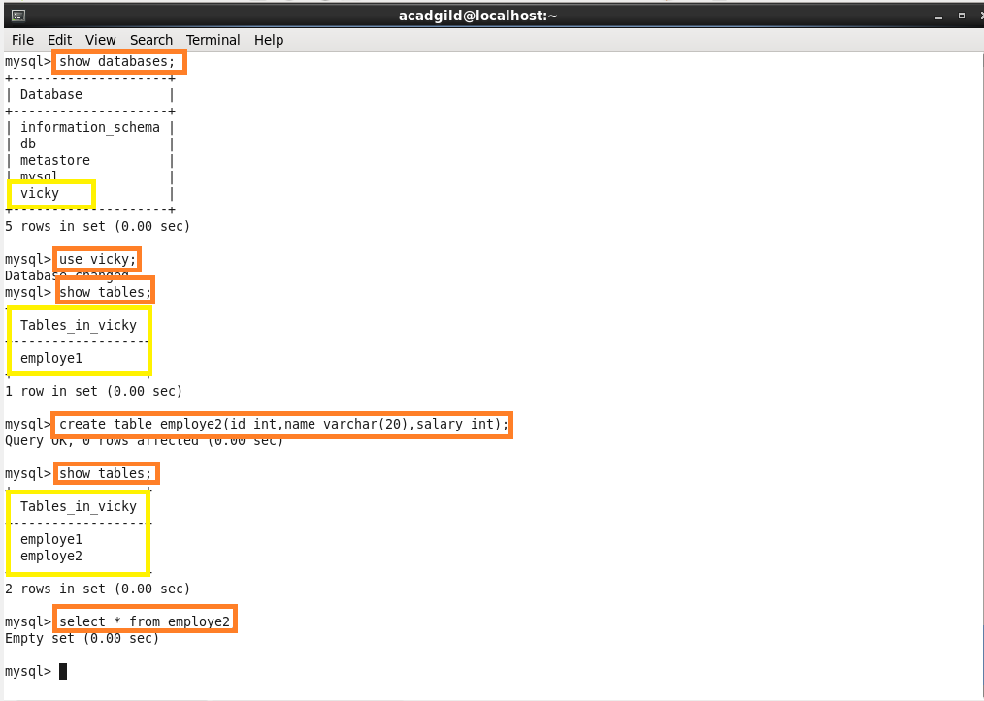

**Step 2**: Showing that the table employe2 is empty.



**Step 3:** Exporting the table from HDFS to MySQL.

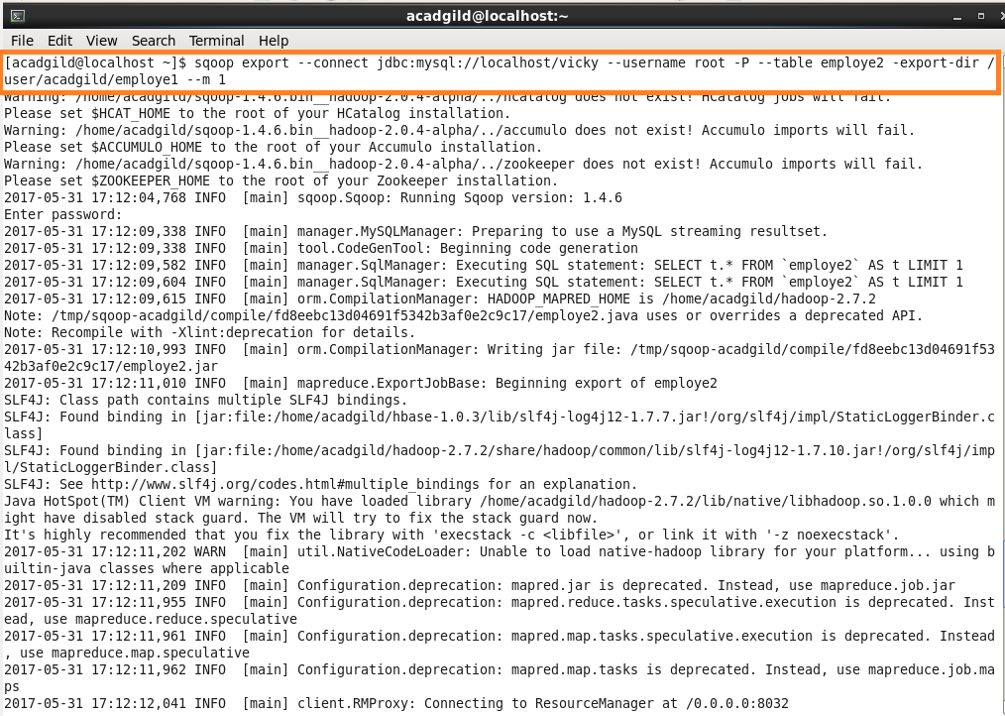

**Step 4:** Successfully exported the data from HDFS to MySQL using Sqoop.

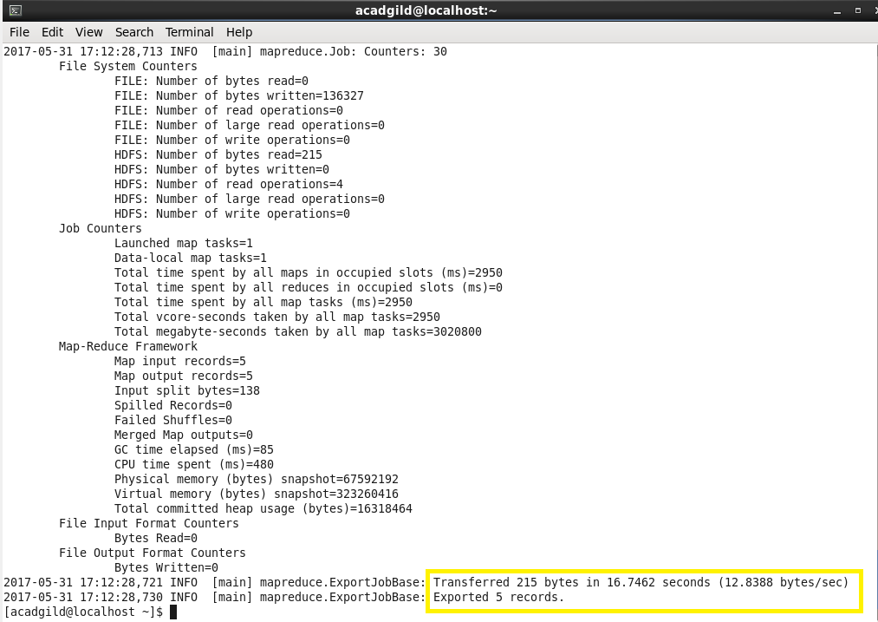

**Step 5:** Previously the table was empty, after exporting this table contains data.

