**ASSIGNMENT 35.2**

* **Explain and perform Sqoop Incremental Import operation to load data from Mysql To HDFS using Sqoop.**
* **Explain the procedures performed, Share the screenshots of commands and results for the same.**

**STEP 1: CREATING A TABLE AND INSERTING VALUES INTO IT.**

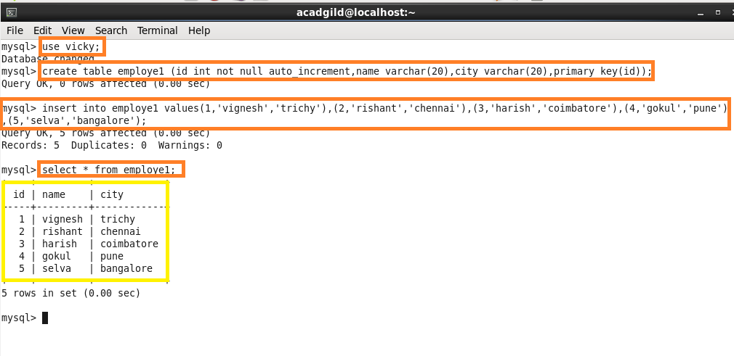

**STEP 2: IMPORTING THE TABLE FROM MYSQL TO HDFS**

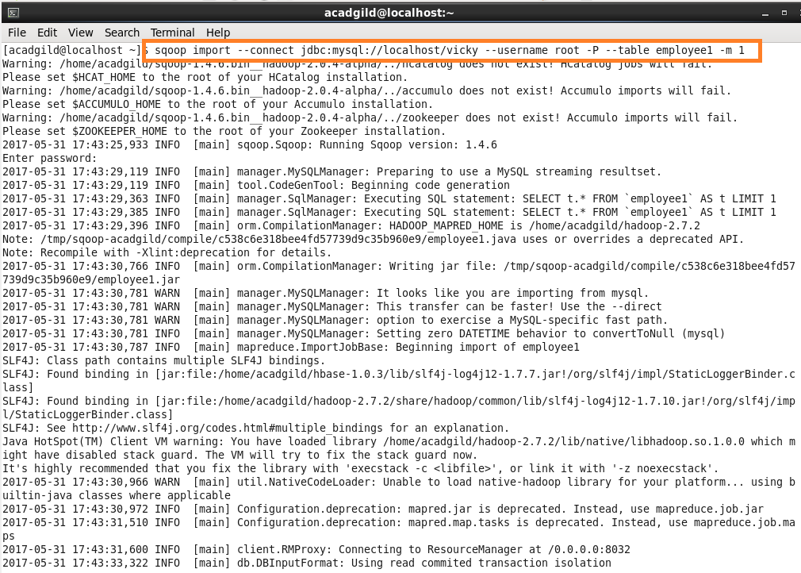

**STEP 3: TABLE WITH 4 ENTRIES IS SUCCESSFULLY IMPORTED FROM MYSQL**

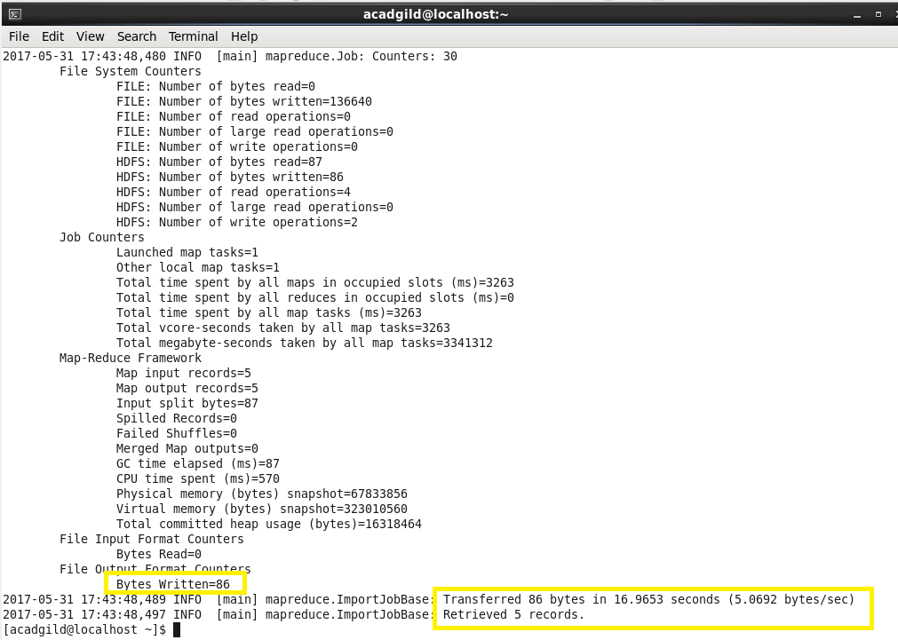

**STEP 4: READING THE FILE TO CHECK WHETHER IMPORT IS DONE SUCCESSFULLY OR NOT**

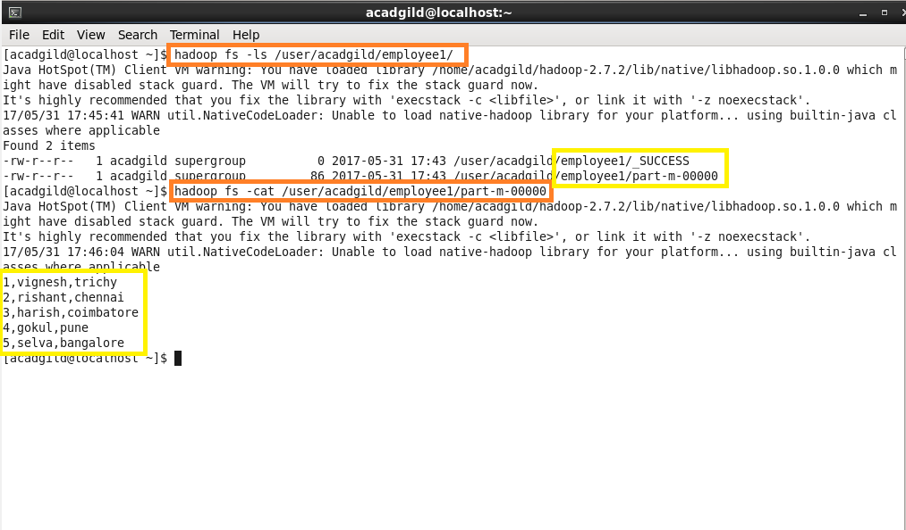

**STEP 5: INSERTING FEW MORE ROWS INTO THE TABLE IN MYSQL**

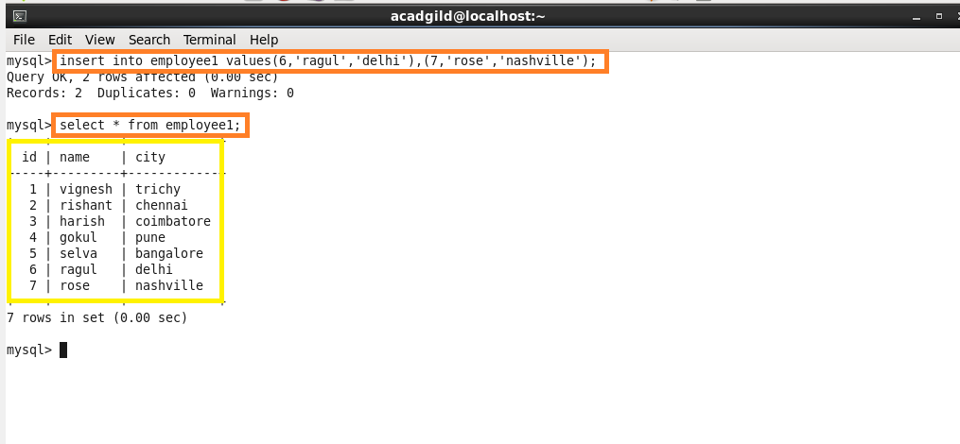

**STEP 6: DOING INCREMENTAL APPEND**

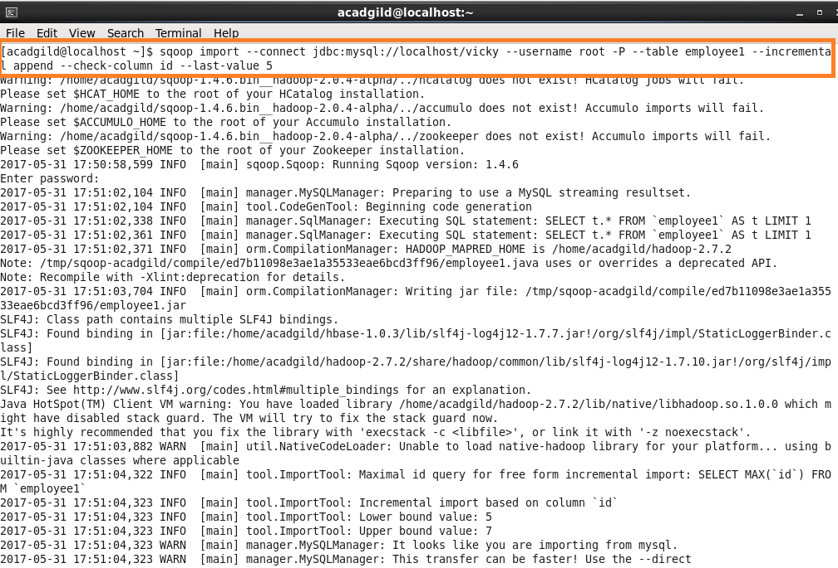

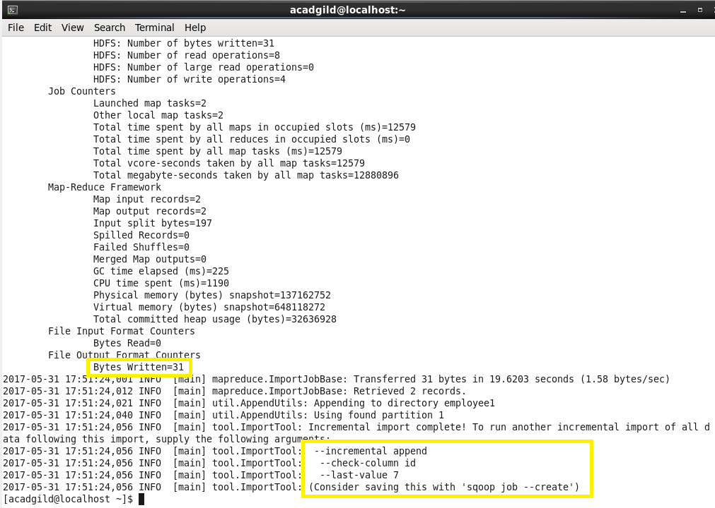

**STEP 7: READING THE TABLE CONTENTS AFTER DOING INCREMENTAL APPEND**

