**Session 35**

**Assignment 3**

**Problem Statements:**

**Part 1:** Explain and perform Importing table contents from MySQL to Hive using Sqoop.

**Step 1:** Creating table “sam” and inserting into the table “sample1” in MySQL

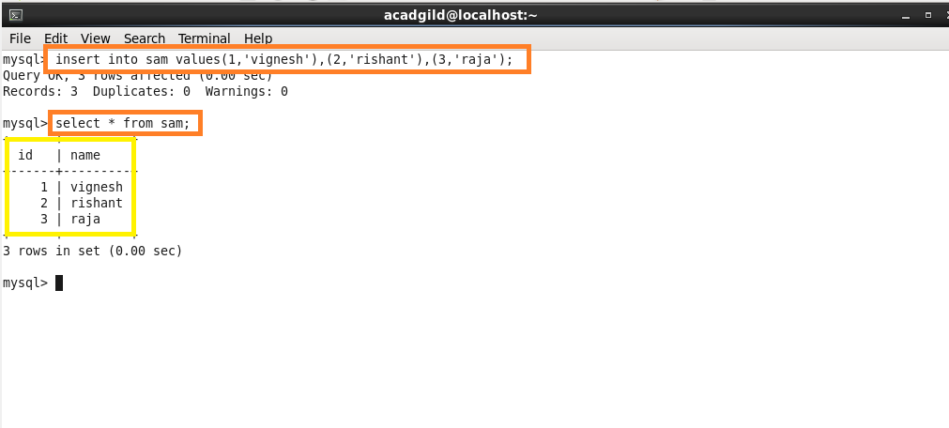

**Step 2:** Performing import using Sqoop (we have to transform the data from MySQL to Hive)

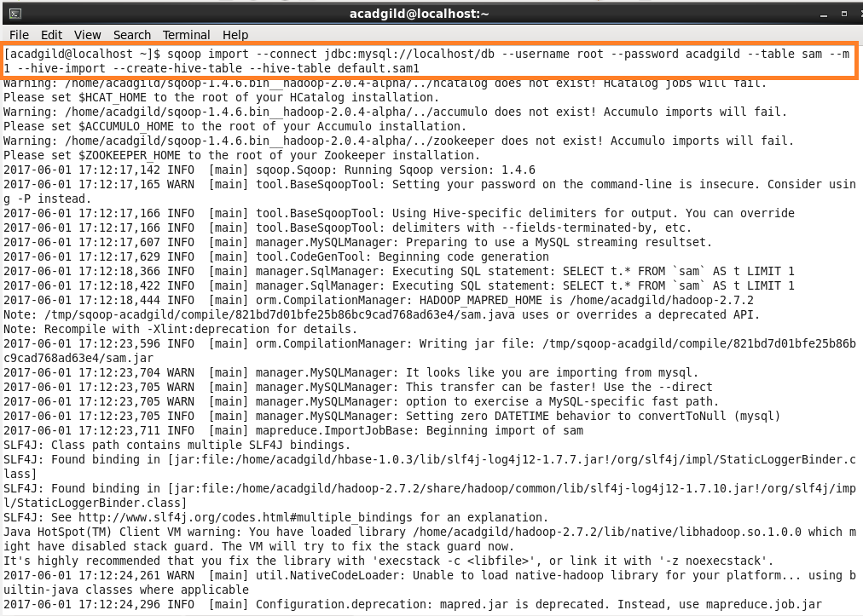

sam1 will be created in Hive automatically.

**Step 3:** Before running the import command we should close the Hive shell, otherwise we’ll get an error.

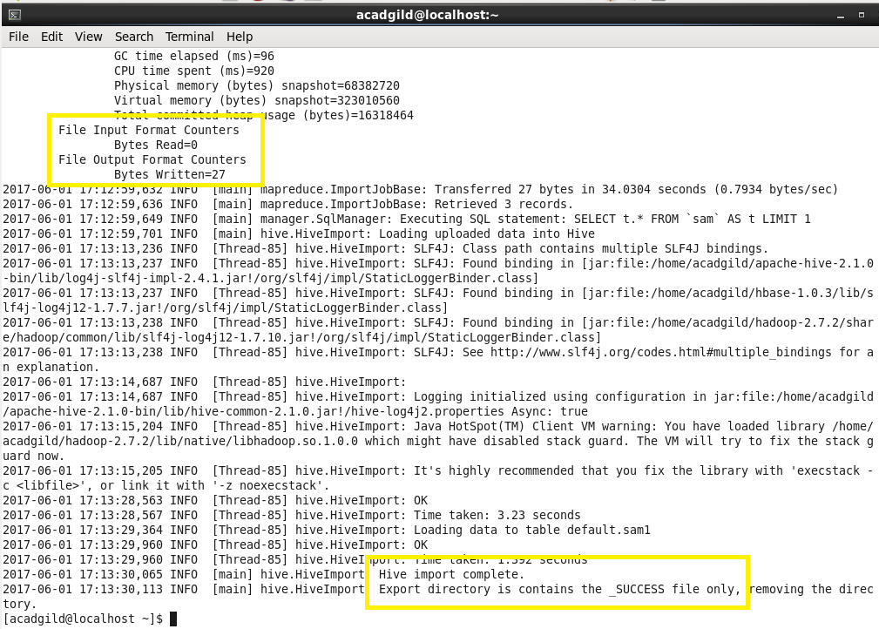

**Step 4:** After running import command “sam1” is loaded with data.

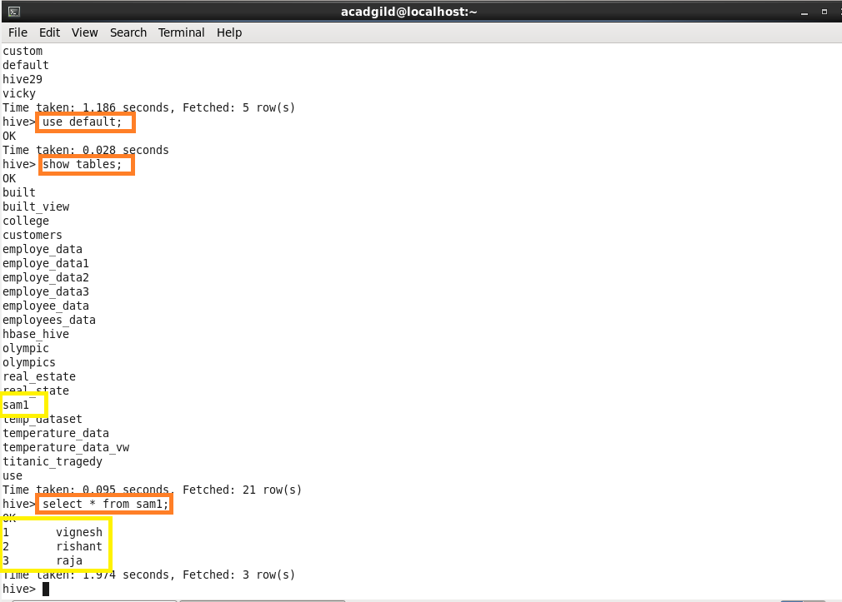

**Part 2:** Explain and perform Importing table contents from MySQL to HBase using Sqoop.

**Step 1:** Create a table “sample” with “details” as column family in HBase.

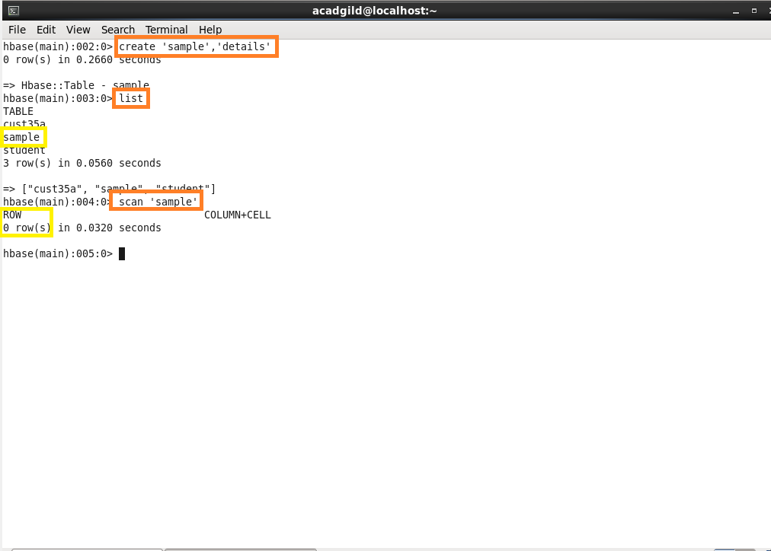

**Step 2:** performing import from MySQL to HBase.

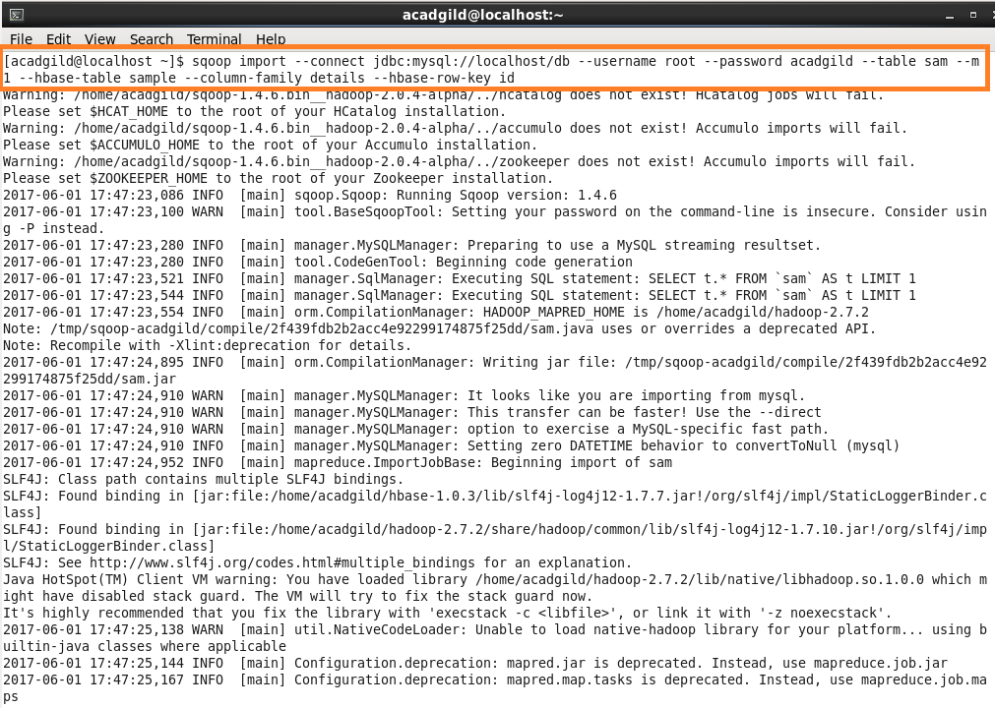

**Step 3:** Successfully transferred data from MySQL to HBase.

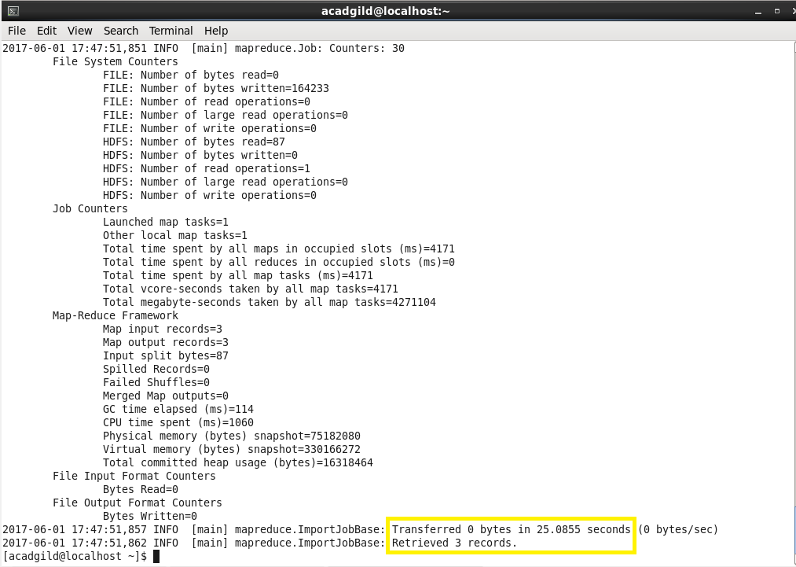

**Step 4:** scan “sample” gives the full details about the table (transferred data)

