**Session 7**

**Assignment 2**

**Part 1: Sales of different TV Task 6:**

Modify Sales of different TV Task 3 (refer session 5, assignment 2) to take advantage of Combiner.

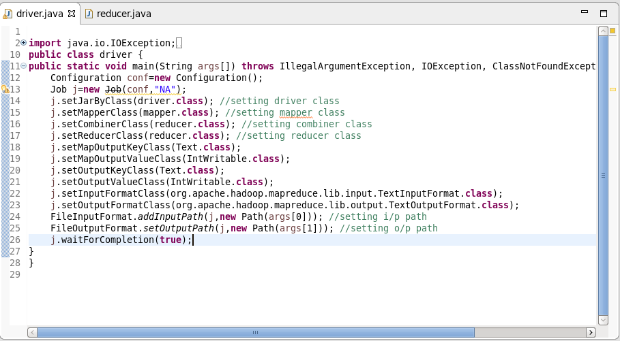

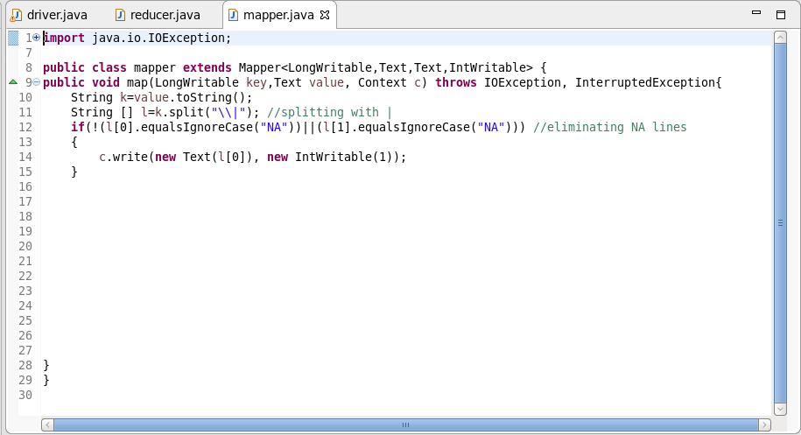

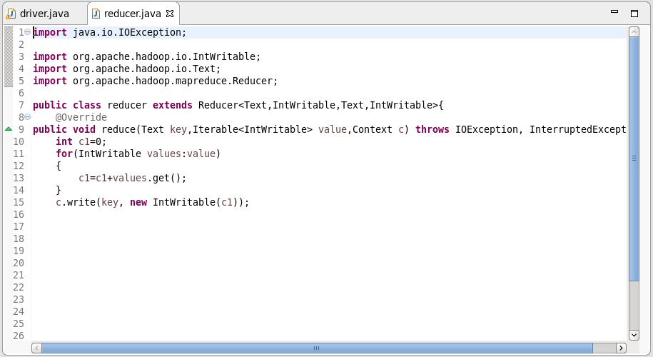

**Output:**

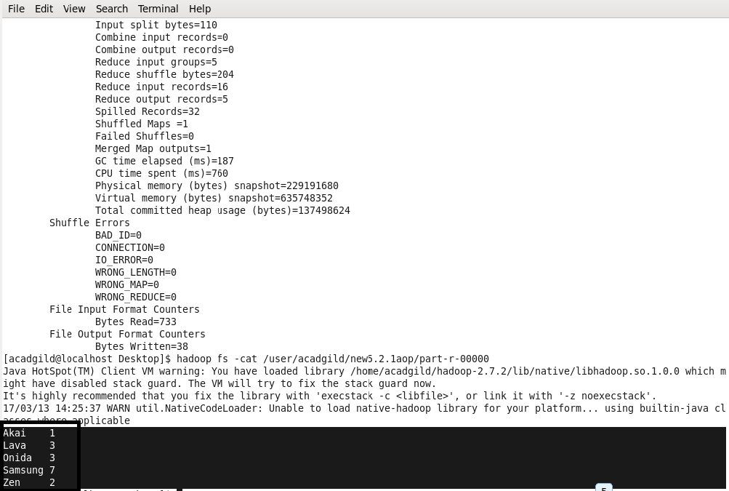

**Part 2: Sales of different TV Task 7:**

Write a MapReduce program to view the total sales for each product for every Company corresponding to each size. Make sure that all records for a single company goes to a single reducer and inside every reducer, keys must be sorted in descending order of the size. You may write a custom WritableComparable for this purpose.

**Driver Class:**

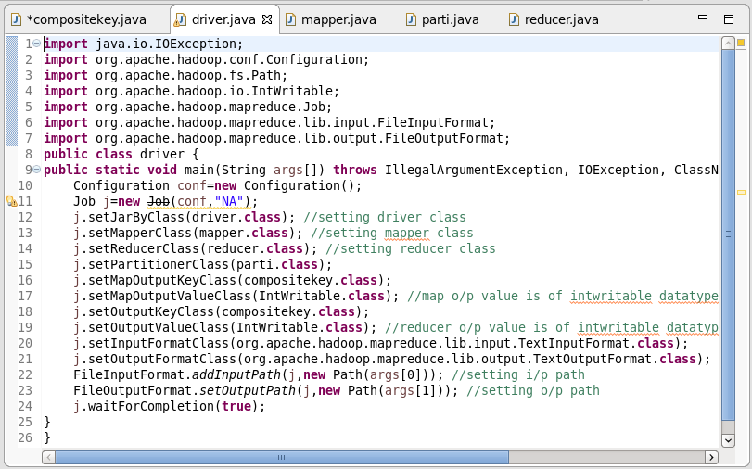

**Composite Key Class:**

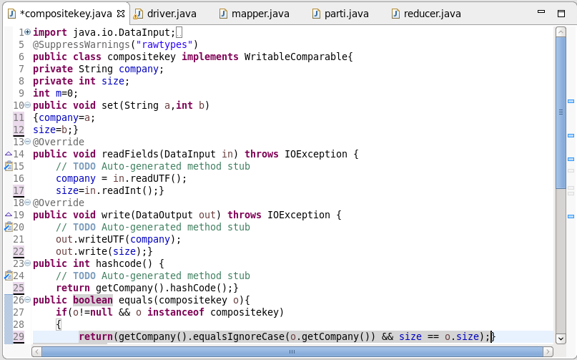

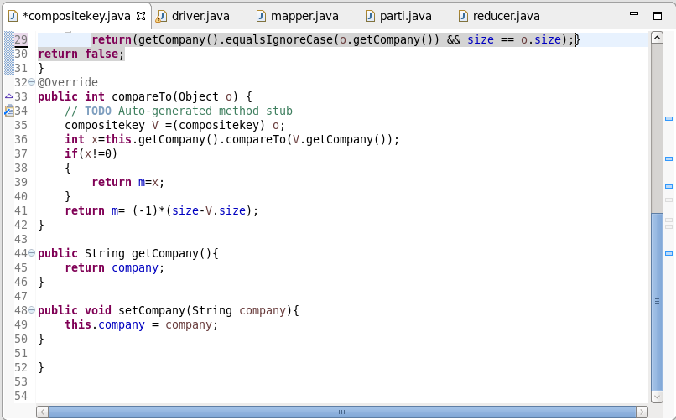

**Mapper Class:**

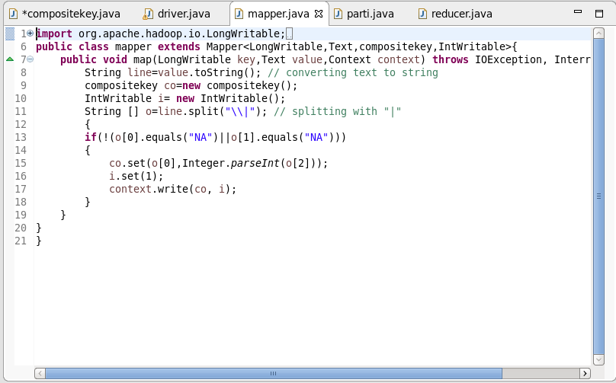

**Partitioner Class:**

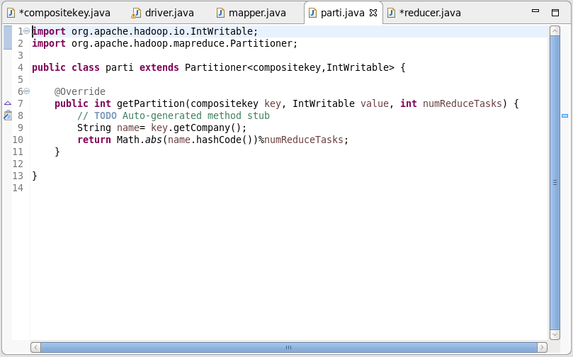

**Reducer Class:**

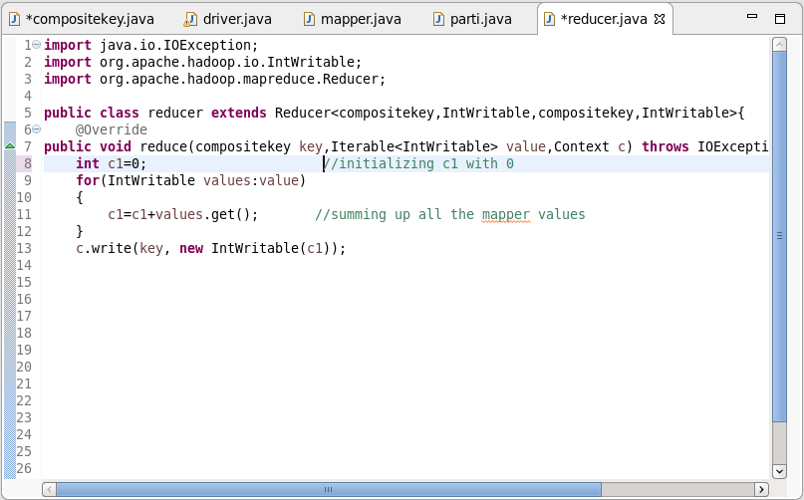

**Output:**

