**Session 7**

**Assignment 3**

Write a custom key to evaluate the number of people who died and the number of people who survived, along with their genders.

**Driver Class:**

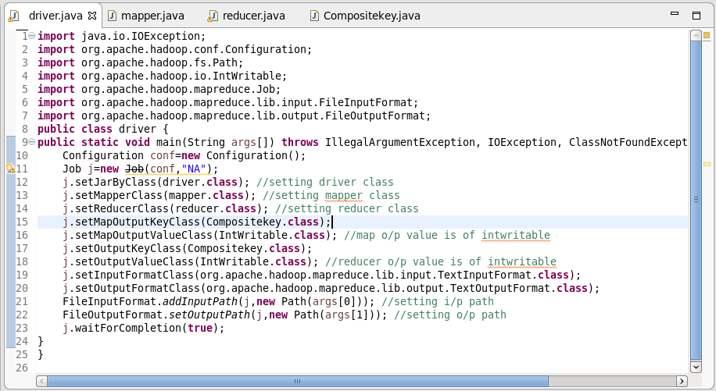

**Mapper Class:**

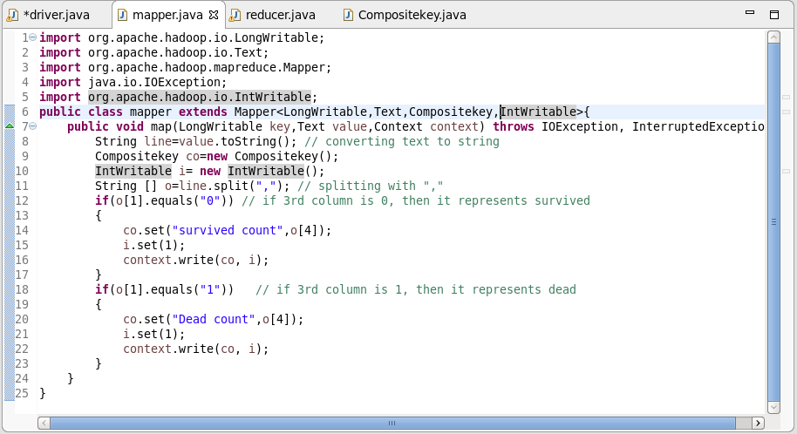

**Reducer Class:**

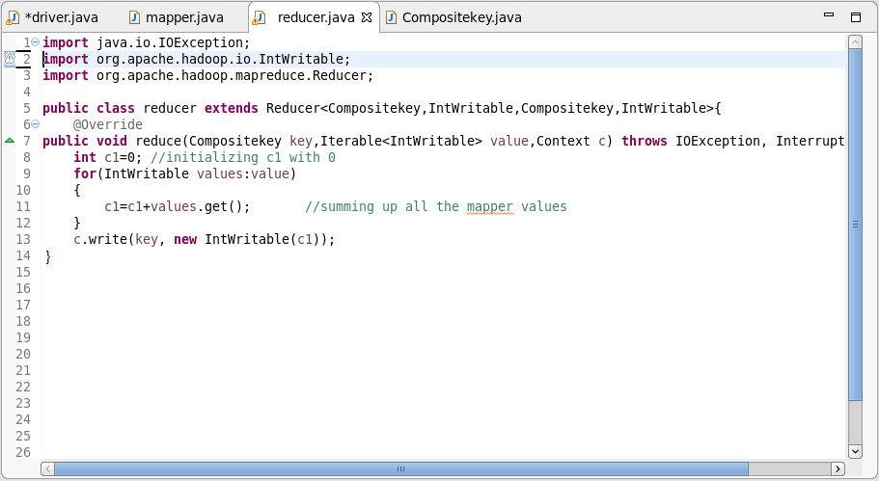

**Composite Key Class:**

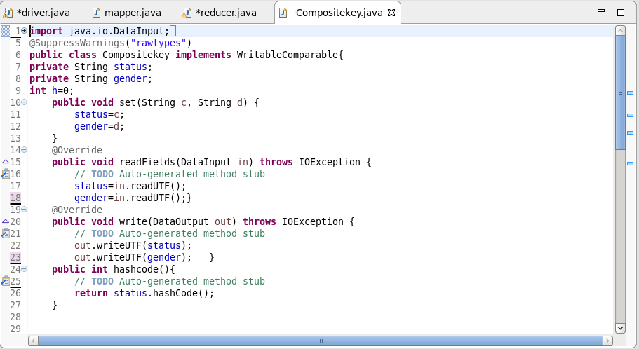

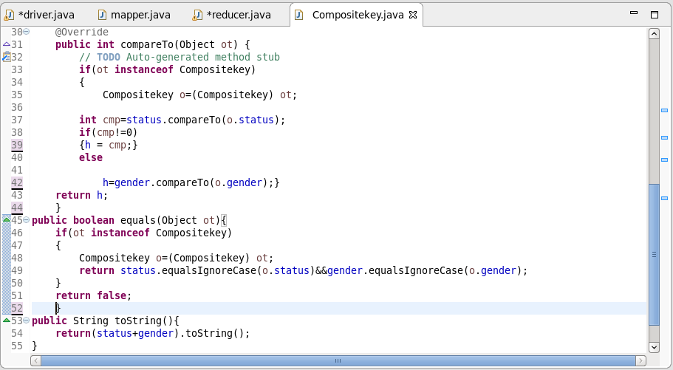

**Output:**

