**Session 7**

**Assignment 4**

Write a word count program using partitioner and implement the following logic in the partitioner words with length 5 should go into reducer 1 and words with length 6 should go into reducer 2 and the rest of the words should go into reducer 3.

**Note:** Can use dataset of user’s choice.

**DRIVER CLASS:**

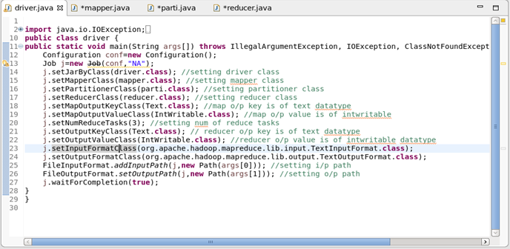

**Mapper Class:**

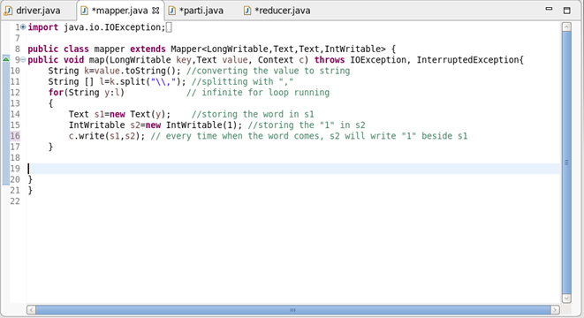

O/P of the Mapper will be like Hadoop 1,1,1,1.

This O/P goes as I/P for partitioner class where the words get partitioned as per length.

**Partitioner Class:**

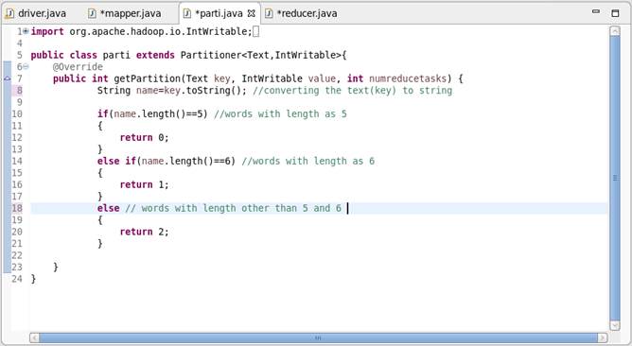

Words of length 5 will go to reducer 1

Words of length 6 will go to reducer 2

Words of length other than 5 and 6 will go to reducer 3.

**REDUCER CLASS:**

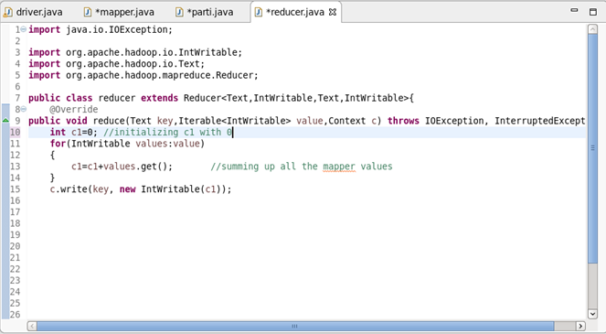

Thus the Reducer produces 3 o/p files.

First file consists of words of length 5 and their count.

Second file consists of words of length 6 and their count.

Third file consists of words whose length is other than 5 and 6 and their count.

**O/P File:**

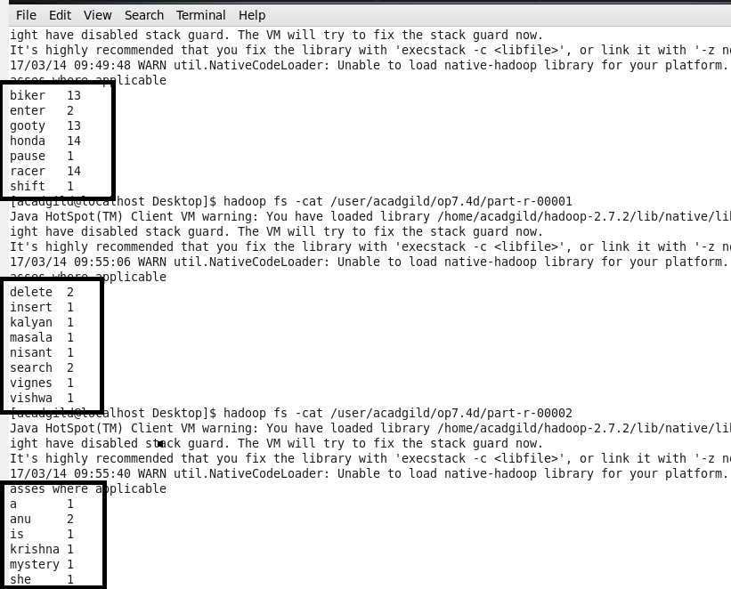

From the O/P image,

* First file has the words of length 5 and their count
* Second file has the words of length 6 and their count
* Third file has the words whose length is other than 5 and 6 and their length