**Session 7**

**Assignment 5**

Write a map only job for the word count program and set the output format as sequence file.

**Note:** Can use the dataset of user’s choice.

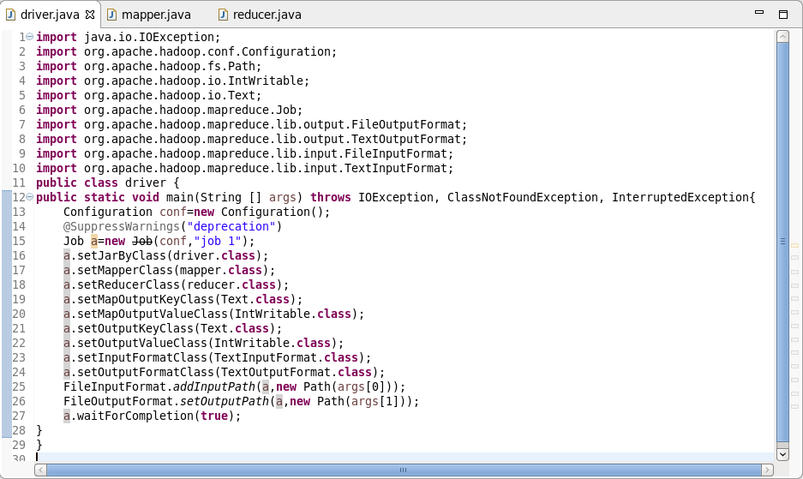

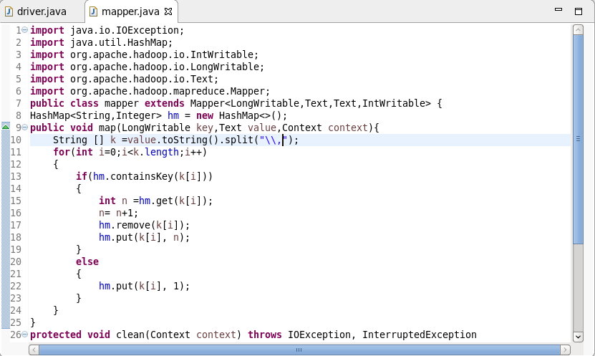

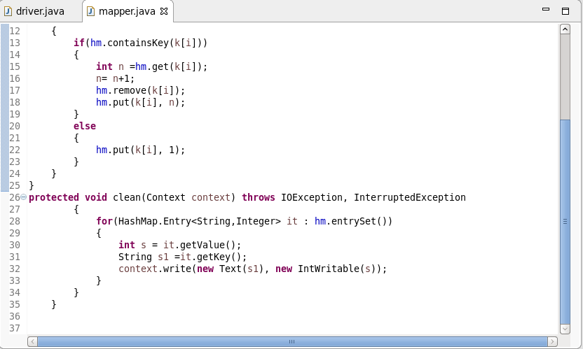

**Output:**

