**Session 7**

**Assignment 6**

Write a map reduce program save the output of the word count program in XML format. You need to write a custom writable to save the output in XML format.

**Note:** Can use any data set of user’s choice for executing this program.

**Driver Class:**

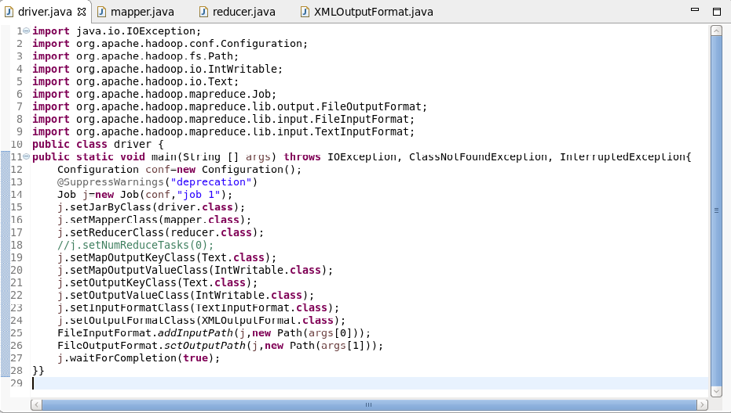

**Mapper Class:**

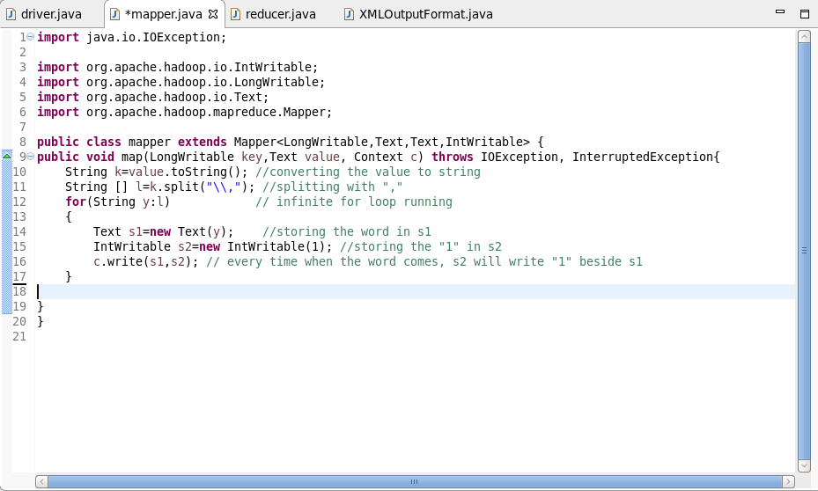

**Reducer Class:**

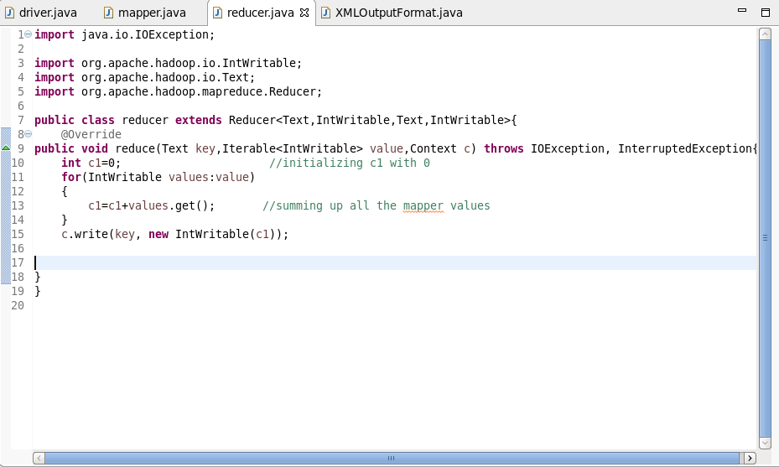

**XML Class:**

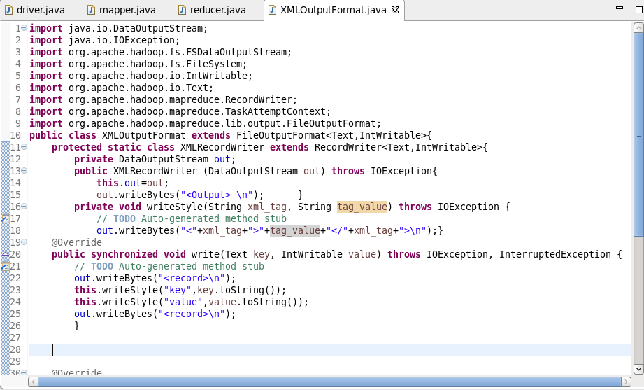

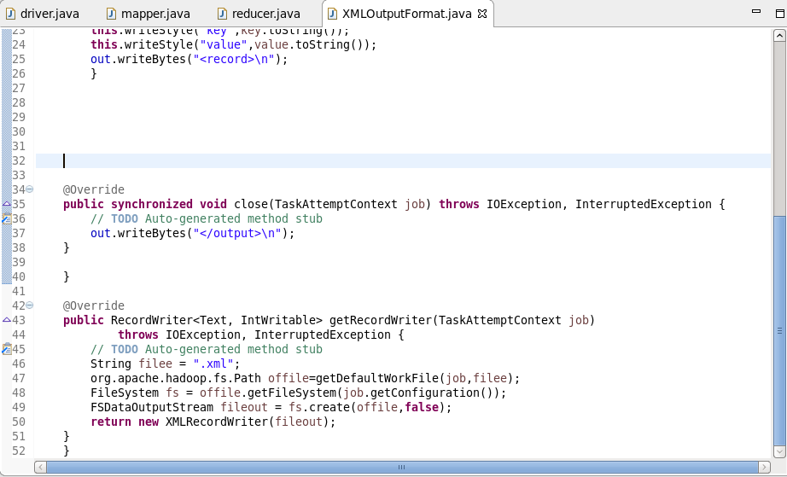

**Output:**

