**Session 8**

**Assignment 1**

**Part 1:**

Write a MapReduce program to find the total amount of petrol in volume sold by every distributor.

Driver Class:

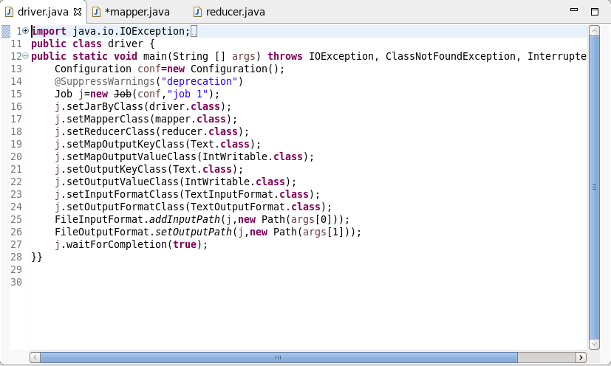

Mapper Class:

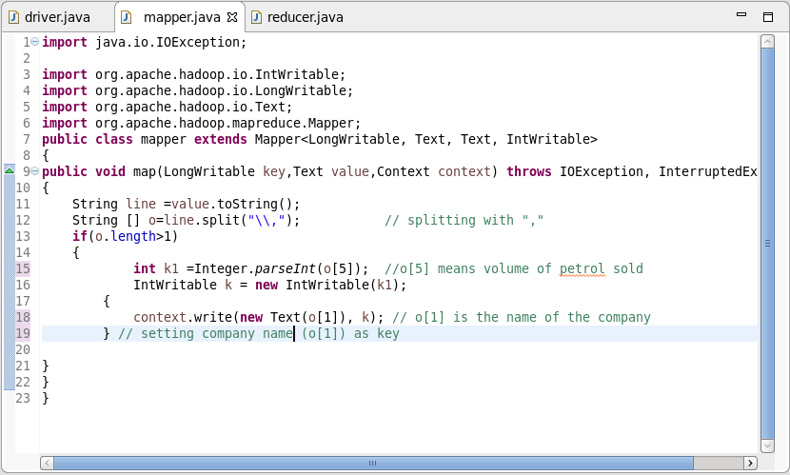

Reducer Class:

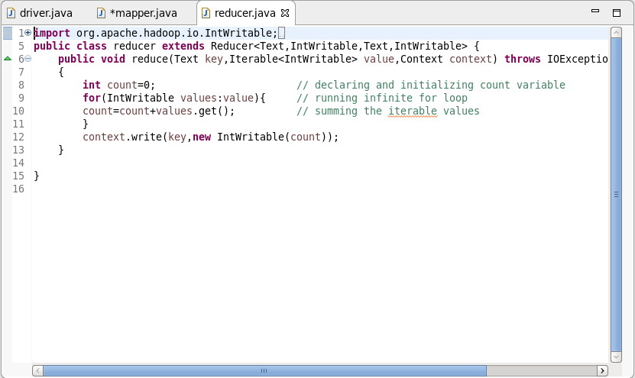

Output:

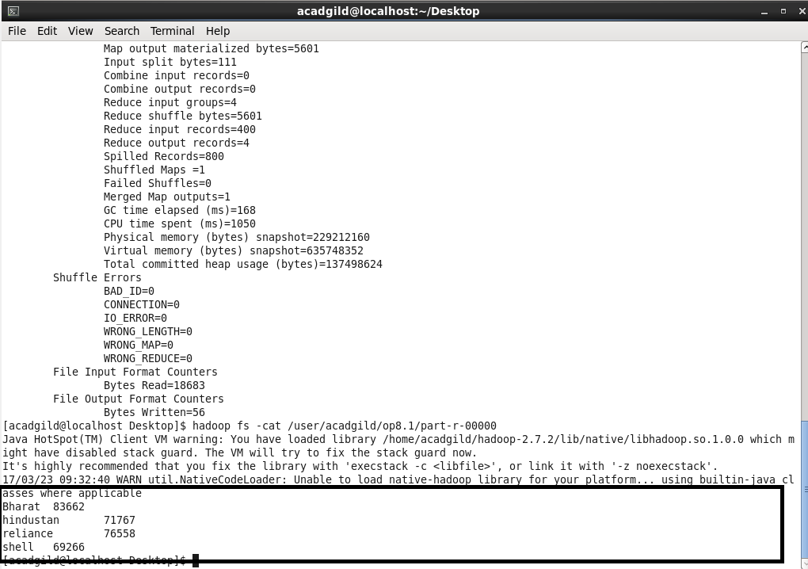

**Part 2:**

Write a MapReduce program to find which are the top 10 distributors ID's for selling petrol and also display the amount of petrol sold in volume.

Driver Class:

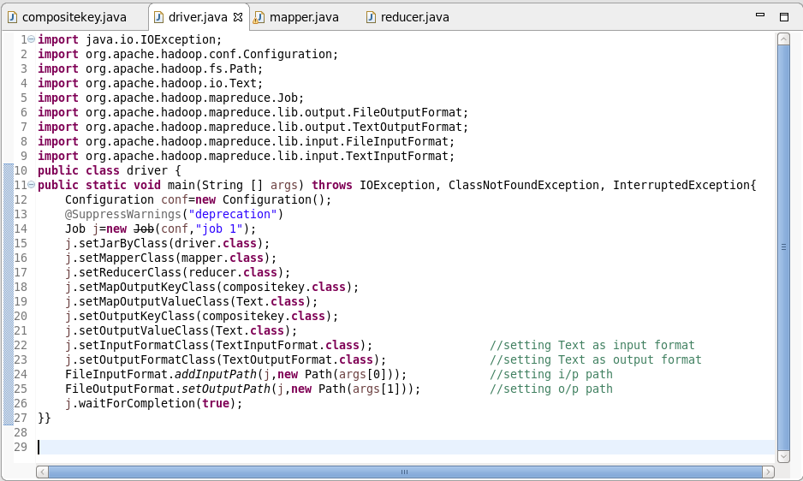

Composite Key Class:

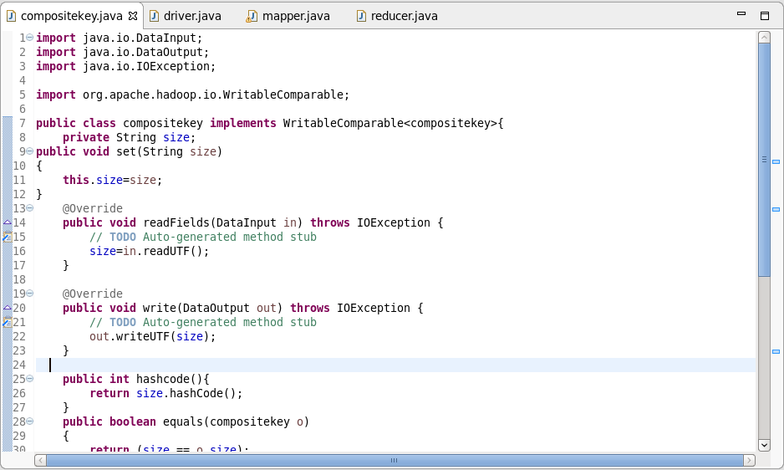

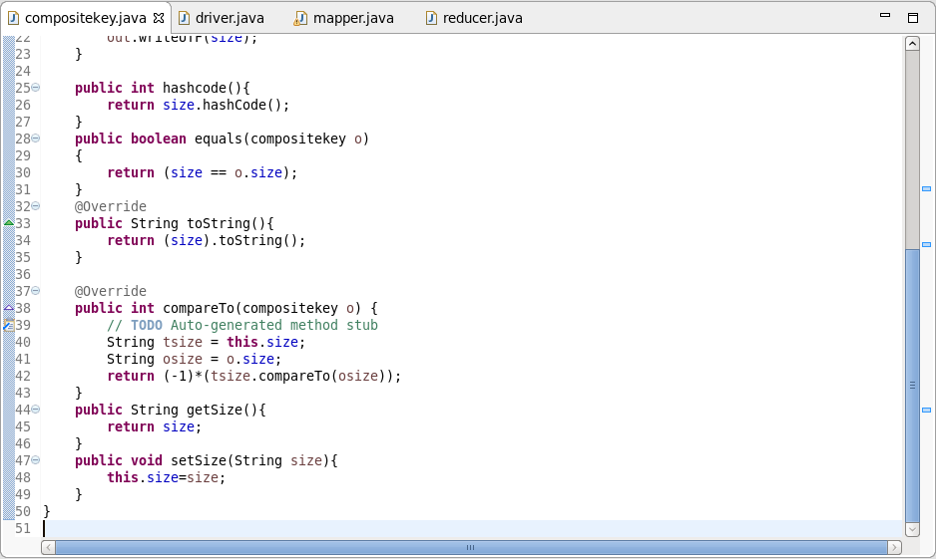

Mapper Class:

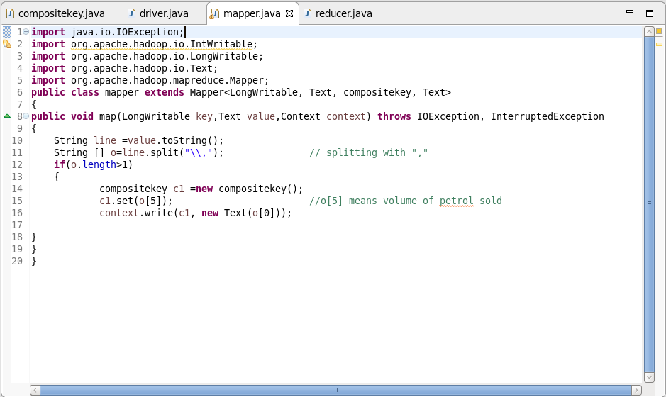

Reducer Class:

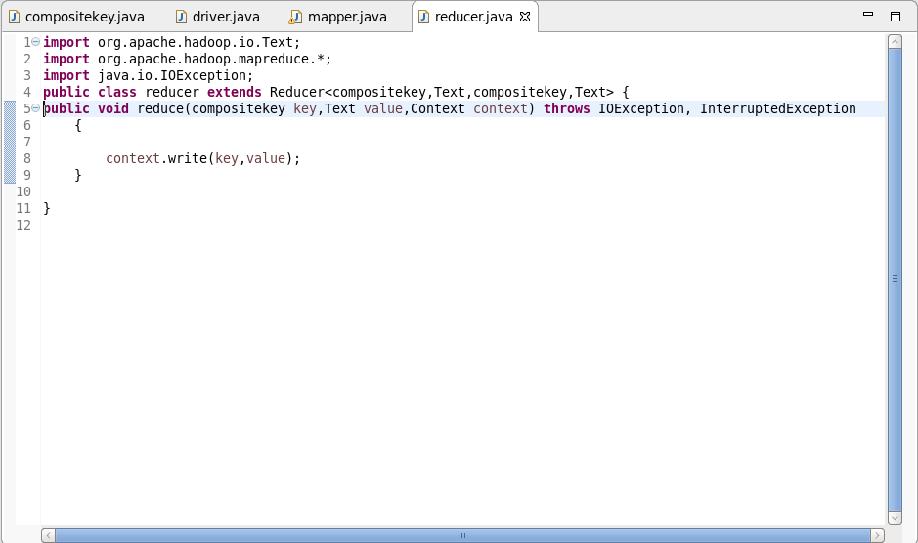

Output:

