Assignment 9.2 : Explain the working of below pig script commands with an example:

1. LOAD

2. STORE

3. DUMP

4. FOREACH

5. FILTER

6. GROUP BY

7. ORDER BY

8. DESCRIBE

1. LOAD

You can load data into Apache Pig from the file system (HDFS/ Local) using LOAD operator of Pig Latin.

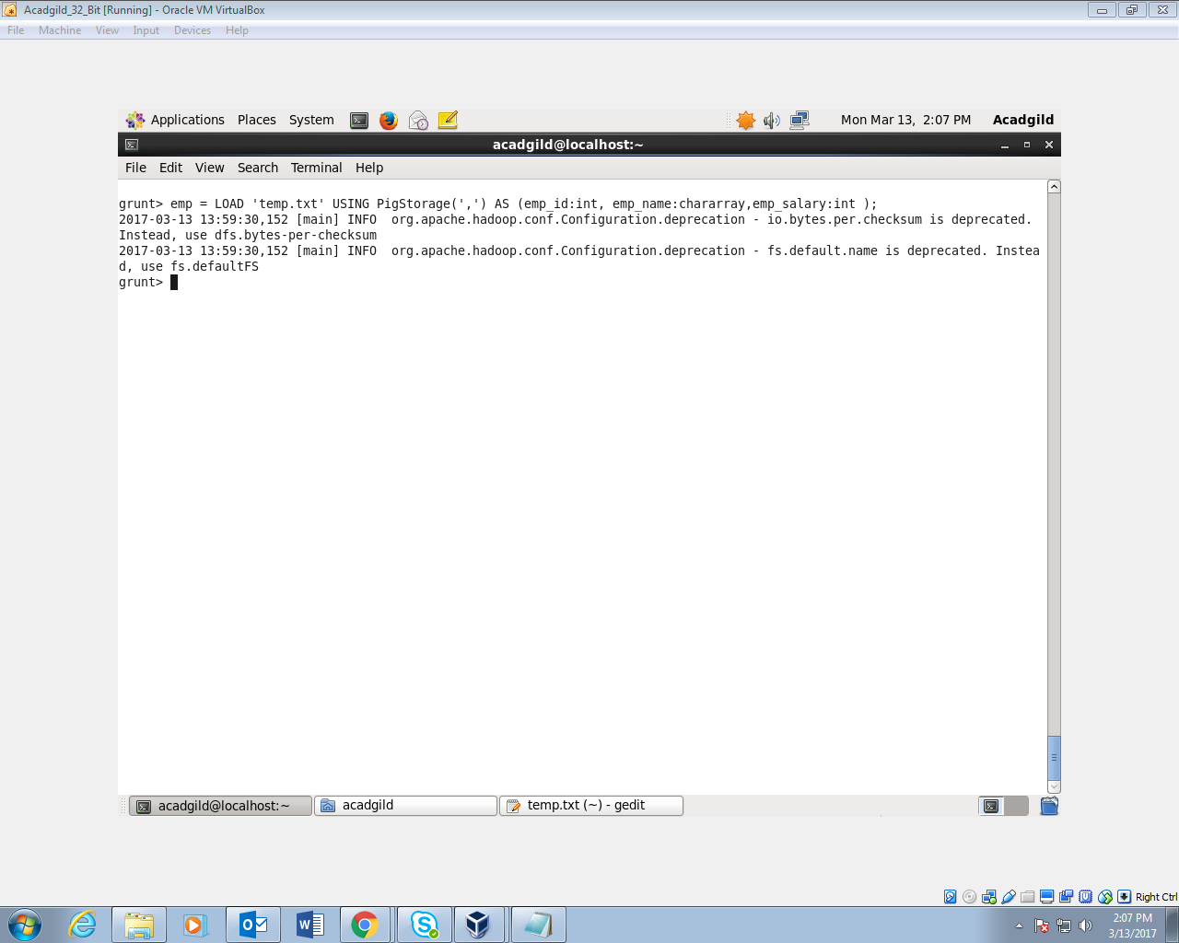

1. STORE

You can store the loaded data in the file system using the store operator.

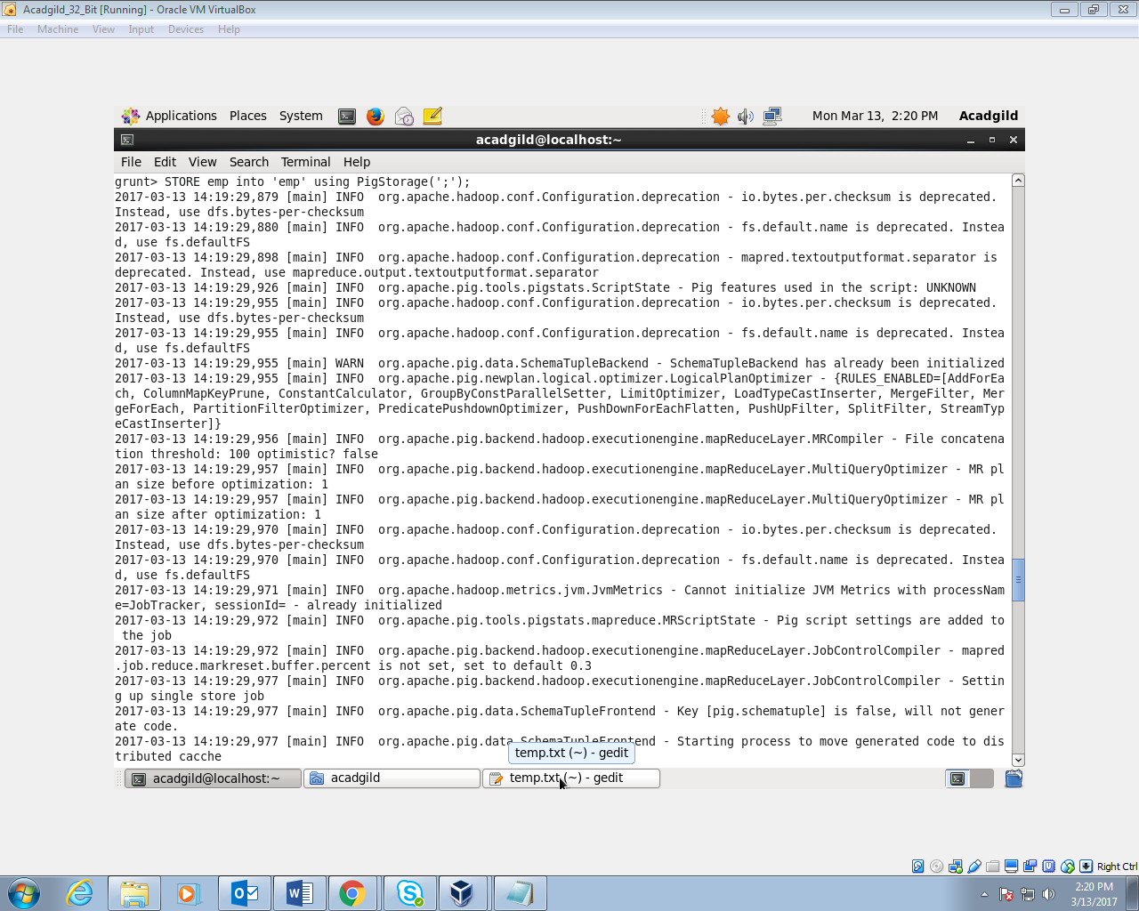

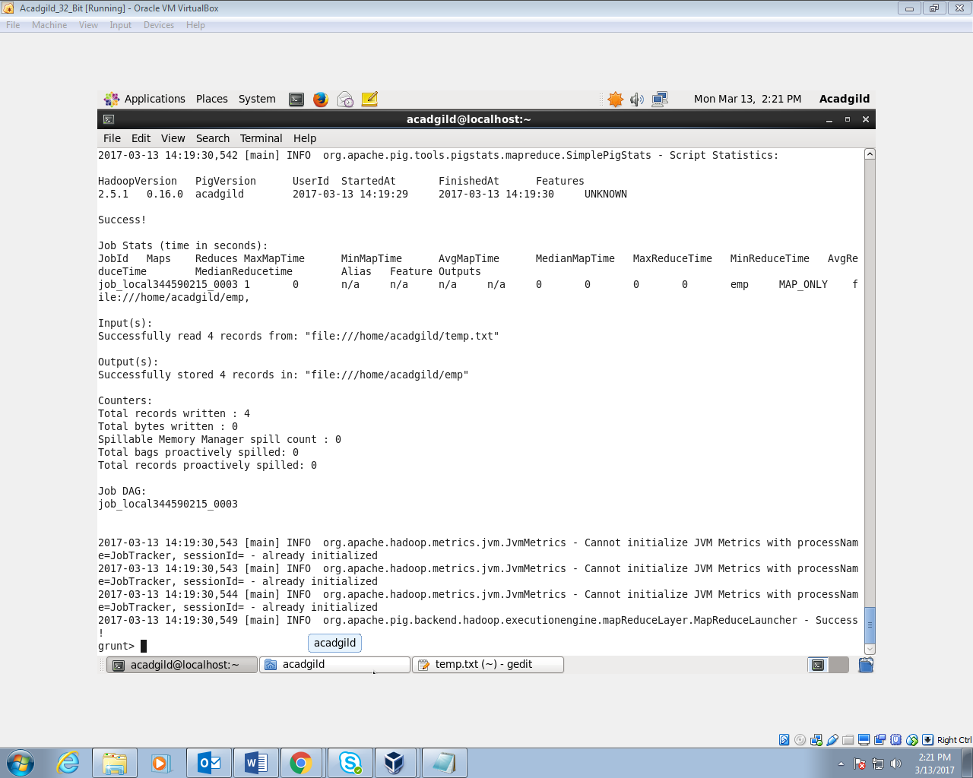

1. DUMP

Use the DUMP operator to display results to a screen.

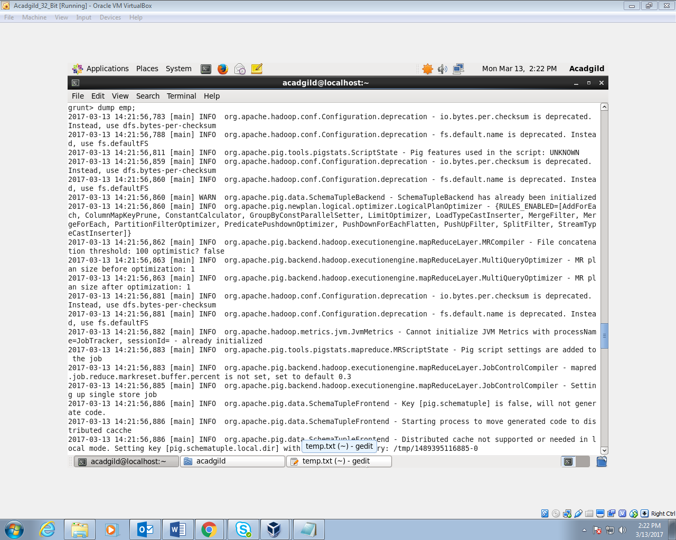

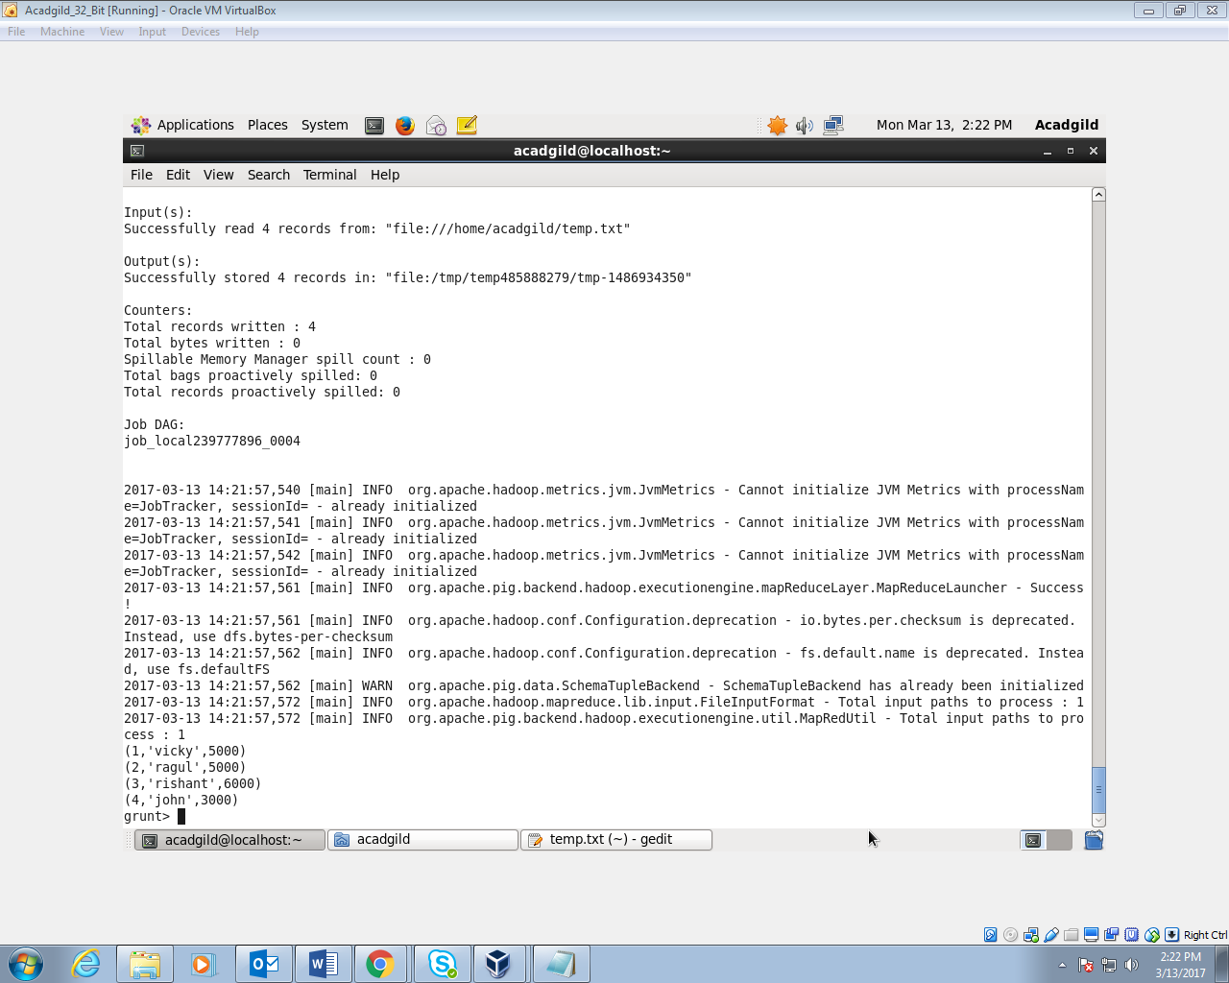

1. FOREACH

The FOREACH operator is used to generate specified data transformations based on the column data.

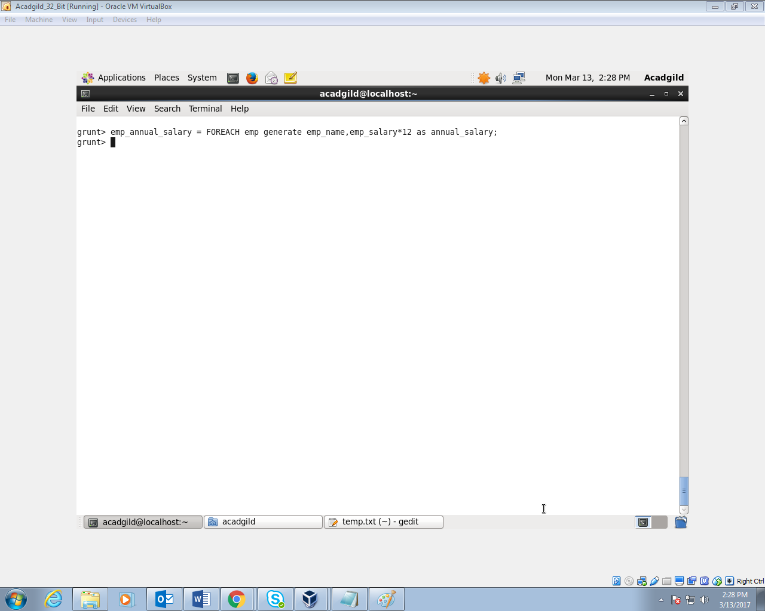

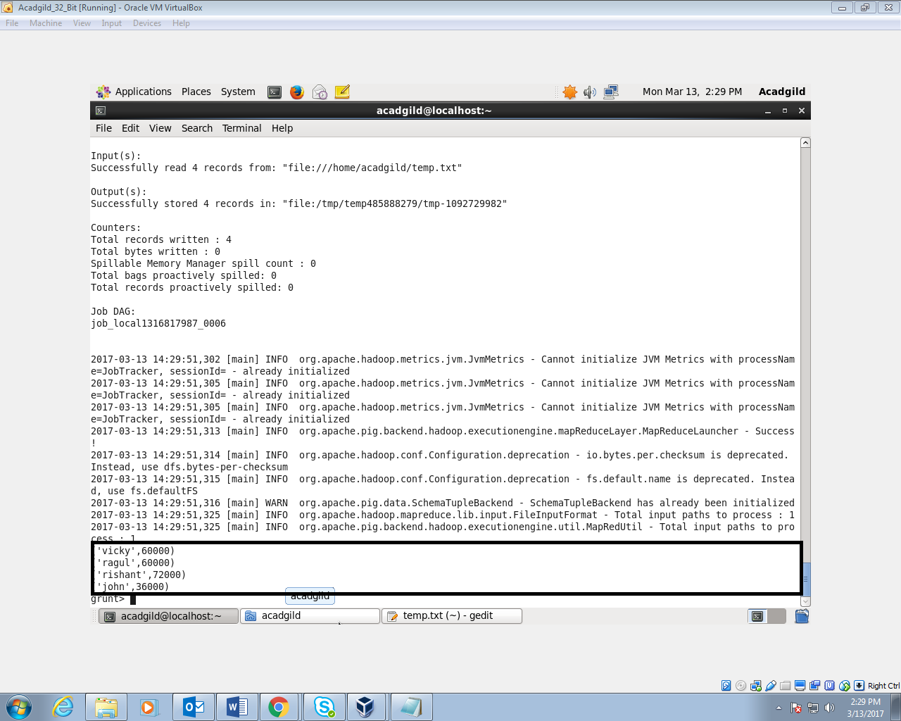

1. FILTER

The FILTER operator is used to select the required tuples from a relation based on a condition.

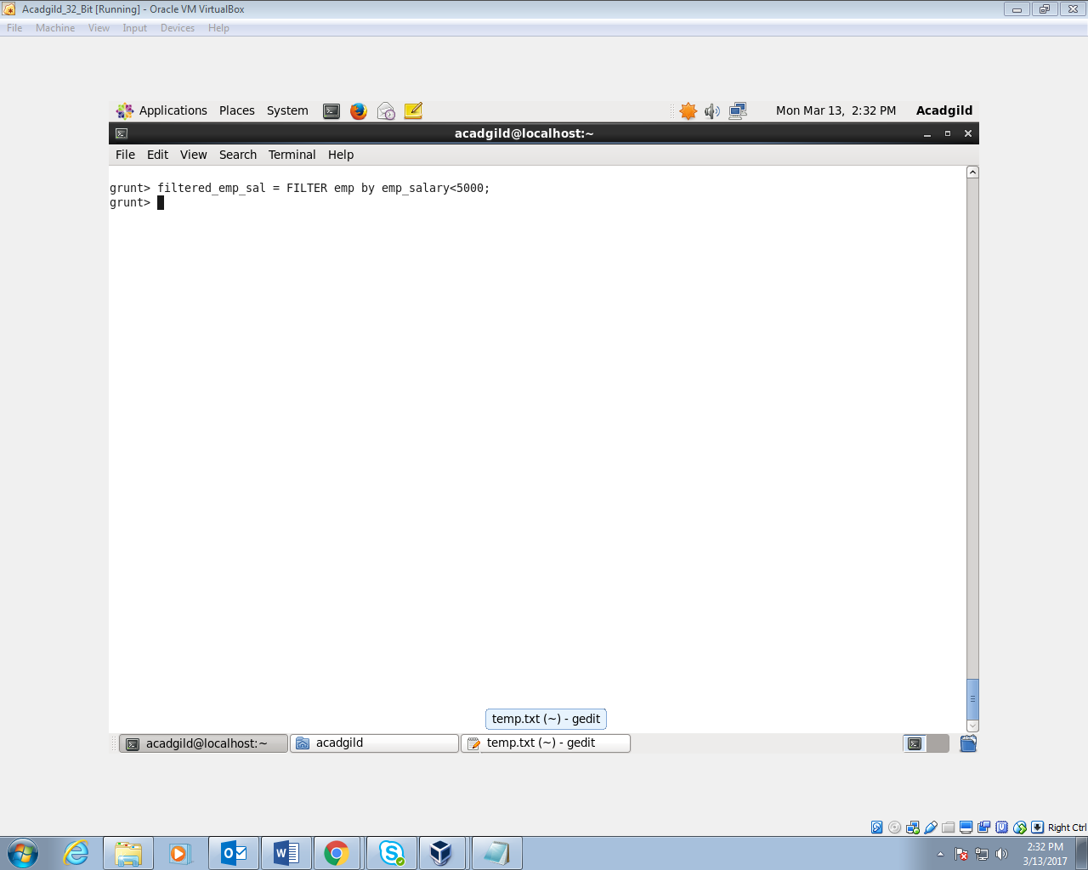

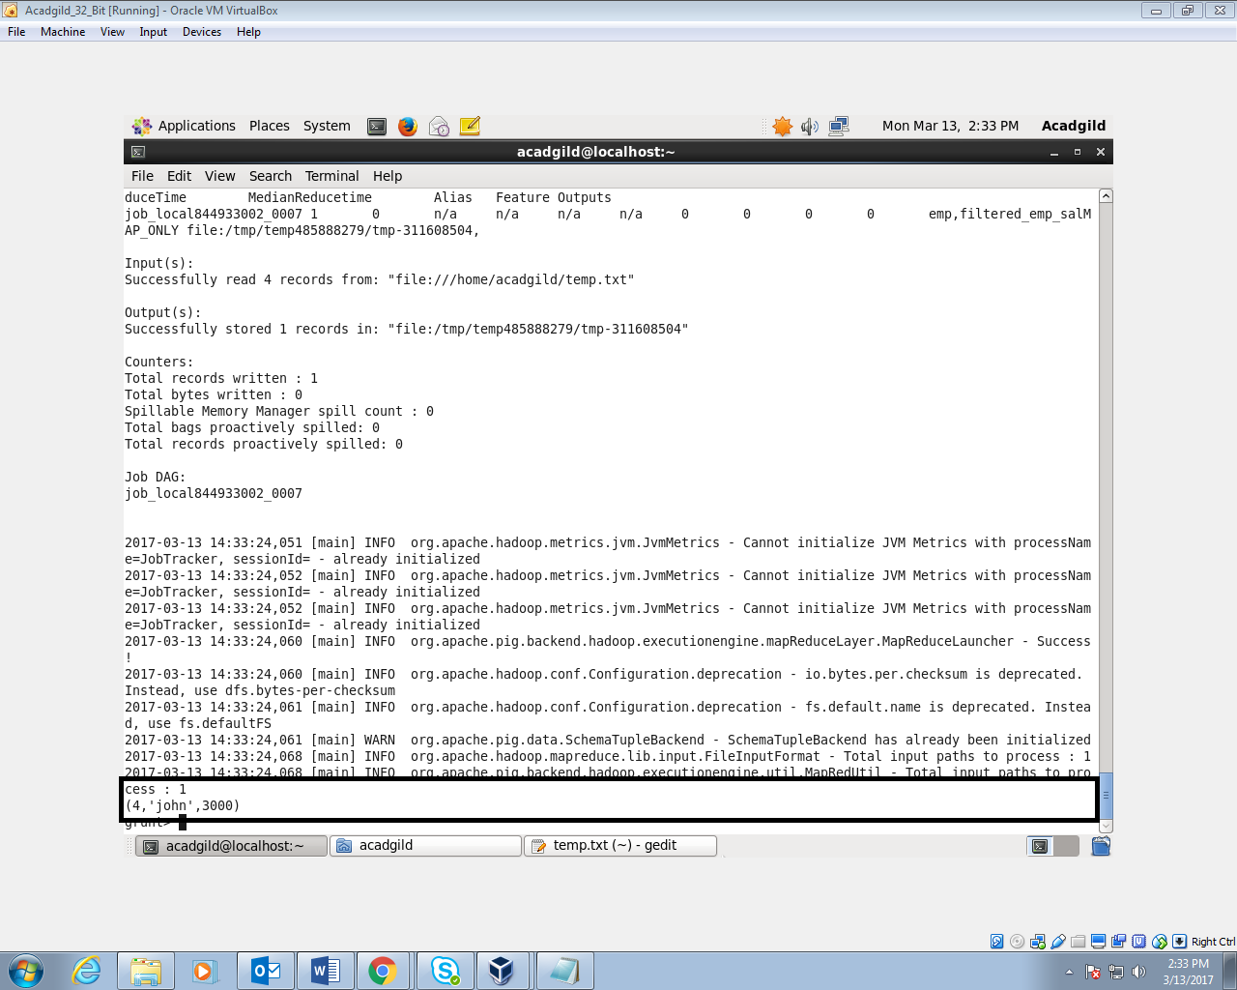

1. GROUP BY

The GROUP operator is used to group the data in one or more relations. It collects the data having the same key.

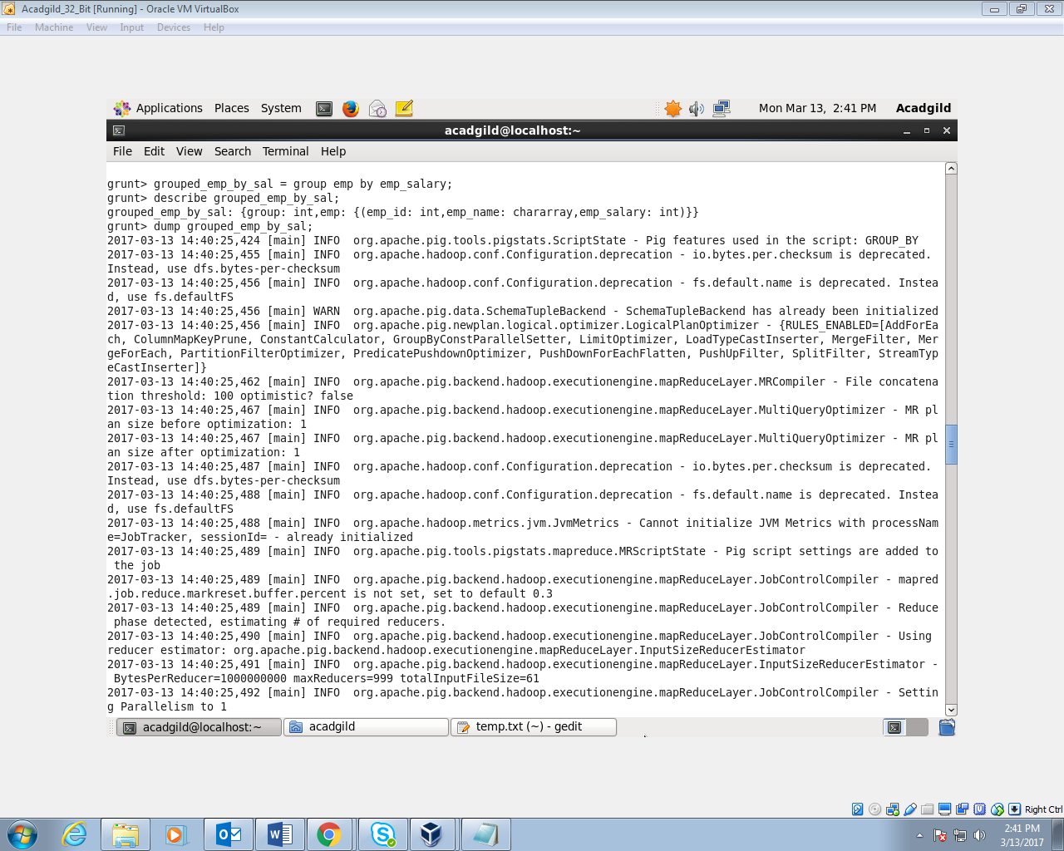

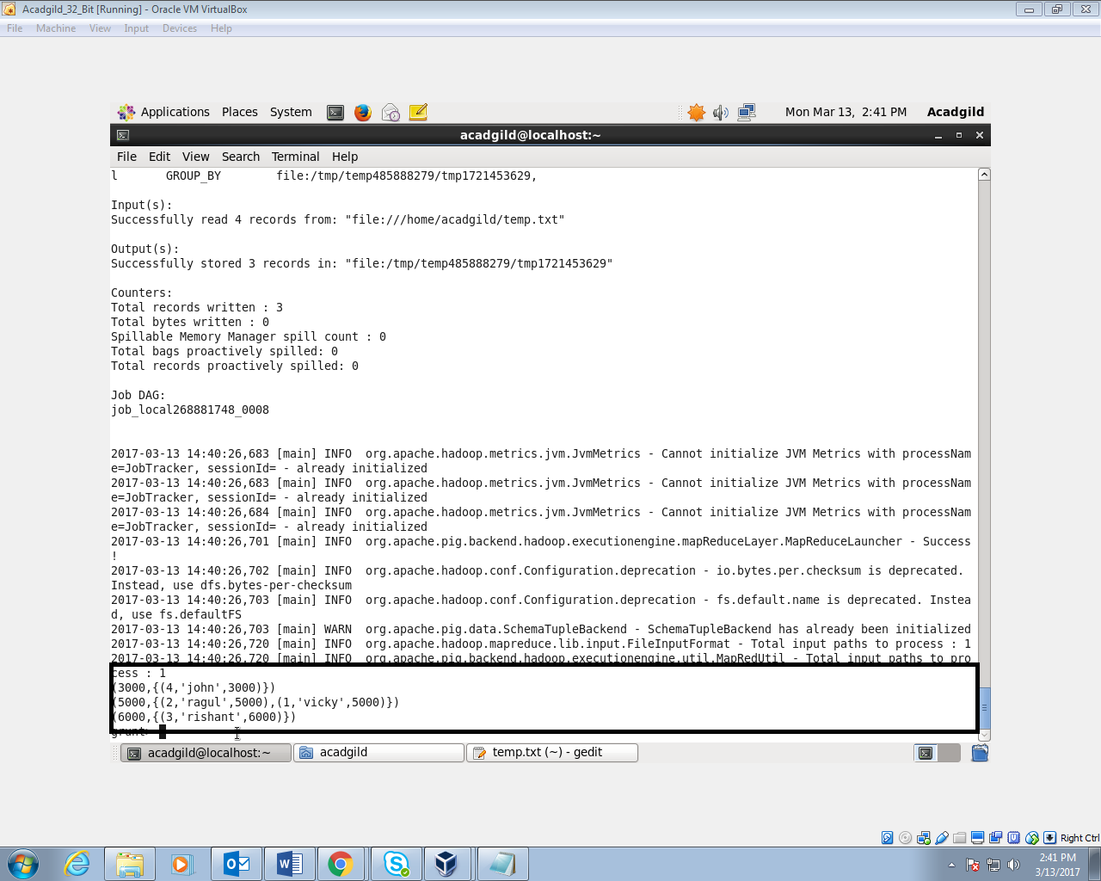

1. ORDER BY

The ORDER BY operator is used to display the contents of a relation in a sorted order based on one or more fields.

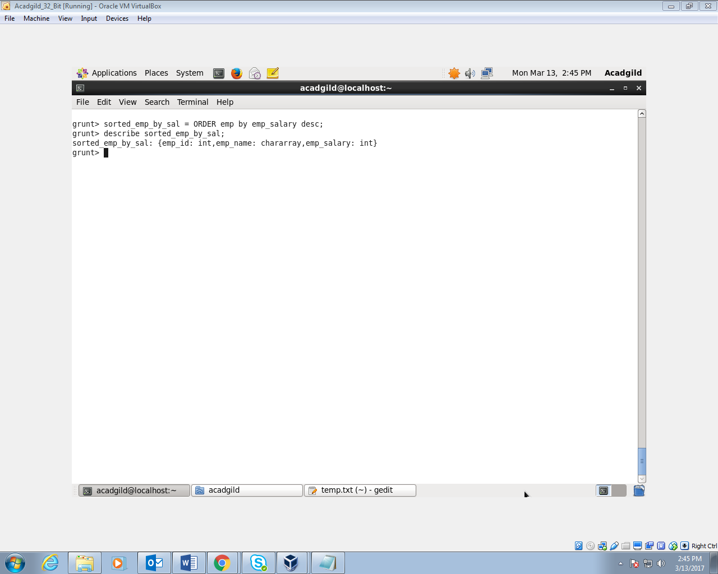

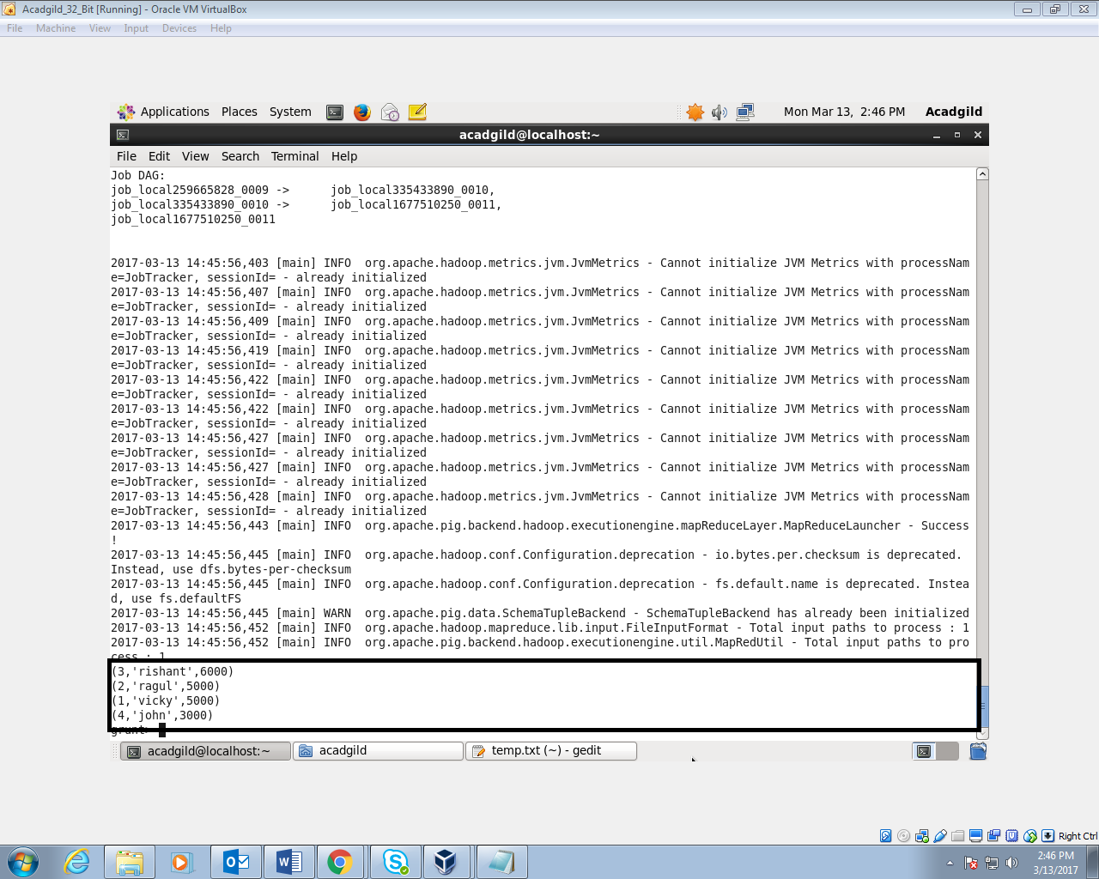

1. DESCRIBE

The describe operator is used to view the schema of a relation.

