**SED COMMANDS:**

* Sed is a Stream Editor used for modifying the files in unix (or linux). Whenever you want to make changes to the file automatically, sed comes in handy to do this.

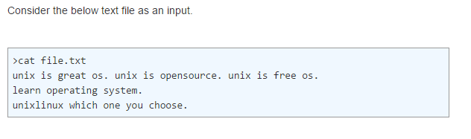

**REPLACING OR SUBSTITUTIONG STRING:**

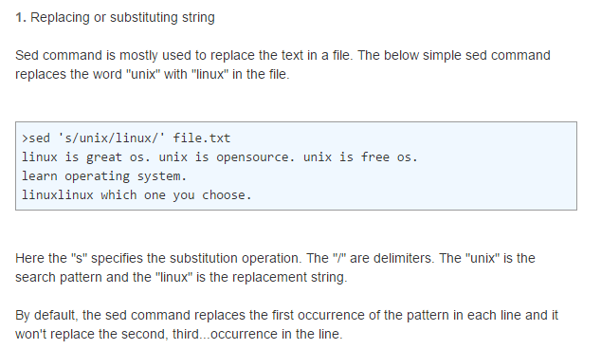

**REPLACING THE NTH OCCURRENCE OF A PATTERN IN A LINE.**

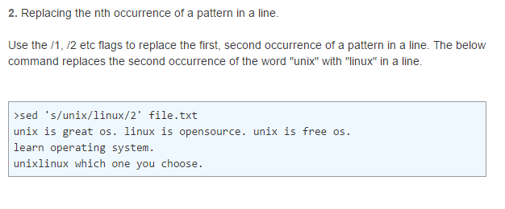

**3. REPLACING ALL THE OCCURRENCE OF THE PATTERN IN A LINE.**

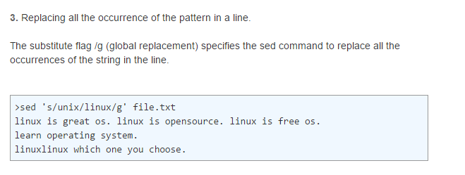

**4. REPLACING FROM NTH OCCURRENCE TO ALL OCCURRENCES IN A LINE.**

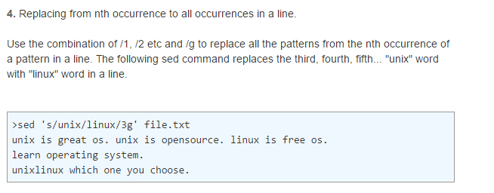

**CHANGING THE SLASH (/) DELIMITER**

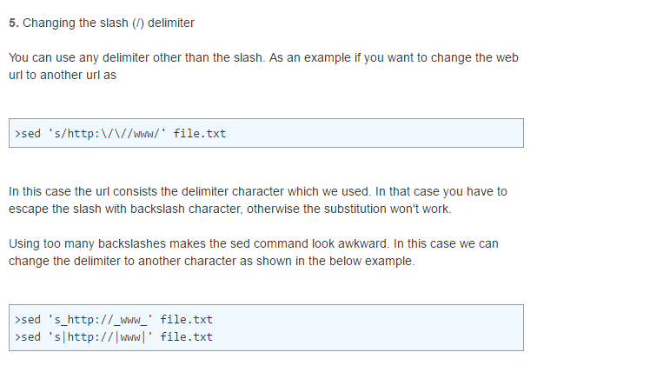

**USING & AS THE MATCHED STRING**

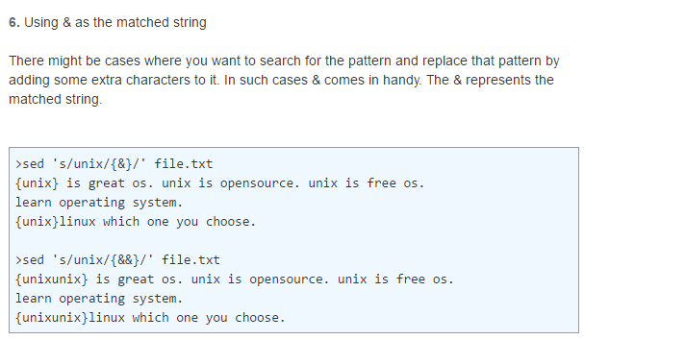

**USING \1,\2 AND SO ON TO \9**

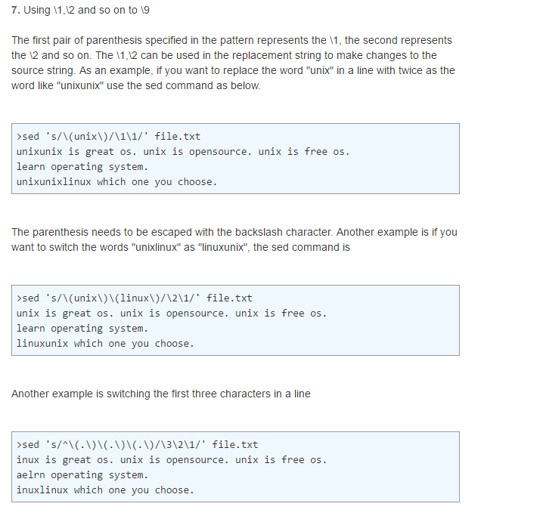

**DUPLICATING THE REPLACED LINE WITH /P FLAG**

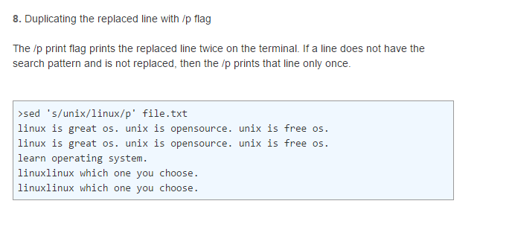

**PRINTING ONLY THE REPLACED LINES**

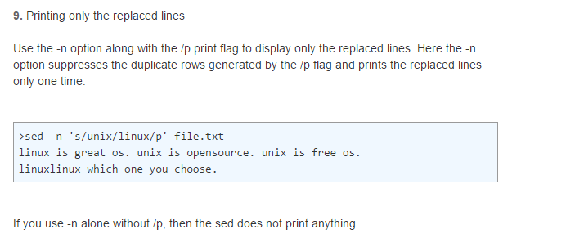

**10**

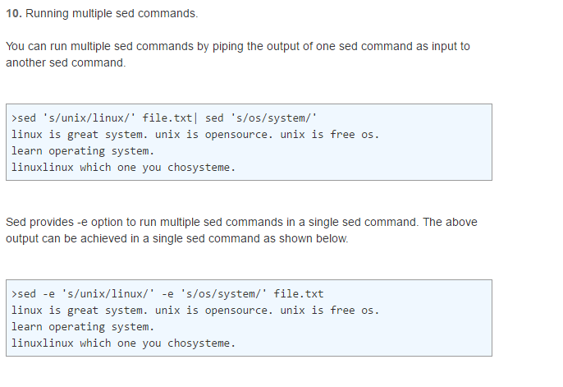

**11**

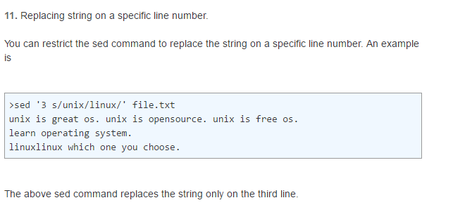

**12**

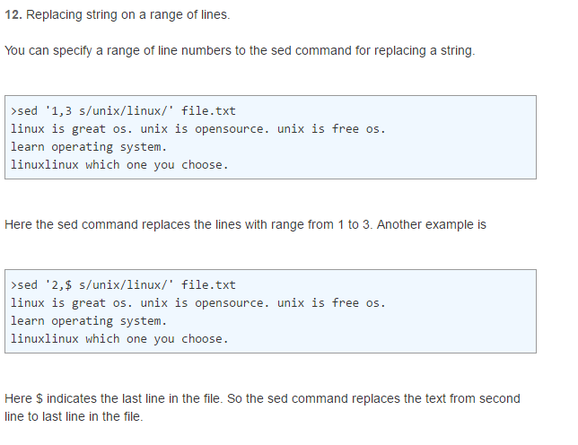

**13**

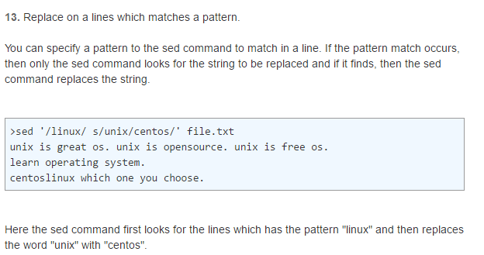

**14,15,16**

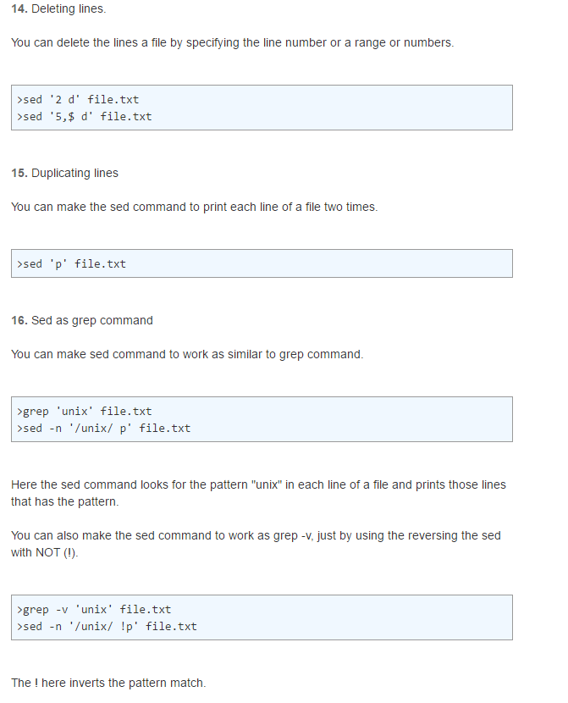

**17,18,19**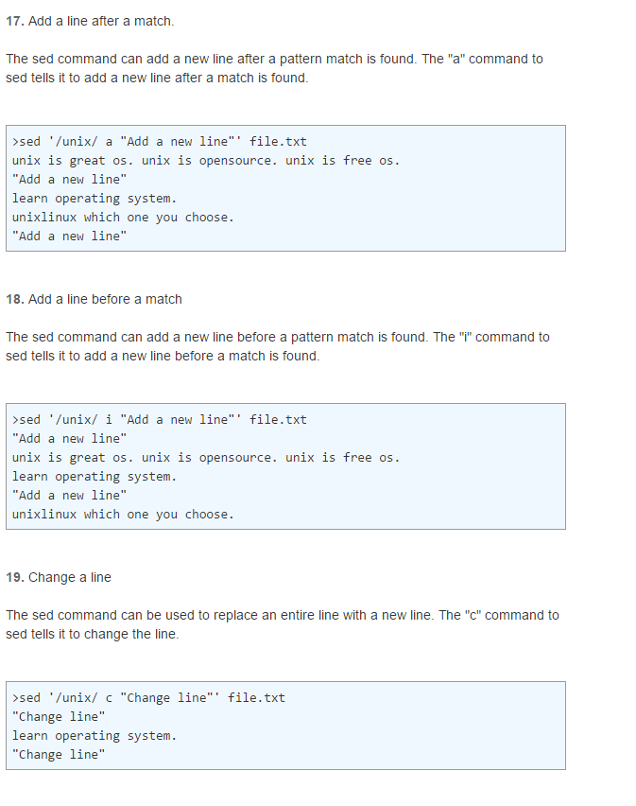

**20**

